**OPTICAL TRANSMITTANCE METER**

**OPERATION MANUAL**

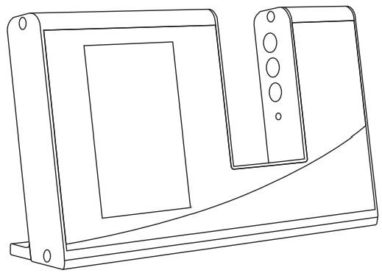

V1.0

Thank you for purchasing our products! Please read this operation manual carefully before use and keep it properly after use in case you need it next time.

**Contents**

I. Overview 3

II.Usage steps and precautions 3

III.Structure description 4

IV.Instrument operation 5

4.1 Instrument startup 5

4.2 Parameter measurement 5

4.3 Full infrared (FULL IR) and SHGC measurement 6

V. Function interface description 7

5.1 Standard management 8

5.1.1 Standard selection 8

5.1.2 Tolerance setting 9

5.1.3 Buzzer 9

5.2 Display setting 10

5.3 Language setting 11

5.4 About instrument 11

VI.Instrument features 12

VII.Product parameters(parameters are only applicable to some instruments) 13

# I. Overview

The optical transmittance meter is independently developed by our company, with complete independent intellectual property rights. The testing principle of the optical transmittance meter is to use ultraviolet light source, visible light source and infrared light source to illuminate the transparent material to be tested, and the sensor detects the incident light intensity of the light source and the light intensity after passing through the transparent material to be tested respectively. The ratio of the transmitted light intensity to the incident light intensity is the transmittance, which is expressed as a percentage. Most solar films have visible light transmittance indicators, and infrared and ultraviolet light blocking indicators. The optical transmittance meter directly measures and displays the ultraviolet blocking rate, infrared blocking rate and visible light transmittance, which is convenient for reading and understanding.

# II.Usage steps and precautions

1. Connect the instrument to a dedicated power source, keep the test slot empty, and turn on the instrument.
2. Place the object to be tested in the test slot, and keep the object as close to the left side of the test slot as possible.
3. When the instrument is not in use, please turn off the power.
4. When the instrument is turned on, the test slot must be empty for self-test and self-calibration, otherwise the self-calibration cannot be completed.
5. Avoid contact with corrosive items and stay away from high temperature and high humidity environments.

6. When used continuously for a long time, due to the decrease in the luminous efficiency of the LED light source, the test data may not be displayed as "0%, 0%, 100%" when there is no test object. At this time, please turn off the power of the instrument, restart the self-test and self-calibration, which will not affect the measurement accuracy and normal use.

7. When not in use, you can turn off the LED light by adjusting to the setting interface.

# III.Structure description

Dial key

O

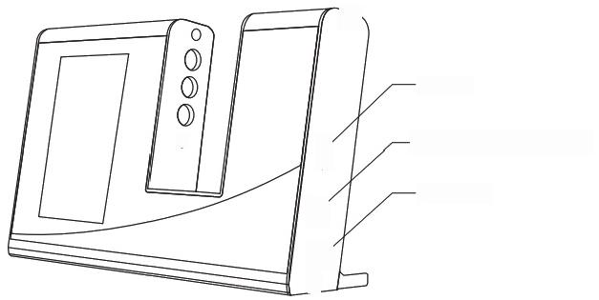

USB Type -C power port

Power switch

O

O

0



0

Figure 1 Product structure

**POWER switch**: Press the switch to power on the instrument; press the switch to flip up to power off the instrument. Press the switch to turn the instrument on and off.

**Dial key**: Long press to enter the main menu interface, short press to exit, and dial up and down to adjust the order.

# IV.Instrument operation

Optical transmittance meter is an instrument specially used to measure the light transmittance of materials. Its application scope includes ultraviolet blocking rate, infrared blocking rate and visible light transmittance of optical lenses, glass, film, coatings, etc. The measurement steps are as follows:

## 4.1 Instrument startup

Plug in the power supply, keep the test slot empty, turn on the power switch of the tester, and the UV blocking rate and infrared blocking rate data will be displayed as "0%", and the visible light transmittance will be displayed as 100%. This means that when there is no object to be tested, the infrared and UV blocking rates are 0%, and the visible light transmittance is 100%.

## 

## 4.2 Parameter measurement

Place the object to be tested (solar film, glass with film, etc.) into the test slot. The UV blocking rate, infrared blocking rate and visible light transmittance of the object to be tested will be displayed in about 0.5 seconds. The infrared blocking rate is the blocking rate of the corresponding band (940nm, Full IR and 1400nm) selected by the dial key (in Display Settings->Infrared Blocking Selection Settings), and the corresponding band is also marked in the middle of the infrared display pointer. As shown in the figure below: The UV blocking rate of the sample solar film is 100%, the infrared blocking rate is 30.5%, and the visible light transmittance is 80.1%.

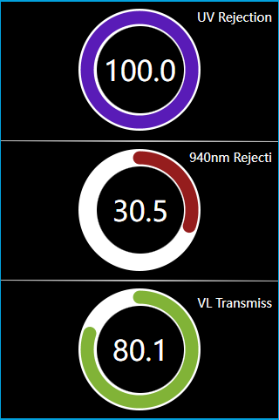

Figure 2 Measurement interface display

## 4.3 Full infrared (FULL IR) and SHGC measurement

Long press the dial key to enter the function interface (refer to Section 5.2), long press the dial key to enter the display setting interface, long press the dial key in the display setting interface to adjust the single option settings, the dial key to select the "Full IR" gear, you can test the material's UV blocking rate, full infrared blocking rate, light transmittance and solar total transmittance (SHGC). Full infrared blocking rate is the comprehensive value of IR940nm and IR1400nm heat insulation rate.

**Quick function**: In these three interfaces, you can switch the interface up and down by using the button on the right, without having to enter the settings interface to switch manually.

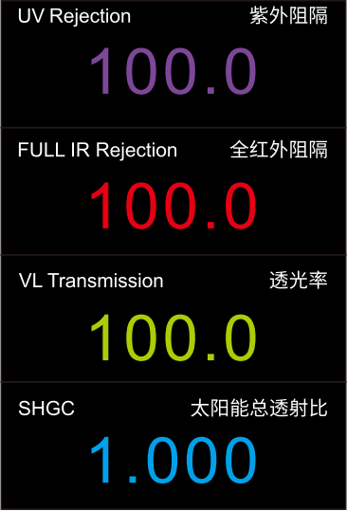

Figure 3 Measurement interface display

# 图4功能主界面V. Function interface description

Figure 4 Main Function Interface

## 5.1 Standard management

Select Standard Management on the main menu interface and long press the dial key to enter the Standard Management interface. The Standard Management interface allows you to select standard and set tolerances.

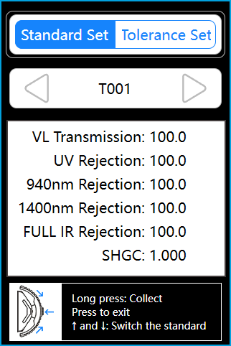

Figure 5 Standard management interface

### 5.1.1 Standard selection

As shown in Figure 5, in the standard selection interface, multiple measured standard data can be viewed by toggling the dial key.

### 5.1.2 Tolerance setting

Move the dial key to the tolerance setting interface. The tolerance setting is based on the allowable deviation range under the currently selected standard. The initial default value is:

SHGC Allowable deviation range: 0.100 (0.000-1.000)

FULL IR Rejection Allowable deviation range: 10.0 (0.0-100)

1400nm Rejection Allowable deviation range: 10.0 (0.0-100)

VL Transmission Allowable deviation range: 10.0 (0.0-100)

940nm Rejection Allowable deviation range: 10.0 (0.0-100)

UV Rejection Allowable deviation range: 10.0 (0.0-100)

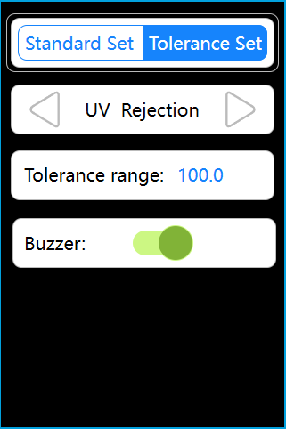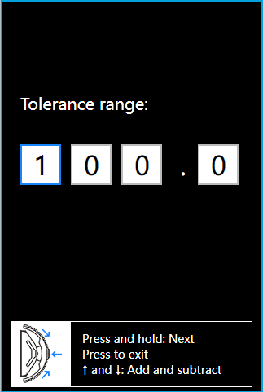

Figure 6 Tolerance Setting Interface

### 5.1.3 Buzzer

In the tolerance setting interface, long press to set the buzzer switch, and a beeping sound will be heard when the dial key is turned on. If the buzzer is turned off, no sound will be heard when the dial key is turned on. The buzzer works only in standard mode.

## 5.2 Display setting

In the main menu interface, turn the dial key to display settings, press and hold the dial key to enter the display settings interface. In the display setting interface, press and hold the dial key to adjust the single option settings.

As shown in Figure 7, the measurement mode can be selected from simple mode and standard mode, and the infrared blocking can be selected from 940nm Rejection, 1400nm Rejection, and FULL IR Rejection.

Simple mode: only measure actual data, without making differential display judgments.

Standard mode: substitute the selected standard and make differential display judgments.

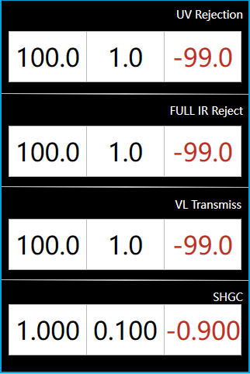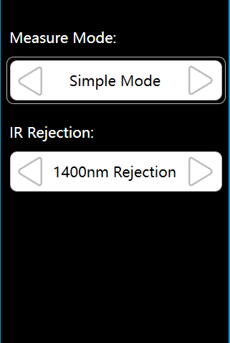

Display setting interface Simple mode Standard mode

Figure 7 Display setting

## 5.3 Language setting

In the main menu interface, slide the dial key to the language setting, and long press the dial key to enter the language setting interface, as shown in Figure 8. In the display setting interface, long press the dial key to adjust the single option setting.

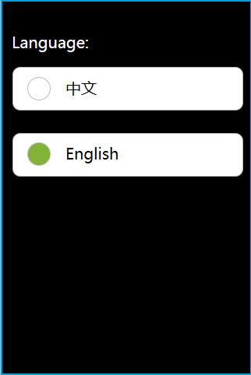

Figure 8 Language setting interface

## 5.4 About instrument

As shown in Figure 9, slide the dial key to About Instrument, and long press the dial key to enter the About Instrument interface, where you can see some relevant configurations of the instrument.

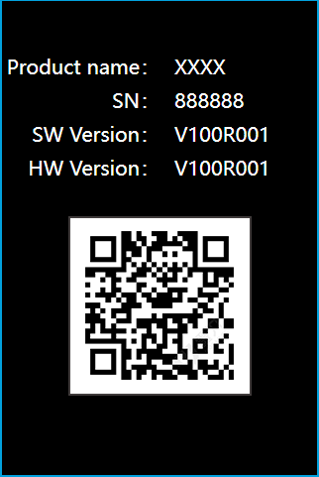

Figure 9 About instrument interface

# VI.Instrument features

1. Parallel light design, large color LCD display (supports 10 standard and standard interface).

2. Reference test of solar total transmittance (SHGC) parameters.

3. Five-band test, ultraviolet, visible light, infrared 940nm, infrared 1400nm, infrared full band.

4. Suitable for transmittance (blocking rate) test of automotive film, explosion-proof film, architectural film, insulation film, filmed glass, etc.

5. The instrument has real-time dynamic self-calibration function, and automatically calibrates after powering on.

# VII.Product parameters(parameters are only applicable to some instruments)

|  |  |
| --- | --- |
| Features | Four types of light sources, used to measure the transmittance, shading coefficient and other parameters of transparent materials such as glass and film |
| Light source | Ultraviolet, visible light, infrared 940nm, infrared 1400nm, infrared full band, SHGC and TSER |
| Spectral method | Plane grating spectrometry |
| Sensor | Silicon photodiode |
| Measurement wavelength range | Visible light 380nm-760nm; infrared peak wavelength 940nm, 1400nm, infrared full band |
| Resolution | 0.001 |
| Measurement time | About 0.5s |
| Measurement accuracy | Better than ±2% (colorless uniform light-transmitting material), factory standard detection better than ±1% |
| Sample thickness | Less than 47mm |
| Dimensions | Length x width x height = 203*120*29mm |
| Weight | 600g |
| Power supply | 5VDC power supply (Type-C) |
| Light source life | More than 3 million measurements in 5 years |
| Display | TFT true color 3.5inch |
| Interface | USB |
| Language | Simplified Chinese/English |
| Operating temperature range | 0~40℃, 0~85%RH (no condensation), altitude: less than 2000m |
| Storage temperature range | -20~50℃, 0~85%RH (no condensation) |
| Standard accessories | Power adapter, data cable, manual |

