Liquid spectrophotometer

O P E R AT I O N M A N U A L

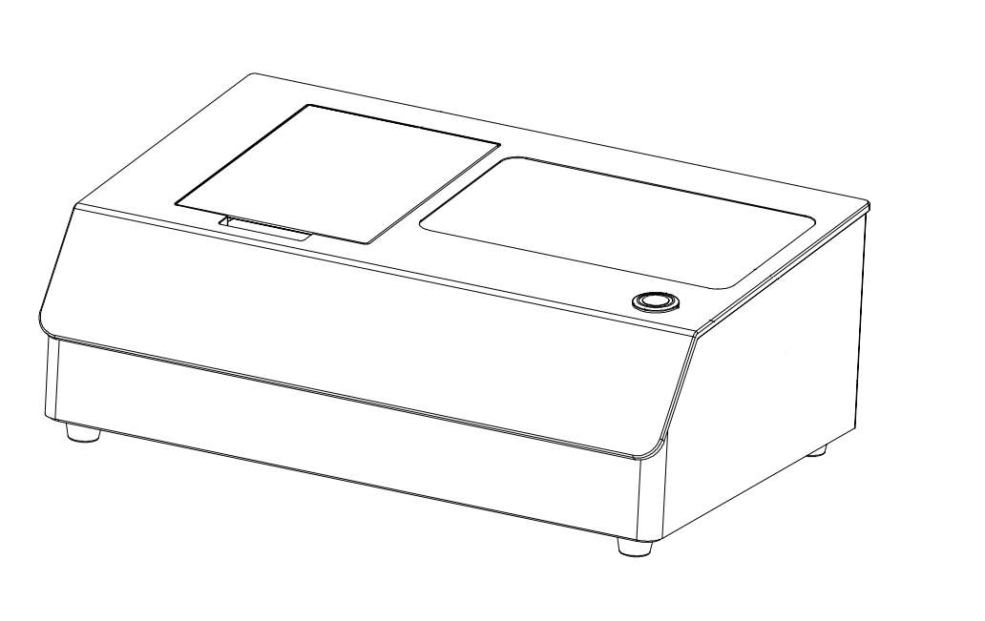

V1.1

Read this manual carefully before use the spectrophotometer.

Safety Symbol
In order to avoid accidents caused by improper operation, the following symbols are used in this manual or on the instrument label.

This symbol instructs relative safety warnings or precautions.
Read these instructions carefully to use this instrument safely and correctly.


This symbol is a description of electrical hazards associated with electric shock.
Read these instructions carefully to use this instrument safely and correctly.

This symbol is a description of fire hazards。
Read these instructions carefully to use this instrument safely and correctly。
 Represents a prohibiting execution. This is absolutely not executable.

Represents an instruction.
The instruction must be strictly performed.


Represents a prohibiting execution. Do not disassemble this instrument.


Represents an instruction.
Make sure that the AC adapter is pulled out from the AC socket.

Cautions
- No copy or copy of all or part of this manual is strictly prohibited without authorization from the company.
- The contents of this manual are subject to change without prior notice.
- When preparing this manual, we have done our best to ensure the accuracy of its contents. If you have any questions or find any errors, please contact your retailer or our authorized maintenance agency.
- The company has no liability for all consequences arising from the improper operation of this instrument。
Please keep this manual carefully for your reference at any time.

- Do not use this instrument in a place where there are combustible or flammable gases (gasoline, etc.), otherwise it may cause fire.
- Do not allow liquid or metal objects to enter the instrument, otherwise it may cause fire or electric shock. If a liquid or metal object enters the instrument, turn off the power immediately, unplug the AC adapter plug, and contact the nearest authorized maintenance institution.
- Do not force, twist or pull the power cord of the AC adapter. Do not scrape or modify the power cord, or place heavy objects on the power cord, otherwise it may damage the power cord, and cause fire or electric shock.
- Do not use wet hand to plug AC adapter plug, otherwise it may cause electric shock.
- If the instrument or AC adapter is damaged, or smokes, do not continue to use this instrument, otherwise it may cause fire. In this case, power should be switched off immediately, AC adapter plug removed from the AC socket, and contact the nearest authorized maintenance institution.
- Do not measure the face directly on the sample measuring aperture, otherwise it may damage the eyes.
Do not place the instrument on an unstable or inclined surface, or it may cause the instrument to slide or overturn, causing injury to personnel.
1.Be sure to always use a standard AC adapter or an optional AC adapter and connect it to an AC socket with rated voltage and frequency. If you use a not specified AC adapter, it may damage the instrument or cause a fire or electric shock.

2.Be careful not to put your hand in the notch of the instrument, or you may get stuck in your finger and cause injury.
Do not disassemble or refit the instrument or AC adapter, otherwise it will cause fire or electric shock.
- If the instrument is not used for a long time, please pull the AC adapter plug from the AC socket. Because the dust or water stains on the AC adaptor pins may cause a fire, they should be pulled out immediately.
- When pulling the AC adapter plug out of the AC socket, be sure to always hold the plug itself to avoid pulling the power cord, which may damage the power cord and cause fire or electric shock.

A liquid spectrophotometer can measure all important parameters related to transparency.

Technical Description

- Transmission measurement geometric optical structure
- Meet the D/0 (diffuse reflectance illumination/0-degree reception) geometric optical structure specified by CIE15
- Approximate CIE15 standard 0/0 (parallel light illumination/0-degree reception) geometric optical structure

- Chromaticity standard
- CIE1964 10 degree observer angle
- CIE1931 2 degree observer angle
- GB/T 3978, GB/T 18833,GB 2893
- ASTM D1003/1044, CIE No.15,ASTM E308,DIN5033 Teil7
- Transmitting multiple light sources
- D65,A,C,D50,D55,D75,F1,F2,F3,F4,F5,F6,F7,F8,F9,F10,F11,F12,CWF,DLF,TL83,TL84,TPL5,U30,B,U35,NBF,ID50, ID65, LED-B1, LED-B2, LED-B3, LED-B4, LED-B5, LED-BH1, LED-RB1, LED-V1, LED-V2, LED-C2, LED-C3, LED-C5 (a total of 41 light sources, all of which are implemented through the upper computer).
Content
O P E R AT I O N M A N U A L 1
Safety Symbol 1
Instruction 8
Cautions 8
1. EXTERNAL STRUCTURE DESCRIPTION 9
2. Operating Instruction 11
2.1 Power On & Off 11
2.2 Calibration 11
2.3 Measurement 15
2.3.1 Measurement Interface 15
2.3.2 Transmission Measurement 17
2.3.3 Transmission Average Measurement 18
2.3.4 Transmission Continuous Measurement 19
2.4 Connect to PC 19
2.4.1 USB Connection 20
2.4.2 Bluetooth Connection 20
2.5 Tolerance Setting 20
2.5.1 System Tolerance Setting 20
2.5.2 Standard tolerance setting 22
2.6 Printing 23
3.System Function Description 24
3.1 Data Management 24
3.1.1 View Records 25
3.1.2 Deleting Records 29
3.1.3 Search History 30
3.1.4 Standard input 31
3.2 Black and White Calibration 32
3.3 Illuminant settings 32
3.4 Measurement setup 34
3.5 Color Options 34
3.5.1 Color Space​ 35
3.5.2 Color difference formula 36
3.5.3 Color Index 37
3.6 Parameter settings 38
3.7 Display Settings 43
3.8 System Settings 44
3.8.1 Bluetooth 45
3.8.2 Buzzer​ 45
3.8.3 Automatic switching 45
3.8.4 Automatic saving​ 46
3.8.5 Fast Mode 46
3.8.6 Language Settings 46
3.8.7 Control Mode​ 47
3.8.8 Sleep time 48
3.8.9 Calibration validity period 48
3.8.10 System time 49
3.8.11 Temperature Threshold 50
3.8.12 Tolerance threshold 51
3.8.13 Print Settings 51
3.8.14 Reset the instrument 51
3.8.15 About Instruments 52
4.Daily maintenance 53
5.Technical Parameters 54
5.1 Product Features 54
5.2 Technical specifications 54

Instruction

This instrument is a domestically produced liquid spectrophotometer independently developed by our company with complete independent intellectual property rights. The instrument meets the transmission D/0 (diffuse illumination, 0° viewing) geometric optical structure specified by CIE 15 (can also achieve approximate transmission 0/0 (parallel light illumination/0° viewing) geometric optical structure), adopts a planar grating splitting form, and uses a silicon photodiode array (40 sets in double rows) for signal acquisition to accurately obtain the transmittance of the transmitted sample. The instrument is equipped with a 360~780nm full spectrum high lifetime light source, and the optical system has an optical resolution of 10nm. The instrument has multiple color spaces and color difference formulas built-in, which can express the chromaticity of the sample in multiple dimensions. This instrument has good human-computer interaction, reliable and accurate measurement data, large storage capacity, equipped with USB and Bluetooth dual communication modes, and PC color management software with powerful expansion functions. It is widely used in pharmacopoeia color measurement, glass processing, plastic processing, film and display processing, packaging industry, liquid medicine analysis, transmittance testing and other fields.

Cautions
(1) This instrument belongs to precision optical measuring instruments. During measurement, drastic changes in the external environment of the instrument should be avoided, such as flickering of ambient light and rapid temperature changes.
(2) When measuring, the instrument should be kept stable, the measured object should be tightly attached to the measuring port, and shaking and displacement should be avoided.
(3) This instrument is not waterproof and cannot be used in high humidity environments or water mist.
(4) Keep the instrument clean and prevent liquids, powders, or solid foreign objects such as water and dust from entering the integrating sphere and the interior of the instrument. Avoid impact or collision with the instrument.
(5) The standard board should be regularly cleaned with a wiping cloth to ensure that the working surface of the standard board is clean. The standard board should be stored in a dark, dry, and cool environment.
(6) After using the instrument, the power should be cut off and the instrument and standard board should be placed in the instrument box for storage in a dry and cool environment.
(7) Users are not allowed to make any unauthorized changes to this instrument. Any unauthorized changes may affect the accuracy of the instrument and even irreversibly damage it.

EXTERNAL STRUCTURE DESCRIPTION
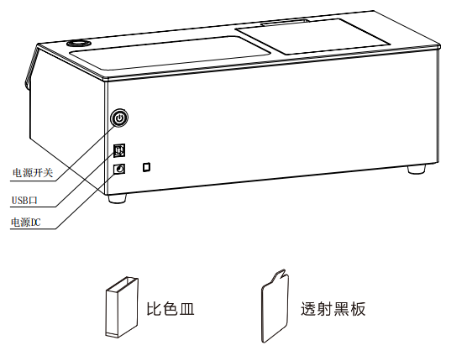
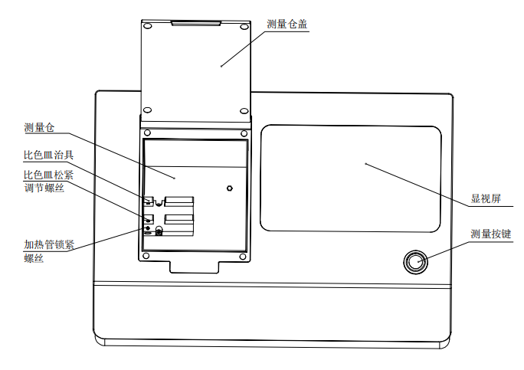

Display screen: TFT true color 7-inch, capacitive touch screen.

Wake up/measurement button: Short press the measurement button in standby mode to wake up the system, and short press to start measurement.

Measurement chamber: When measuring samples, the sample needs to be fixed with a measuring fixture and the transmission measurement chamber cover needs to be closed before measurement can be carried out.

Measurement chamber cover: manually control the opening and closing of the measurement chamber.

Spectrophotometer fixture: used to fix the placement position of the cuvette and the position of the heating tube.

USB interface: The USB interface is used to connect and communicate with a PC computer, enabling more functional expansion through the PC computer color management system software.

Power DC port: The power adapter is connected to AC power (AC110V-240V) to supply power to the instrument. The specification of the external power adapter is DC 24V/3A.

Power switch: Press the power button to turn on the indicator light, and the instrument will be powered on; Press the power button, the indicator light will turn off, and the instrument will be powered off and shut down. Manually turn on and off the instrument by toggling the switch.

Transmission board: used for black correction.

Cuvette: Used for measuring liquids or powders.

Operating Instruction

2.1 Power On & Off

Press the power switch the red indicator light always on, the instrument is powered on. Press the power switch, power on the instrument, the power indicator light stays on, and the instrument starts up normally; Press the power switch, the instrument shuts down, and the power indicator light goes out.

If no operation is performed for a long time during the startup state, the instrument will automatically enter standby mode. At this time, press the measurement button to wake up the instrument and enter working mode. (Refer to section 3.8.8 Sleep Time)
Please cuff off the power if not to use the instrument for a long time.

2.2 Calibration

Black and white calibration is required under the following circumstances.
- Before the first time of measuring after power is on.
2.When the environmental condition change relatively large (such as temperature changes exceeding 5 degrees Celsius).
3.Use the instrument for a continuous long time (over 8 hours)
4.When the user finds that the measuring data is inaccurate.

Calibration Steps:

1. Click "Black and White Calibration" on the main menu interface to enter the black and white calibration interface (Figure 3). The interface will display whether the current calibration is effective and the remaining time for calibration to be effective.
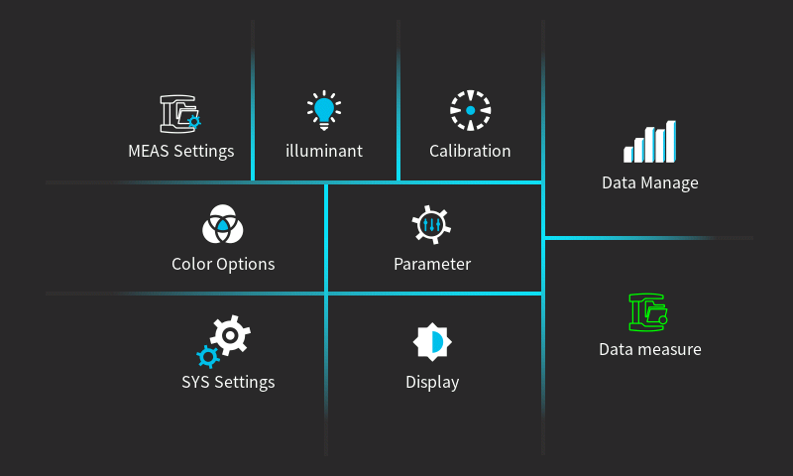
Figure 2 Main Menu

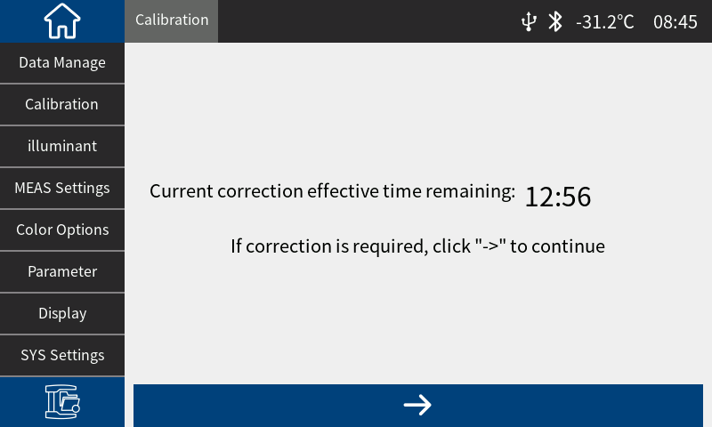
Figure 3 Black and White Calibration
- Within the calibration validity period, you need to click "" to enter the calibration interface. After placing the transmission blackboard according to the prompts, press the measurement button to perform transmission black calibration. If it is not within the calibration validity period, it will automatically enter the 40% calibration interface in Figure 4.
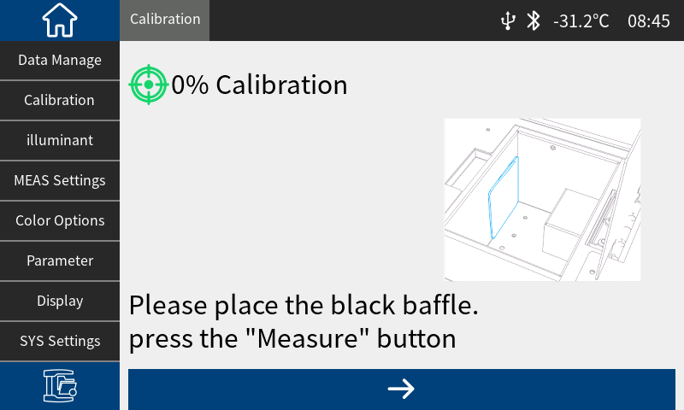
Figure 4 0% Calibration

- After completing the 0% calibration, automatically enter the 100% interface in Figure 5, take out the blackboard according to the prompts (place the corresponding reference object or leave nothing), and then press the measurement button to perform white calibration.
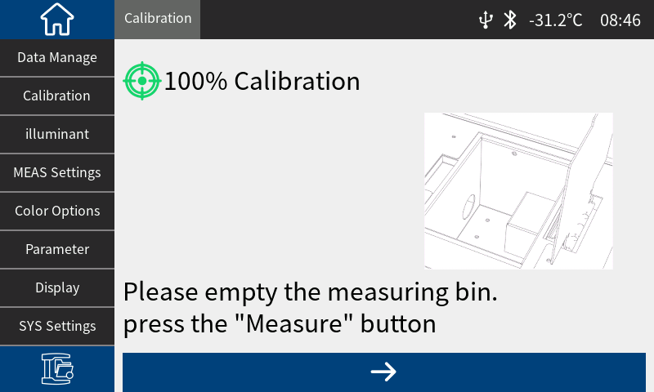
Figure 5 100% Calibration
Attention: Users can choose the corresponding white calibration reference material based on different types of transmission test samples. For example, if the test sample is plastic, glass, etc., air can be selected as the white calibration reference material; When the sample to be tested is a liquid, a cuvette filled with deionized water or distilled water can be selected as a white calibration reference; When the sample to be tested is a powder loaded in a cuvette, an empty cuvette can be selected as the white calibration reference; Of course, users can also choose a calibrated standard solution (such as potassium permanganate solution with calibrated transmittance) as the white calibration reference (the calibration parameters should be selected for the corresponding calibration channel).

After correct black and white calibration, the instrument system will re time according to the user's set black and white calibration validity period.

2.3 Measurement

2.3.1 Measurement Interface
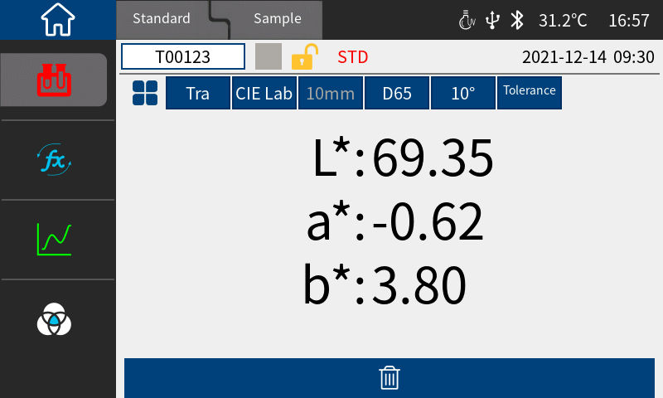
Figure 6 Measurement Interface

As shown in Figure 6, the upper part of the measurement interface is the working status area, which is used to display the current set working status and interface switching, including: main interface switching, Standard measurement interface, sample measurement interface, USB connection status, system time, simulation color, caliber size, etc. Some information needs to be displayed by clicking "".

The left part of the measurement interface is the quick display area, where you can click the corresponding shortcut keys to quickly switch test data.

The middle part of the measurement interface is the data display area, where the instrument displays the corresponding chromaticity data based on the current user's settings.

The bottom of the measurement interface is the operation button area, which can be operated on the current data by clicking the corresponding operation button.

Detailed description of the operation interface:

Above the instrument:

- Click on the Standard measurement to enter the Standard measurement interface, which displays the Standard; Click on the sample measuring instrument to enter the sample measurement interface, where the sample is displayed.

- Click on the top left corner to directly return to the main interface.

- The UV status, USB connection status, Bluetooth status, current temperature, and current system time are displayed in the upper right corner.

- Click on "" to open the shortcut bar (quick operation can only be performed on the standard measurement interface), click ① to quickly set the color space, click ② to quickly set the light source, click ③ to quickly set the observer angle, and click ④ to quickly set the tolerance.

- Click on the color index to enter the color index interface, which displays the color index of the current measurement data. The color index can be changed in the color index setting interface in the color options.

- Click on the transmittance graph to enter the transmittance spectrum interface, which displays the transmittance of the current data in different nm ranges.

- Click on the color coordinates to enter the color coordinate interface, which displays the color coordinates of the current data

2.3.2 Transmission Measurement

After turning on, place the sample into the transmission chamber and clamp it with a fixture. For special samples such as liquids, powders, etc., the correct reference material needs to be selected for calibration. Please refer to the black and white calibration method. After placing the sample, you can set the light source, color space, and observer angle according to your own needs. After setting up, simply press the measurement button and the interface will automatically display the data of the current measured sample.

2.3.3 Transmission Average Measurement

When the tested object is relatively large or the chromaticity is relatively uneven, by measuring representative multiple test points, the average transmittance of multiple points can be obtained, and then the calculated chromaticity data can better represent the true chromaticity data of the tested sample. This instrument can achieve an average measurement of 1-99 times, and the average measurement times can be set for both the sample and the Standard.
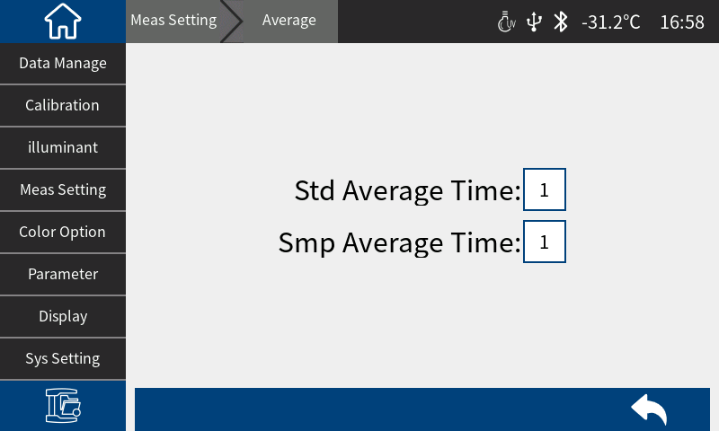
Figure 7 Transmission Average Measurement

Main menu ->Measurement settings ->Average measurement, you can enter the average measurement settings interface and set the average measurement times for Standards or samples, as shown in Figure 7.

2.3.4 Transmission Continuous Measurement

When the measurement conditions are fixed and continuous measurement of samples is required (such as in automated assembly line operations), continuous measurement mode can be used to reduce operational steps and save measurement time. Both Standard measurement and sample measurement can set the number of continuous measurements and the time interval between each measurement, and save the results of each measurement. During the continuous measurement process, you can press the measurement button to abort the continuous measurement.

Main menu → Measurement mode → Continuous measurement, you can enter the continuous measurement setting interface to set the interval time or continuous frequency of the standard/sample, as shown in Figure 8:
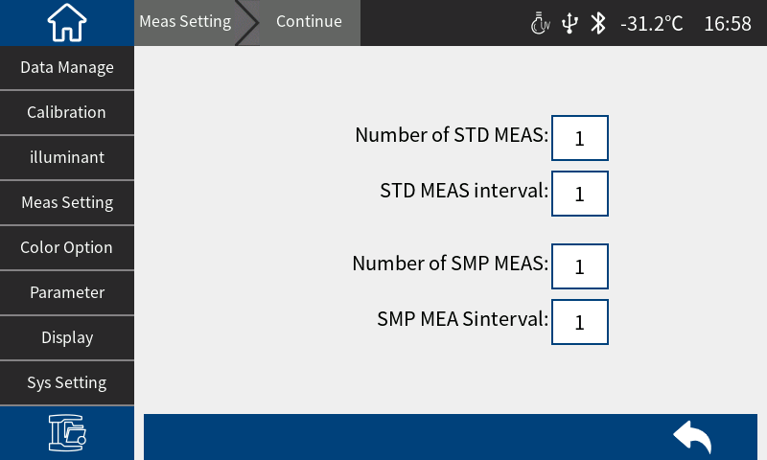
Figure 8 Transmission Continuous Measurement

2.4 Connect to PC

The PC color management software has functional scalability and can achieve richer chromaticity data analysis. This series of instruments can communicate with the installed PC color management software through USB or Bluetooth module (limited to product models equipped with Bluetooth module).

2.4.1 USB Connection

After installing the color management software on the PC, connect the instrument to the PC by using a USB data cable, and the software will automatically connect to the instrument. If the connection is successful, the status bar of the instrument will display the USB connection icon, allowing for comprehensive control of the terminal instrument and conducting relevant sample testing and analysis through the PC color management software.

2.4.2 Bluetooth Connection

For instruments equipped with Bluetooth function, first turn on the Bluetooth function in the system setting interface (Figure 9) , and turn on Bluetooth on the PC with Bluetooth function, search for devices, and the search box will display the model and SN code of the current instrument. After turning it on, the status bar of the instrument will display the Bluetooth connection icon " ". After the connection is successful, the PC color management software can be used to fully control the terminal instrument and perform relevant sample testing and analysis.

2.5 Tolerance Setting

Tolerance is for Standards. The tolerance of Standards will affect the instrument's judgment of the sample results. System tolerance is the tolerance assigned to the Standard by the instrument by default. If the Standard tolerance is not set, the system tolerance will be used by default. Therefore, the accuracy of the system tolerance is crucial to the accuracy of the test data.

2.5.1 System Tolerance Setting

Main Menu → System Settings , slide the interface, find the tolerance threshold (Figure 9 ), click "Tolerance Threshold " to enter the system tolerance editing interface, as shown in Figure 10 :

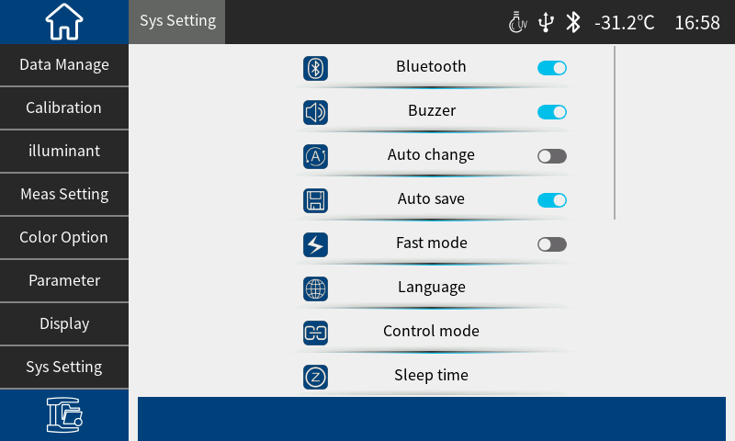
Figure 9 System settings interface
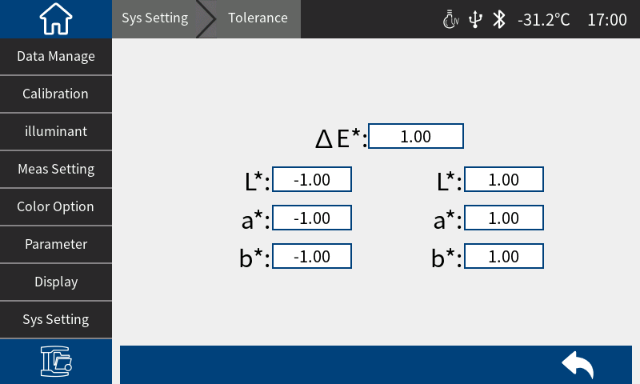
Figure 10 System tolerance setting interface
In Figure 10, ΔE* is the total tolerance of the Standard (CIE1976); L* on the left is the lower limit of the Standard tolerance, and L* on the right is the upper limit of the Standard tolerance. The upper limit on the right must be greater than the lower limit; the setting method of a* and b* is the same as L*. After all settings are completed, click " " to exit.

When the Standard uses the default system tolerance, the sample data is compared with the Standard data. Only when ΔE*, L*, a*, and b* are all within the tolerance range, the sample will be prompted as qualified, otherwise it will be prompted as unqualified (the test result prompt function is turned on).

2.5.2 Standard tolerance setting

In the Standard measurement interface (Figure 6 ), click “Tolerance” to enter the Standard tolerance editing interface, as shown in Figure 11 .

The standard tolerance setting is the same as the system tolerance setting, except that the setting path is different. When the user has special tolerance requirements for the standard, the tolerance is set for the standard. If the standard tolerance of the current standard is not set, the system tolerance is used by default.
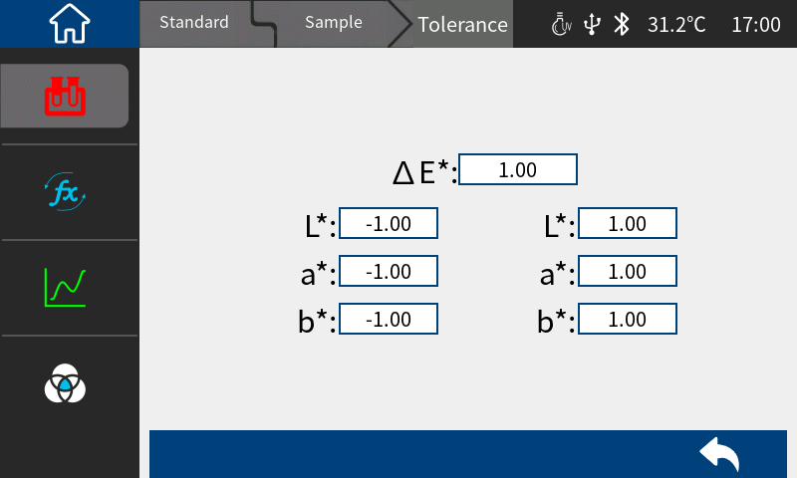
Figure 11 Standard tolerance setting interface

2.6 Printing

There are two ways for users to print the sample chromaticity data tested by this instrument. One way is to connect the instrument to the PC color management software and print it through the printer connected to the PC (refer to the color management software manual for usage); the other way is to print it through the micro printer connected to this instrument. The second method is introduced in detail below.
The micro printer is a non-standard accessory and needs to be purchased separately.
Printing steps:
The user first measures the sample data and saves the sample records to be printed;
Enter "System Settings" in the main menu, click " Printer Settings " to open this function Figure 12 ;
Connect the micro printer to the instrument via USB;
Enter "Data Management" from the main menu and find the sample record to be printed (Standard record or test sample record);
Click " " , select "Print" in the pop-up menu and click "Confirm" to start printing the sample chromaticity data, as shown in Figure 13 :
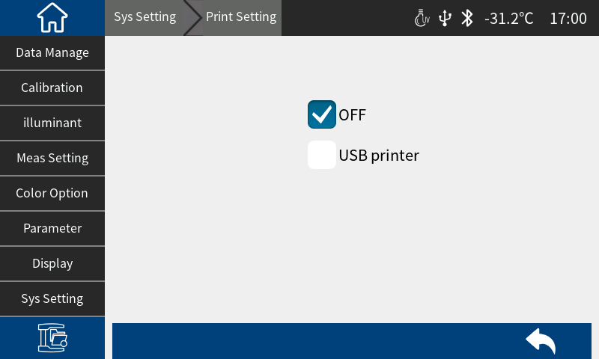
Figure 12 Printer settings

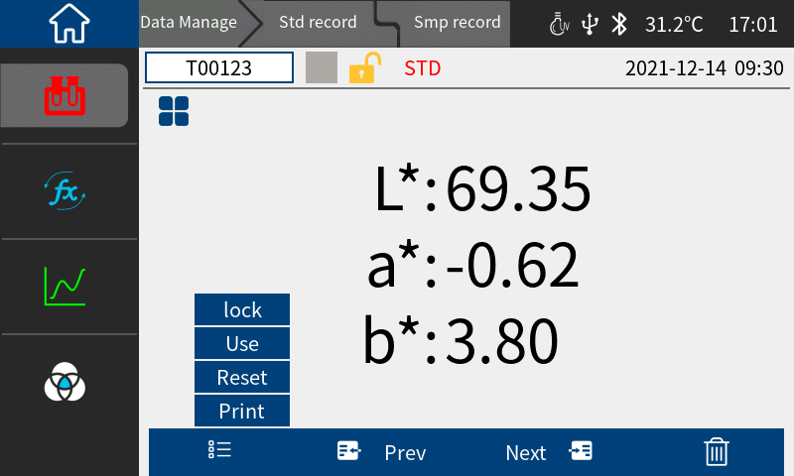
Figure 13 Sample Recording Interface

3.System Function Description

Click " " to enter the main menu. From the main menu, you can enter various submenus to implement all system function settings.

3.1 Data Management

Main Menu → Data Management , enter the data management interface. (Figure 1 4) Data management can realize functions such as viewing records, deleting records, searching records, and inputting Standards.
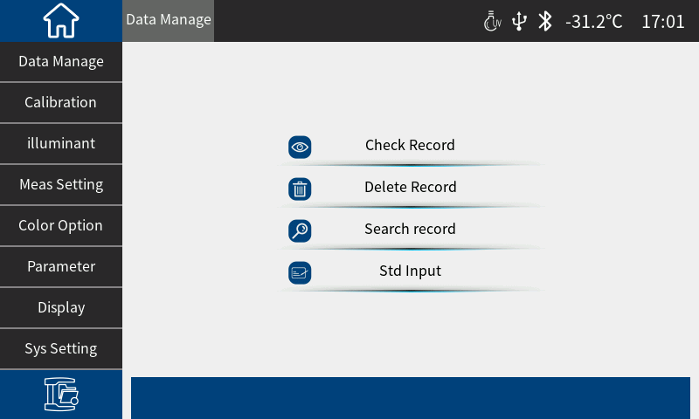
Figure 1Data management interface

3.1.1 View Records

(1) View the Standard records
In the data management interface, click “View Records” to enter the “Standard Records” interface. The Standard will be displayed after the current data name in the Standard record interface, as shown in Figure 1 5.

Figure 15 Standard Recording Interface

Switch records by clicking " Previous Page " or " Next Page ".
Click " " to lock data , load Standards , reset data, and print.
Click the data number position to modify the data number, and click the sample record to view the samples under the Standard.
Delete the sample record being viewed: Click “ ”, select Delete, and enter the record deletion reminder interface, as shown in Figure 1 6. Click “Confirm” to delete; click “ Cancel ” to cancel the deletion and return to the operation interface.
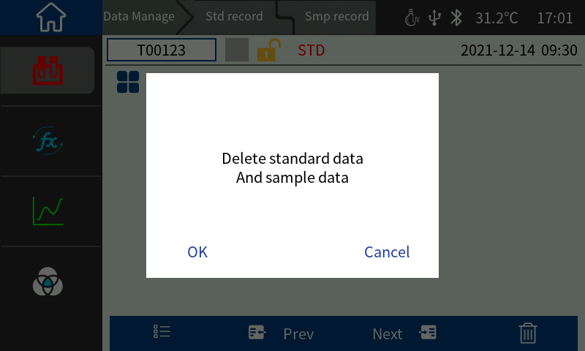
Figure 16 Deletion record reminder interface
Edit record name: Click the name to enter the name editing interface, enter a new name, press " √ " to confirm and save, and click " × " to cancel the name editing operation, as shown in Figure 17 :
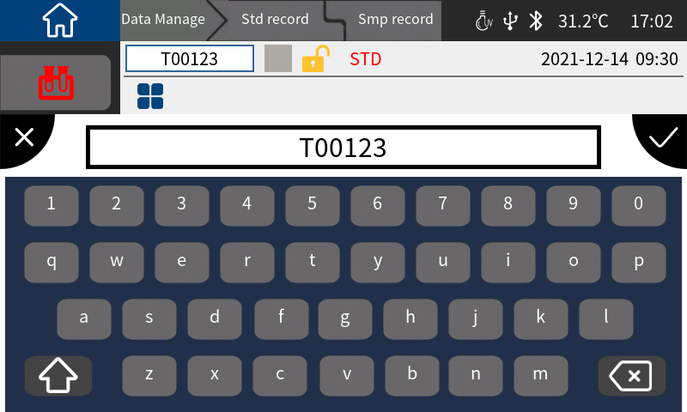
Figure 2Edit name interface
Lock the sample record being viewed: This function can only lock the sample data. Click " " and then click Lock to set the sample record being viewed to a locked state. After setting it to a locked state, the lock icon on the sample record will turn into a locked state. (Figure 18) 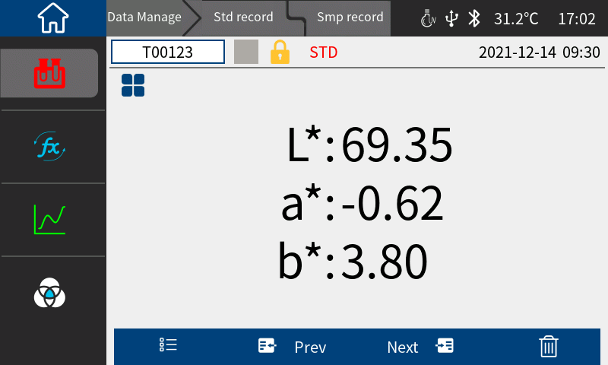
Figure 18 Standard lock
Set the Standard record being viewed as the current Standard: Click " ", then click Load to set the Standard record being viewed as the current Standard, and then click " Sample Measurement " to perform sample measurement operations under this Standard.
Reset the sample record data being viewed: Click “ ” and then click Reset ( place the sample to be measured before clicking ).

(2) View sample records
In the Standard viewing interface, click " Sample Record " to switch to the sample record interface and view the sample record corresponding to the Standard. In the sample record interface, click " Sample Record " to return to the Standard record interface. The sample will be displayed after the current data name in the sample interface, as shown in Figure 19 .
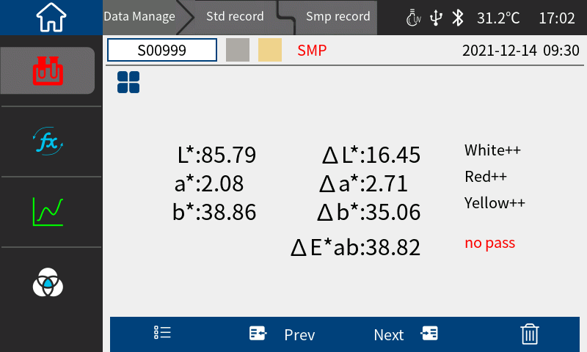
Figure 3Sample record viewing interface

3.1.2 Deleting Records

In the data management interface, the deletion options are: " Delete all records " and " Delete all samples ". (Figure 20)
Click the corresponding option to enter the deletion prompt interface. The prompt will tell you whether to delete the Standard or the sample according to your operation. Click " Confirm " in the deletion prompt interface to delete all corresponding records; click " Cancel " to cancel the deletion operation. (Figure 21)

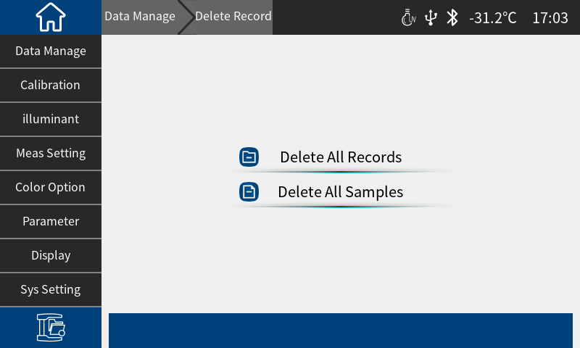
Figure 4Delete record interface
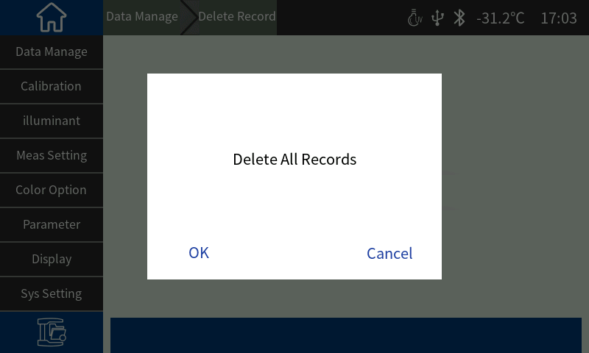
Figure 5Delete prompt interface

3.1.3 Search History

In the data management interface (Figure 22), you can select " Search by standard name " and " Search by sample name ".
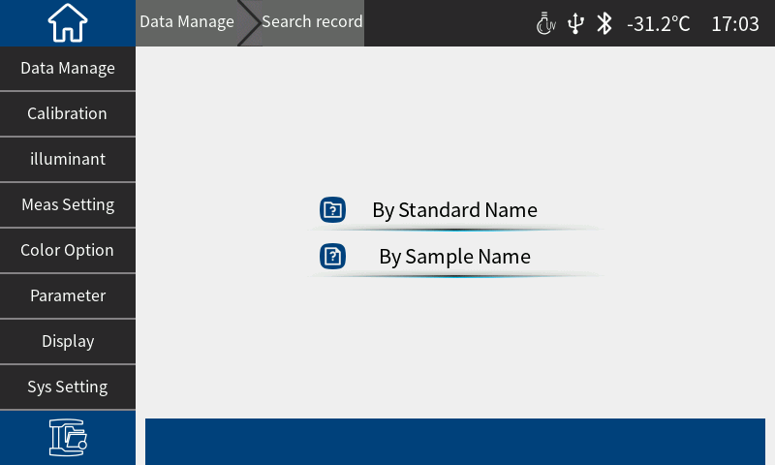
Figure 22 Search records

3.1.4 Standard input

In the data management interface, click “Standard Input” to enter the Standard input interface (Figure 23)

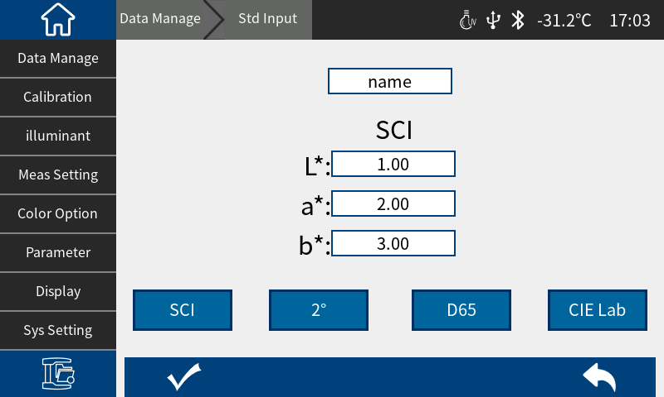
Figure 23 Standard input interface
In the data management interface, click "Standard Input" to enter the Standard input interface. Click the 10° position to set the observer angle, and click the CIELab position to set the color space. After entering all, click " " to save the input data, and click " " to exit the Standard input interface. The saved data can be viewed and called out in the Standard record interface.

3.2 Black and White Calibration

This liquid spectrophotometer is the basis for measuring data. Please refer to Chapter 2.2 for specific operations.

3.3 Illuminant settings

The user sets the corresponding light source according to the actual measurement situation. In the illuminant setting interface, the system's standard observer angle and standard light source type can be set.
Main menu → illuminant settings , enter the settings interface (Figure 24) , click on the observer angle, you can switch between 10° and 2°. 10° is the CIE1964 standard, and 2° is the CIE1931 standard.
Click on the light source, you can choose D65, A, C, D50, D55, F1~F12 and other light sources Figure 25.
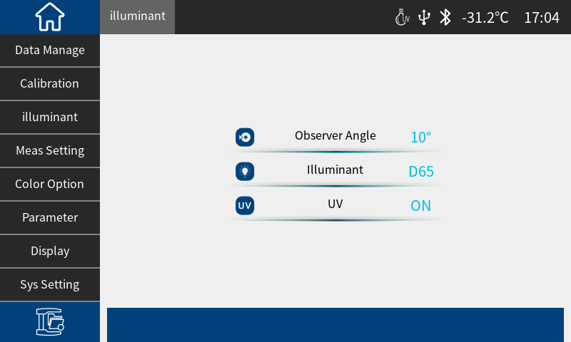
Figure 6Illuminant setting interface
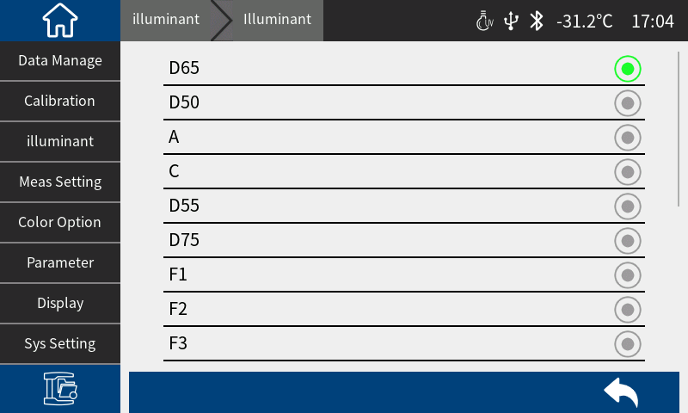
Figure 7Illuminant optional interface

3.4 Measurement setup

Main Menu → Measurement Settings , enter the measurement settings interface (Figure 26) . Contains: average transmission measurement, continuous transmission measurement, select different options to perform the corresponding operation, please refer to 2.3.4 Average transmission measurement and 2.3.5 Continuous transmission measurement for details;
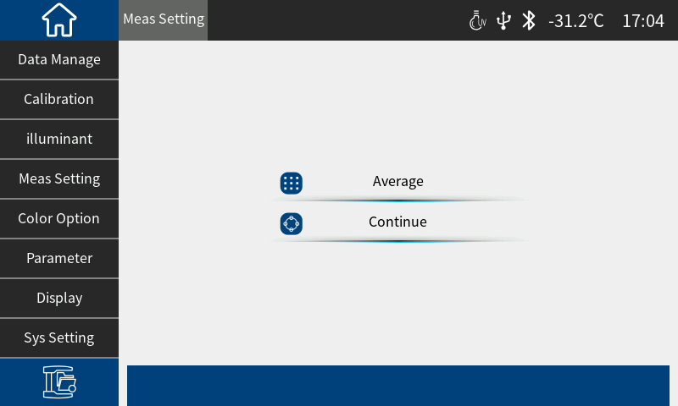
Figure 26 Measurement setting

3.5 Color Options

Options " in the main menu to enter the color options interface, which includes color space, color difference formula, and color index. ( Figure 27)

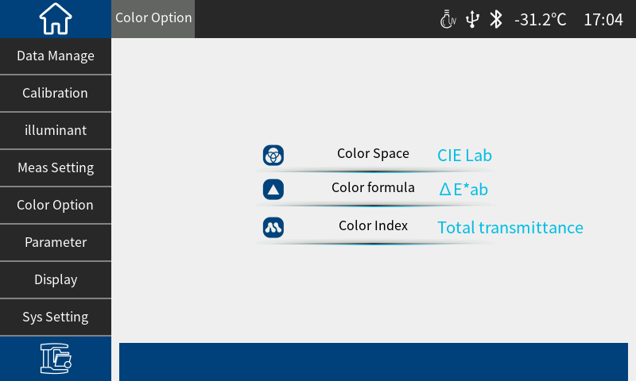
Figure 27 Color option interface

3.5.1 Color Space​

Click "Color Space " under the color option to enter the color space interface (Figure 28) , and select the corresponding color space in the color space selection interface .
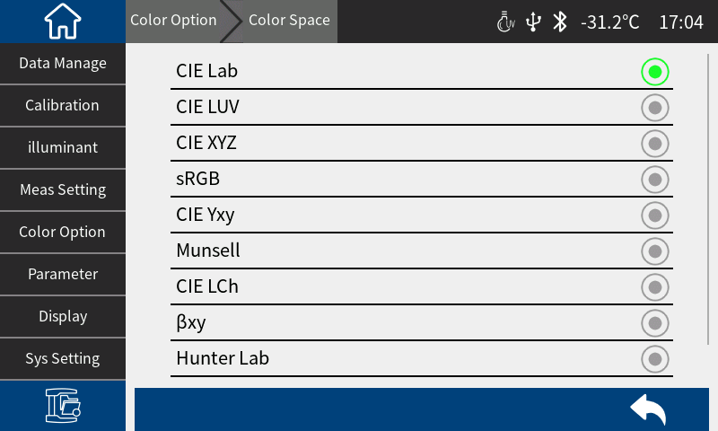
Figure 28 Color Space Interface

3.5.2 Color difference formula

To set the color difference formula, users can choose ΔE* ab , ΔEcmc(2:1), ΔE94, etc. ( Figure 29)
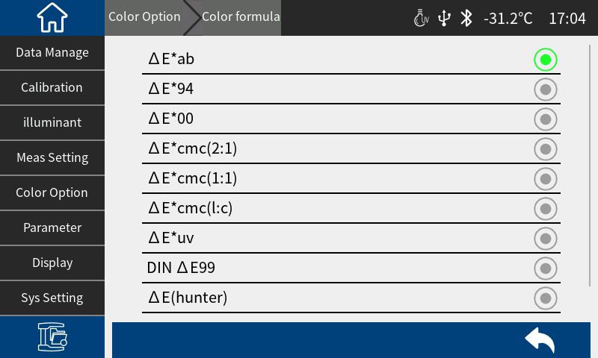
Figure 29 Color formula selection interface

3.5.3 Color Index

Color index setting (Figure 30), the selected color index will be displayed in the color index area of the standard and sample measurement interface (depending on the index, some indexes are only displayed under specific observer angles and light sources ). Click " " in the measurement interface to switch to the color index display area, as shown in Figure 31 , which is the display interface of the United States Pharmacopoeia .

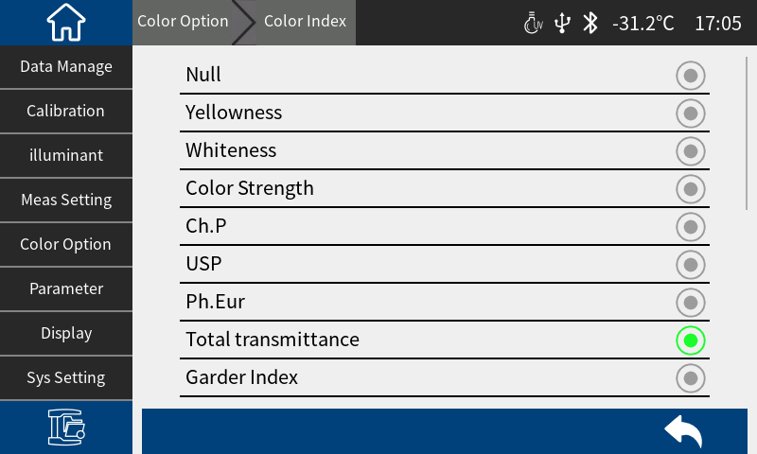
Figure 30 Color Index Interface
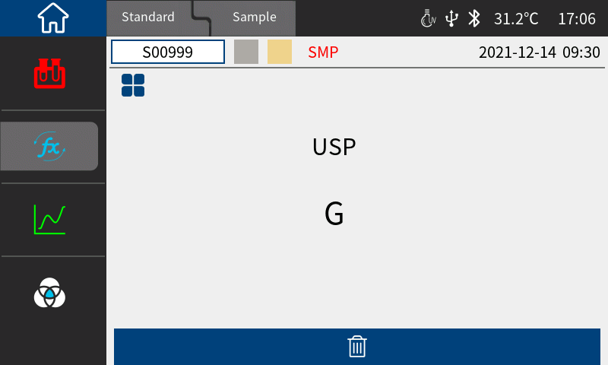
Figure 31 USP display interface under Standard measurement

3.6 Parameter settings

Parameter Setting " in the main menu to enter the parameter setting interface. In the parameter setting interface, you can choose to set the color difference formula parameter factor, metamerism index, yellowness and whiteness , 555 color classification, and strength. ( Figure 32)
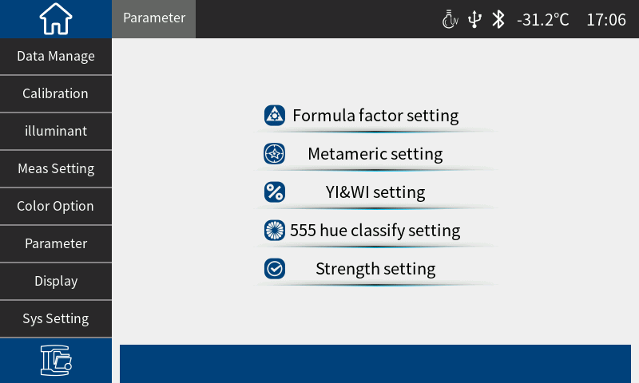
Figure 32 Parameter setting interface
Click "Color Difference Formula Parameter Factor Settings " to enter the setting interface, where you can set the parameter factors of the color formulas ΔE*94, ΔE*cmc, and ΔE*2000. ( Figure 33)

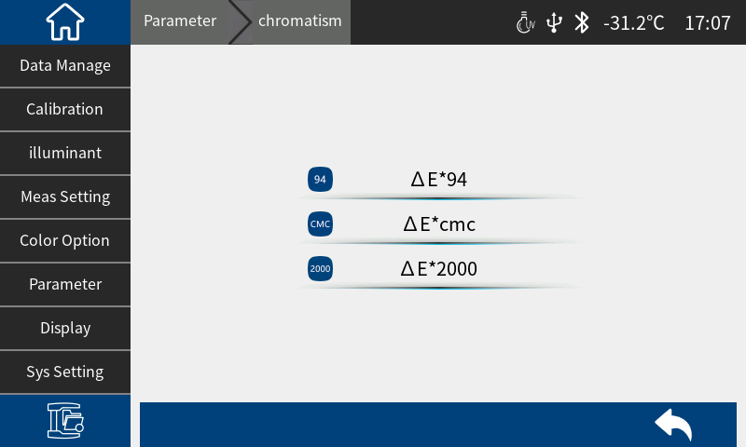
Figure 33 Color difference formula parameter factor setting interface
Click “Metamerism Index Settings” to enter the settings page (Figure 34), where you can set the standard light source and observer angle for metamerism reference 1 and reference 2.
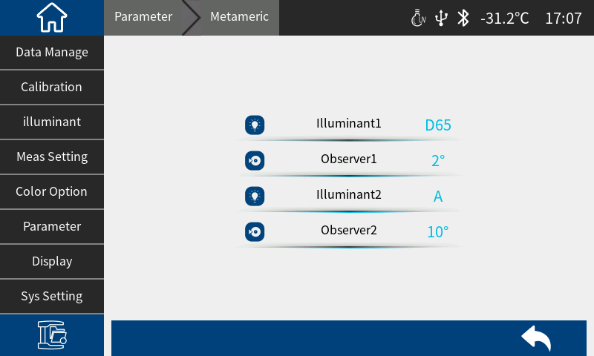
Figure 34 Metamerism index setting interface
Click "Yellowness, Whiteness Settings" to enter the settings interface, where you can select the yellowness or whiteness index standard to be displayed. (Figure 35)
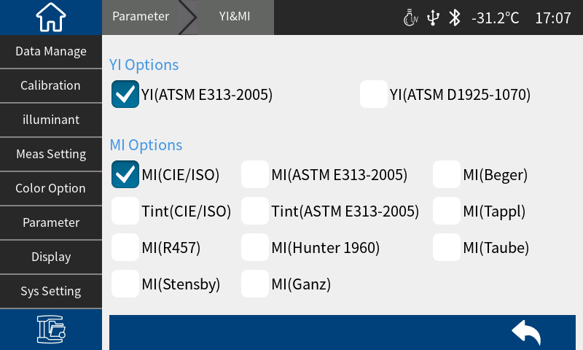
Figure 35 Yellowness and whiteness setting interface
Click "555 Tone Classification Settings" to enter the settings interface, where you can select the basis and tone tolerance for 555 tone classification. (Figure 36)
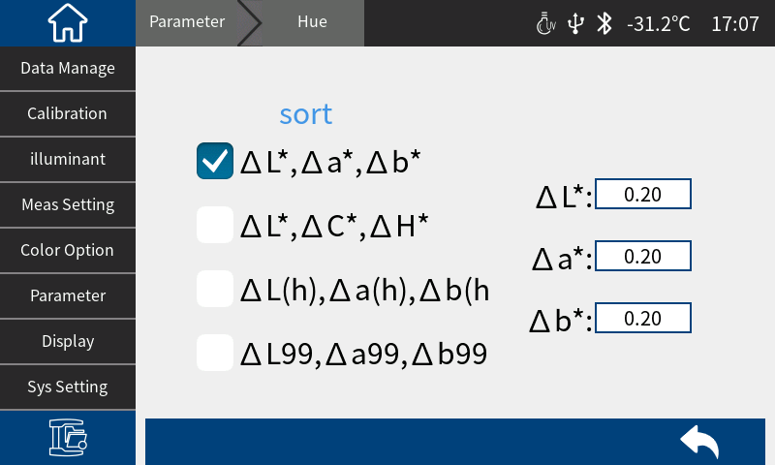
Figure 36 555 color classification settings
Click "Strength Setting" to enter the setting interface, where you can select the strength type to be displayed and specify the strength wavelength position. (Figure 37)
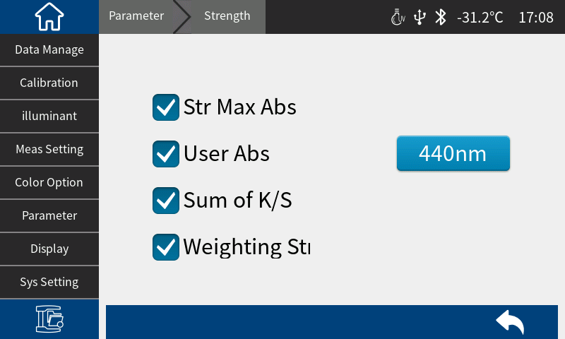
Figure 37 Color Strength setting interface

3.7 Display Settings

Click "Display Settings" on the main menu interface to enter the display settings interface (Figure 38) . In this interface, you can set whether to open the color bias, test result prompt, spectrum curve or spectrum difference display , etc.
When the color deviation is turned on, the color deviation of the sample compared with the Standard will be prompted during sample measurement. When it is turned off, there will be no corresponding prompt.
If the test result prompt is turned on, when measuring the sample, if the test result exceeds the tolerance range set by the Standard, a red font " bad " will be displayed. If the error of the sample is within the tolerance range allowed by the Standard, a green font "pass" will be displayed.
If the spectrum curve display is turned on, click " " in the measurement interface to display the spectrum curve. If the spectrum difference is turned on, the difference between the sample and the standard (sample spectrum minus standard spectrum) will be displayed.
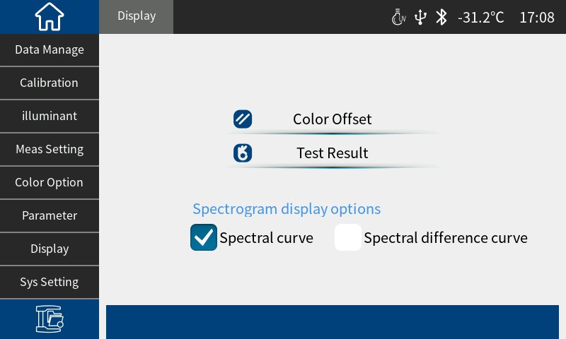
Figure 38 Display setting interface

3.8 System Settings

Click "System Settings" in the main menu to enter the system settings interface. (Figure 39-40)
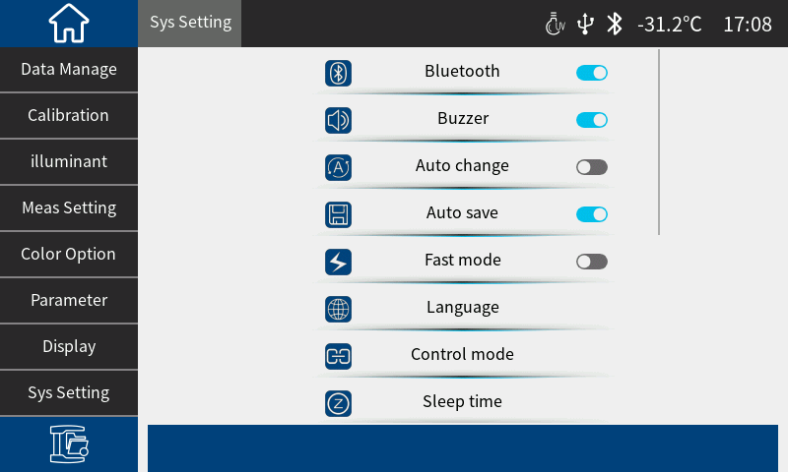Figure 39 System settings interface 1
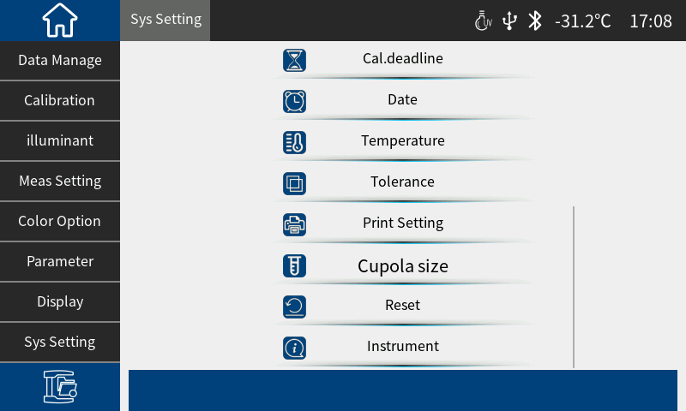
Figure 40 System settings interface 2
System settings include: Bluetooth, buzzer, auto switch, auto save, fast mode, language setting, control mode, sleep time, calibration validity period, system time, temperature threshold, tolerance threshold, print settings, reset instrument, about instrument.

3.8.1 Bluetooth

For instruments equipped with Bluetooth , click the menu item to toggle Bluetooth on or off.

3.8.2 Buzzer​

Switch the buzzer on or off. When the buzzer is on, there will be a beep when the measurement key is pressed .

3.8.3 Automatic switching

When automatic switching is turned on and data is measured, the interface will automatically switch to the sample measurement interface after the Standard measurement is completed.

3.8.4 Automatic saving​

Automatic save function is turned on, each sample tested will be automatically stored in the instrument. Otherwise, after the sample test is completed, the measurement record will not be automatically saved and you need to manually click " " to save it. (Figure 41)
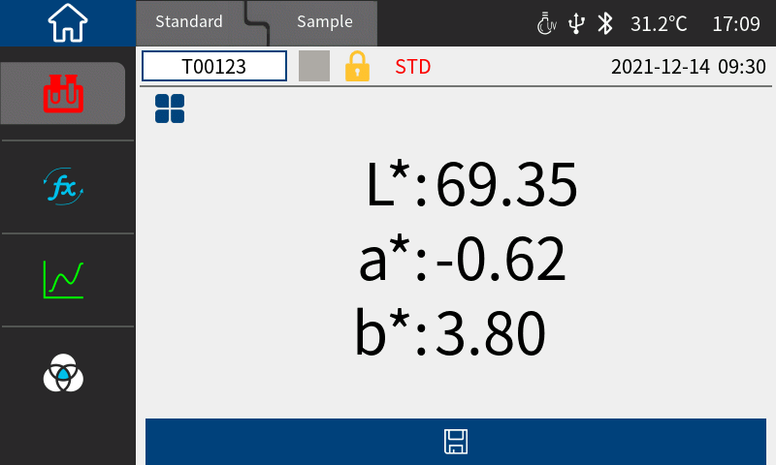
Figure 41 The auto-save interface is not turned on

3.8.5 Fast Mode

When the fast mode is turned on, the instrument measurement time will be shortened.

3.8.6 Language Settings

Language setting is used to set the language of the instrument interface. In the system setting interface, click "Language Setting" and then select the corresponding language to confirm.

3.8.7 Control Mode​

When the instrument communicates with the PC color management software, the customer can set a specific measurement control method as needed. Click "Measurement Control Method" in the system settings interface to open the measurement control method selection interface. There are three options: button, PC software, button | PC software. Select the corresponding method and confirm. (Figure 42)
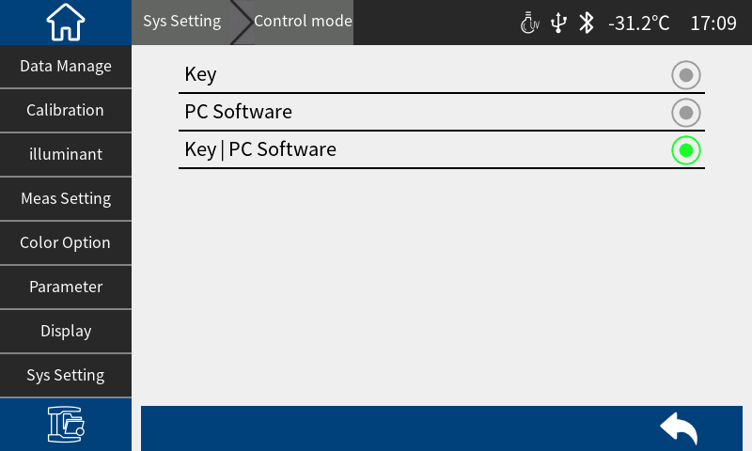
Figure 42 Measurement control mode configuration interface
Button: When this mode is selected, the user can only measure through the instrument measurement button when the instrument communicates with the PC software. After the measurement is completed, the test results will be automatically sent to the PC .

PC software: When this mode is selected, the instrument communicates with the PC software. The instrument can only be measured by issuing instructions through the PC color management software to control the instrument, complete data testing, and upload data to the PC software.

Button | PC software: Select this mode, the user can complete the sample test through the instrument test button or PC software instructions, and upload the data. This mode is the default selection mode of the instrument.

3.8.8 Sleep time

Sleep Time " in the system settings interface to enter the sleep time settings interface. (Figure 43)
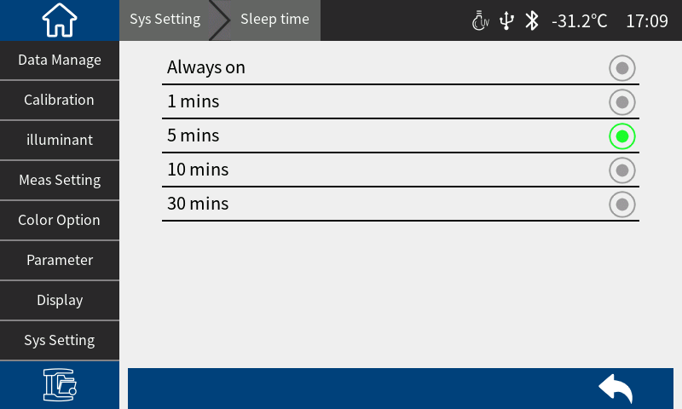
Figure 43 Sleep time setting interface
Sleep time are: always on , 30 minutes, 10 minutes, 5 minutes, 1 minute. If always on is selected , the screen will not automatically turn off when there is no operation; if set to other modes, the instrument will start counting down from the last operation, and enter the power saving screen state if there is still no operation after the countdown ends.

When the instrument enters the power-saving screen-off state, you can wake up the instrument by short pressing the test key.

3.8.9 Calibration validity period

validity period " in the system setting interface to enter the calibration validity period interface (Figure 44). Set the calibration validity period. When the validity period exceeds the validity period, the instrument will prompt you to calibrate again. The optional calibration validity period is 4 hours, 8 hours, 24 hours , and power-on calibration .
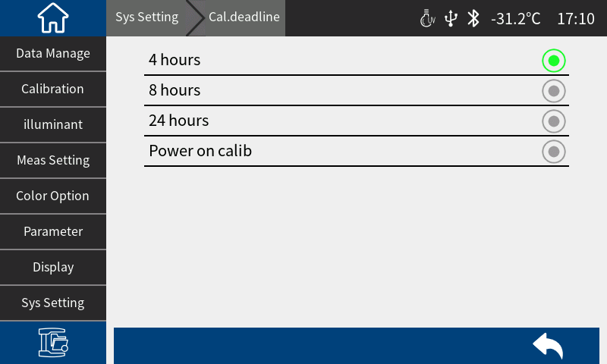
Figure 44 Calibration validity settings interface

3.8.10 System time

When the instrument leaves the factory, it is usually synchronized with the local time of the manufacturer. Users can set the instrument time according to actual conditions. In the system setting interface 2 ( Figure 40 ), click "Date and Time Settings" to enter Figure 45 for setting.
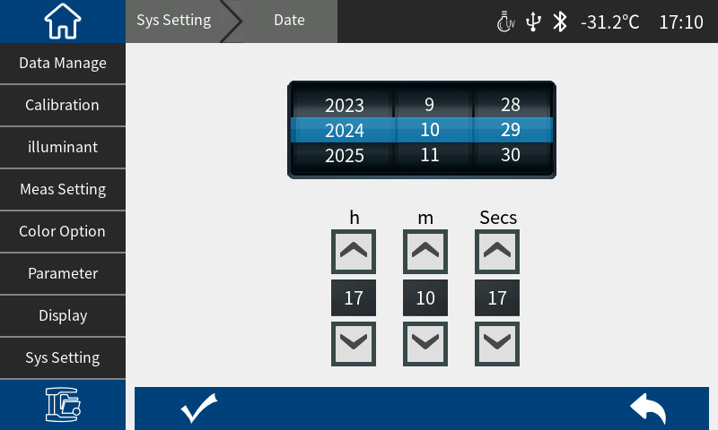
Figure 45 Time and date setting interface
After setting the date and time , click " " to save the settings, or click " " to cancel the save.

3.8.11 Temperature Threshold

Click "Temperature Threshold" in the system setting interface to enter the "Temperature Threshold" interface. When the alarm switch is turned on, set the alarm threshold . When the temperature change and the temperature difference during calibration exceed the threshold, the instrument buzzer will sound continuously, and the instrument needs to be recalibrated during measurement. (Figure 46)
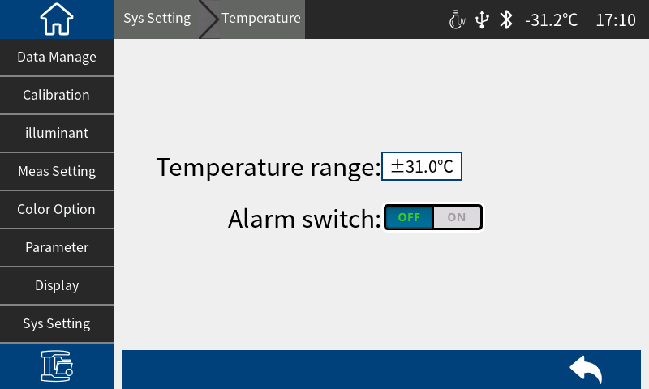
Figure 46 Temperature threshold setting interface

3.8.12 Tolerance threshold

Tolerance Threshold " in the system settings interface to enter the default system tolerance interface. For system tolerance settings, please refer to Section 2.5.1.

3.8.13 Print Settings

Turn on the print data switch and connect the printer to print data output. For specific operations, see Section 2.6 .

3.8.14 Reset the instrument

Reset Instrument " in the system settings interface to enter the "Restore Factory Settings" interface, Figure 47. Click " " to clear all measurement records and parameter settings of the instrument and restore them to the factory state; click " " to cancel this operation.

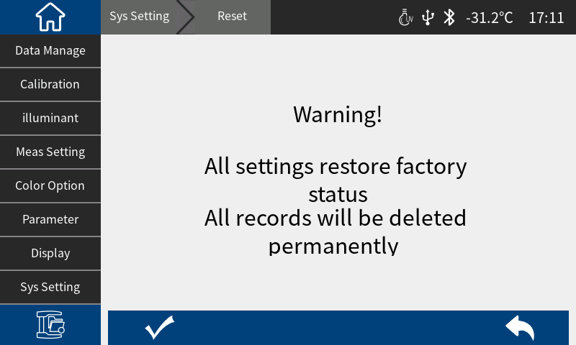
Figure 47 Restore factory settings interface

3.8.15 About Instruments

Click "About Instrument" in the system settings interface to enter the "About Instrument" interface. You can view the instrument's product model, SN code, software version, hardware version, whiteboard number and other information. ( Figure 48)
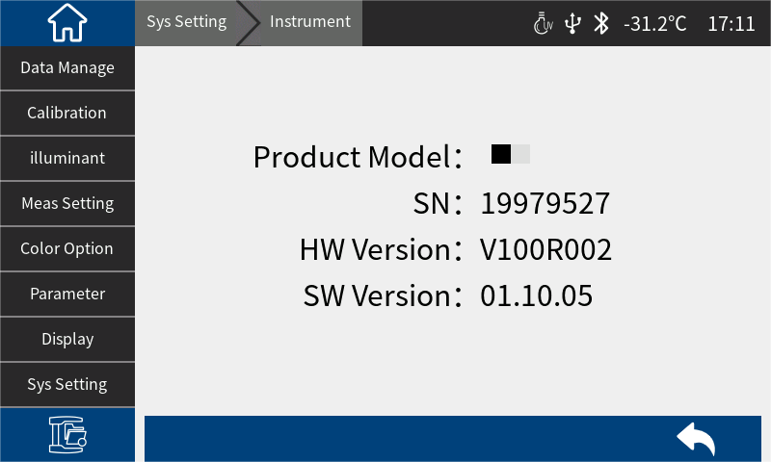
Figure 48 About the instrument

4.Daily maintenance

1) This instrument is a precision optical instrument. Please keep and use it properly. Avoid using and storing the instrument in a humid environment, strong electromagnetic interference, strong light, or dusty environment. It is recommended to use and store the instrument in a standard laboratory environment.
2) The whiteboard is a precision optical component and should be properly stored and used. Avoid hitting the working surface with sharp objects, avoid dirtying the working surface with dirt, and avoid exposing the whiteboard to strong light. Clean the working surface of the whiteboard regularly with a cloth dipped in alcohol. Clean the dust on the working surface of the whiteboard in time when calibrating.
3) To ensure the validity of the test data, it is recommended that the instrument and whiteboard be inspected by the manufacturer or a qualified metrology institute every one year from the date of purchase.
4) This instrument is powered by an external power adapter. The power supply should be used in a standardized manner to avoid frequent plugging and unplugging of the power supply to protect the power supply performance and extend the power supply life.
5) Please do not disassemble the instrument without permission. If you have any questions, please contact the relevant after-sales staff. Tearing off the easy-to-tear label will affect the after-sales maintenance service of the instrument.

5.Technical Parameters

5.1 Product Features

1. High hardware configuration: 7-inch TFT pure color capacitive touch screen, Bluetooth, flat grating ;
2. Silicon photodiode array (40 groups in double rows), long-life full-spectrum LED lamp ;
3. Measure sample transmission spectrum and Lab data accurately ;
4. Transmission aperture: Φ 10 mm ;
5. Temperature monitoring and compensation, built-in temperature sensor, monitor and compensate the test environment to ensure more accurate measurement results ;
6. Test wavelength range : 360 ~ 780nm ;
7. Independent light source detector, constantly monitors light source changes to ensure light source reliability ;
8. Various accessories: Transmission fixing frame, suitable for more working conditions;
10. Large storage space, can store 1000 Standards and 10000 test data of samples ;
11. PC color management software has powerful extension functions.

5.2 Technical specifications

Illumination | Transmission: D/0 (diffuse illumination, 0° Viewing);  Approximately CIE15 stipulates 0/0 (parallel light illumination/0 degree reception);  Comply with standards: ASTM D1003/1044, CIE No.15, GB/T 3978, GB 2893, GB/T 18833, ASTM E308, DIN5033 Teil7
Characteristic | in pharmacopoeia color measurement, glass processing, plastic processing, film, display processing, packaging industry, liquid medicine analysis, transmittance testing, etc. , and supports trace transmission measurement.
Integrating sphere size | Φ 40 mm
Light source | Combined full spectrum LED light source
Spectral method | Plat grating spectrometer
Sensor | Silicon photodiode array (dual row 40 groups)
Wavelength range | 360 ~780 nm
Wavelength interval | 10nm
Half bandwidth | 10nm
Transmittance range | 0~200%
Measuring aperture | Transmission: Φ 10 mm
Color Space | CIE LAB, XYZ, Yxy, LCh, CIE LUV, Musell, s-RGB, HunterLab, βxy, DIN Lab99, CMYK ( the above parts are realized by the host computer)
Color difference formula | ΔE * ab ,ΔE * uv ,ΔE * 94 ,ΔE * cmc(2:1) ,ΔE * cmc(1:1) ,ΔE * 00 ,DINΔE 99 ,ΔE (Hunter) ,ΔE* CH
Other color indexes | Transmittance T,  WI (ASTM E313, CIE/ISO, AATCC, Hunter, Taube, Berger, Stensby),  YI (ASTM D1925, ASTM 313),  TI (ASTM E313, CIE/ISO),  Metamerism index Mt,  Staining Fastness,Color fastness,absorbance,  APHA / Hazen / Pt-Co (Platinum-Cobalt Index), Gardner Index, Iron-Cobalt Index,  Saybolt (Saybolt Index), ASTM D1500 color scale, Pharmacopoeia (Chinese Pharmacopoeia, European Pharmacopoeia, United States Pharmacopoeia), EBC (beer color), ICUMSA Color (sugar color)
Observer Angle | 2°/10°
Illuminant | D65,A,C,D50,D55,D75,F1,F2,F3,F4,F5,F6,F7,F8,F9,F10,F11,F12,CWF,DLF,TL83,TL84,TPL5,U30,B,U35,NBF, ID50, ID65, LED-B1, LED-B2, LED-B3, LED-B4, LED-B5, LED-BH1, LED-RGB1, LED-V1, LED-V2, LED-C2, LED-C3, LED-C5 (a total of 41 light sources, the above part is realized by the host computer)
Displayed Data | Spectrum/values, sample chromaticity value, color difference value/graph, chromaticity diagram, color simulation, pass/fail results, color bias
Measuring time | Fast mode: about 0.8s
Repeatability | Spectral transmittance: standard deviation within 0.05% ( 360 ~ 780nm : within 0.04%);  Chromaticity value: within ΔE*ab 0.01 (after preheating correction, measured at intervals of 5S);
Inter-instrument Error | Δ E*ab within 0.2 (average value of 5 standard transmission color plates measured by the original manufacturer)
Size | Length x width x height = 370 x 300 x 200 mm
Weight | About 9.6kg
Power supply mode | Powered by DC 24V/3A power adapter
Illuminant Life Span | More than 3 million measurements in 5 years
Display | TFT true color 7-inch, capacitive touch screen
Interface | USB, print serial port , Bluetooth
Data Storage | 1000 Standards, 10000 test samples

Special Features | Intelligent zero calibration
Language | Simplified Chinese, Traditional Chinese, English
Operating Environment | 0~40°C (32~104°F)
Storage Environment | -20~50°C (-4~122°F)
Standard accessories | Power adapter, manual, quality management software (download from official website), data cable, transmission blackboard, transmission test fixture assembly, 10mm cuvette, 50mm cuvette, micropore (4mm) transmission test fixture assembly
Optional accessories | Micro printer, 30mm cuvette, 100mm cuvette
Note: | The technical parameters are for reference only, please refer to the actual products sold

