**YS 45 series Plus**

**Grating spectrophotometer**

**OPERATION MANUAL**

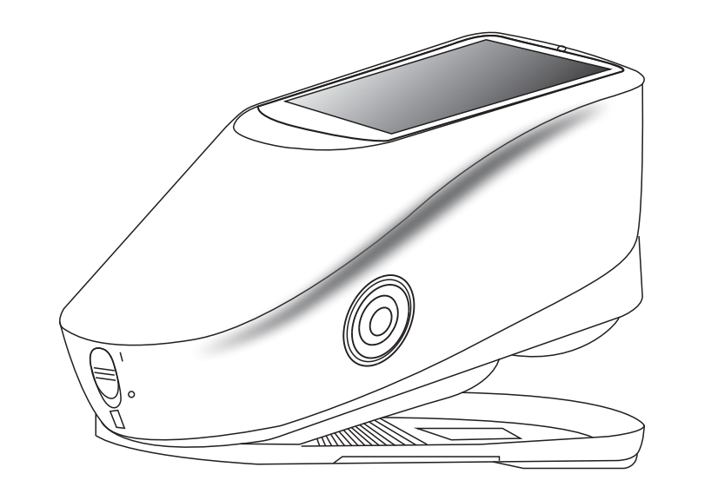

V1.0

**Safety instructions**

Please read carefully and strictly abide by the following provisions to avoid accidental injury or harm. The company shall not be liable for any loss arising from the use of the instrument in violation of this manual.

|  |  |
| --- | --- |
| Battery | 1. This instrument uses built-in battery which can not be replaced with other batteries, in case of damage to the instrument or other malfunctions. 2. Do not dismantle, squeeze, strike and heat the battery, and do not put the battery in the fire or high temperature environment, otherwise the battery will explode and cause fire. 3. When the instrument is fully charged and not in use, cut off the external power supply to prevent electric shock and instrument damage. 4. If the instrument is not used for a long time, charge the instrument every two weeks, or the internal battery may be damaged and the instrument cannot be used again. 5. For the first three times of charging, it is better to get fully charged and then use it out before next charging. |
| External power supply | 1. When external power supply is required, please use the standard power adapter of the instrument, or it may shorten the battery life or even cause electric shock to damage the instrument or cause fire. 2. If the instrument is not used for a long time, the external power should be cut off to prevent burning the instrument and causing fire. |
| Instrument | 1. Do not use the instrument in a place with flammable gas (gasoline, etc.), as this may cause a fire. 2. Do not dismantle the instrument privately, or it will be damaged. 3. If the instrument emits peculiar smell like burning when using it, it should be stopped immediately and sent to the maintenance point for testing and maintenance. |

**Please keep this manual carefully for your reference at any time.**

**Contents**

Instruction 1

Cautions 1

1. Interface Description 2

2. Operating Instruction 3

2.1 Power On& Off 3

2.2 Calibration 4

2.3 Measurement 6

2.3.1 Measurement Instruction 6

2.3.2 Standard Measurement 9

2.3.3 Traffic Signs Measurement 11

2.3.4 Sample Measurement 13

2.3.5 Average Measurement 15

2.4 Connecting PC 16

2.4.1 USB Connection 16

2.4.2 Bluetooth Connection 16

2.5 Print 17

3. Main Menu 18

3.1 Data Manage 18

3.1.1 Check Record 19

3.1.2 Delete Record 21

3.1.3 Search Record 22

3.1.4 Standard Input 25

3.2 Calibration 26

3.3 Illuminant Setting 26

3.4 Average Measurement 28

3.5 Color Space 28

3.6 Color Index 28

3.6.1 Set Color Index 29

3.6.2 Parameter Factors and Metameric Setting 30

3.7 Display Settings 32

3.8 System Settings 33

3.8.1 Auto Save 34

3.8.2 Measuring Aperture 35

3.8.3 Bluetooth 37

3.8.4 Buzzer 37

3.8.5 Traffic Sign Measurement 37

3.8.6 Calibration Validity 37

3.8.7 Control Mode 38

3.8.8 Language Settings 40

3.8.9 Time & Date Settings 40

3.8.10 Backlight Time 41

3.8.11 System Tolerance 41

3.8.12 Screen Brightness 42

3.8.13 Restore Factory Setting 42

3.8.14 Work Mode 42

4. The daily maintenance of the instrument 43

5.Technical Parameters 44

5.1 Product Features 44

Instruction

YS series grating spectrophotometers are independently developed by 3nh company, who has complete intellectual property rights. The instrument is a high-precision spectrocolorimeter with the character of stable working, accurate color measurement, powerful functions, taking the leading position in the color industry. They are widely used in plastic, electronics, paints, textile, printing, automobile, medical, cosmetic and food industries or science research institutes and laboratories.

Under the condition of 45/0 geometric optical illumination, the instruments can measure reflectance data of sample or fluorescent sample, and can measure and indicate all color difference formulas and color indexes in various of color spaces accurately. The instruments are equipped with high-end color management software which can be connected to PC to achieve more extension functions.

Cautions

● The spectrophotometer is a precise measuring instrument. Please avoid drastic changes of external environment when measuring. These changes, including the flash of surrounding light and the rapid change of temperature, will affect measurement accuracy.

● Keep the instrument stable; make sure the measuring aperture touch the surface of the test sample placidly, and no shaking or shifting when measuring.

●The instrument is not waterproof. Do not use it in high humidity environment or in water.

● Keep the instrument clean. Avoid dust, powder or solid particle entering the measuring aperture and the instrument. Please prevent the colorimeter from fierce collision or crash.

● White calibration cavity should be cleaned regularly with wiping cloth to ensure the surface clean, and kept it in a dark cool dry place.

● Please take out the battery to prevent the instrument from damage if you don’t use it for a long time.

● Please keep the instrument in a cool dry place.

● Any unauthorized changes to the instrument are not permitted, or it will

affect the measuring accuracy, even cause irreversible damage.

1. Interface Description

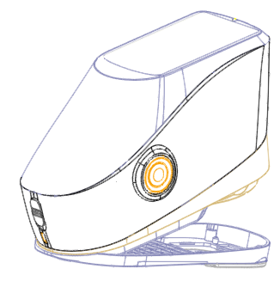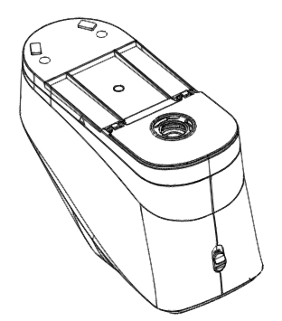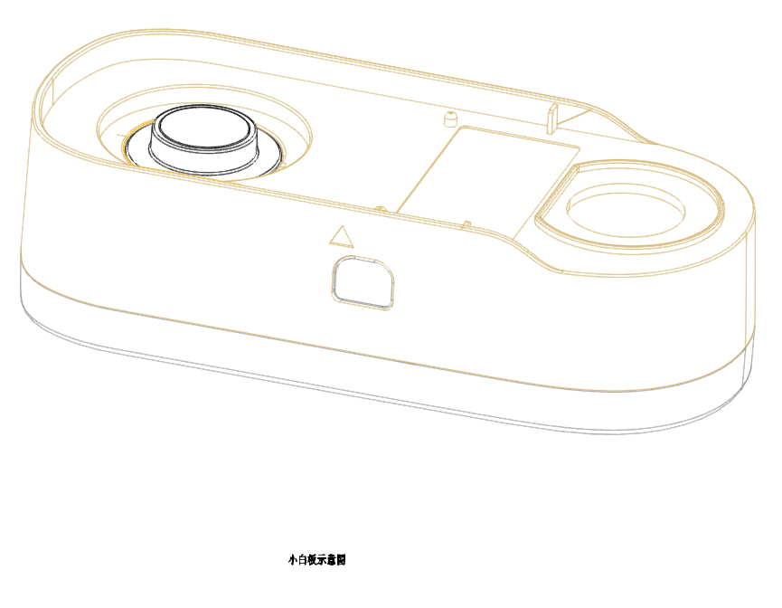

Calibration Board

Black Plate

White Plate

Aperture

Aperture Switch

Testing Button

Power switch

Indicator Light

USB

TFT LCD screen

Figure 1 Instrument Structure Diagram

**Port Description**

**Power Switch 1/0:** Push the switch to “1” to turn on the instrument.

Push the switch to “0” to turn it off.

**Display:** Used to display measurement data and instrument operation navigation.

**Switch / Testing button:** Long press for 3 seconds to turn ON/OFF

power, short press for measurement.

**Indicator light:** LED light includes green, yellow and red.

* Turn to red when battery in charge and turn to green when battery is full.

* Without doing black/white calibration or out of validation, LED light turns to red when switching on the instrument and measurement could not be performed.

* LED light turns to yellow during measuring and turns to green when finished. If the instrument shakes or the test data is abnormal during the measurement, it turns to red when finished and the measuring date needs to be checked.

* LED light turns to yellow when doing the black/white calibration, and

turns to green for calibration succeeded, to red for calibration failed.

**DC Power Port / USB :** A common interface. The instrument will judge the connection status automatically. DC Power Port is connected with AC adapter for charging. The adapter specification is 5V, 2A. USB port is used to transfer data to PC.

**Aperture switch:** used for changing the measuring aperture, setting this switch to “MAV”, turn to Φ8mm aperture, while setting this switch to “SAV”, turn to Φ4mm aperture.

**Calibration board:** includes a white plate and a black plate. The white plate is used for white calibration, and the black plate is used for black calibration. For specific operation please refer to the section of black and white calibration.

1. Operating Instruction

## Power On& Off

The instrument supports both hard power on & off and soft power on & off.

As per Figure 1, Setting power switch to “0” turns the power OFF, and setting it to “1” turns the power ON. The instrument will enter into soft turn off after long time no operation (Please look into chart 3.8.10 for backlight time), press “Power/Test” button for 3 seconds to turn on. Press “Power/Test” button for 3 seconds to soft turn off the instrument.

After the instrument turns on, it will enter into the display as show in

Figure 2 if the black/white calibration is out of validation or the turn-on

calibration is set. Or it will enter into the display as show in Figure 3 to

measurement interface.

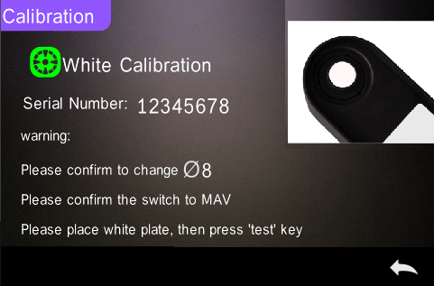

Figure 2 White and Black Calibration

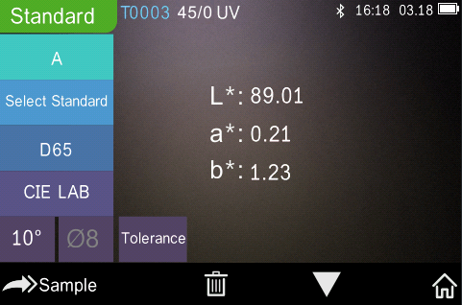

Figure 3 Standard Measurement

## Calibration

In the measurement interface, click “图片1” to enter main menu, others please click “图片2” or “图片3” to enter main menu, as shown in Figure 4.

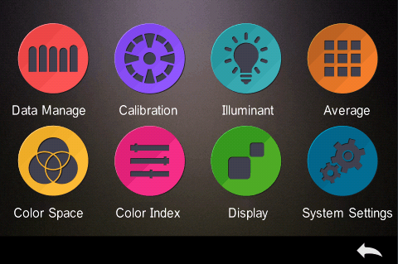

Figure 4 Main Menu

Select “Calibration” to enter white and black calibration interface as shown in Figure 5. It will show if the calibration is valid or not, and the remaining time if it is valid.

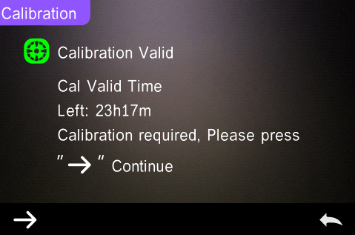

Figure 5 White and Black Calibration

Click “ 图片4 ” to continue and enter “White Calibration” as shown in Figure 2. According to warning, confirm the serial number of white calibration plate correspond to the instrument and correct aperture setting, then put the measuring aperture on white plate and press “Testing” button for white calibration, or click “图片3” to cancel and quit the calibration.

After white calibration, it will prompt you to black calibration as shown in Figure 6. According to warning, put the measuring aperture on black plate and press “Testing” button for black calibration, or click “图片3” to cancel and quit the calibration.

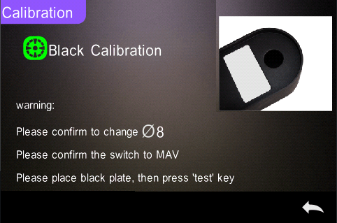

Figure 6 Black Calibration

After black calibration finished, it will automatically enter the main menu, follow the menu to do correspond operations, and click “图片3” back to “Standard Measurement”.

## Measurement

After black and white calibration are completed, the standard measurement and sample measurement can be performed (the user sets the corresponding color space and color index in the main menu according to requirements. The default color space of the system is CIE Lab, and the color difference formula is ΔE*ab, the color index is empty).

## 2.3.1 Measurement Instruction

As shown in Figure 7, it is working condition area at the top of measurement interface, displaying the status of measurement mode (SCI/SCE), Bluetooth and UV conditions. At the left side, it is shortcut display, it could switch different modes by pressing different icons. At the middle, it displays different chromatic data according to different setting of color formula. It is operation buttons area at the bottom, which could operate the data by pressing the different buttons. Figure 8A is spectral reflectance interface and Figure 9 is color index interface. Click “图片5” to do quick switchable.

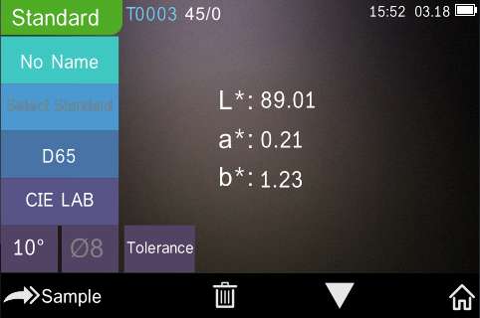

Figure 7 Chroma measurement

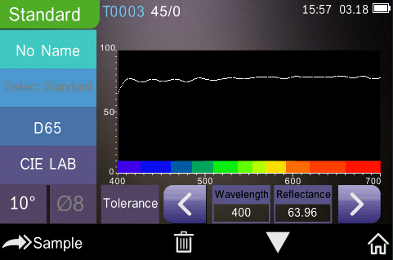

Figure 8A Spectral Reflectance

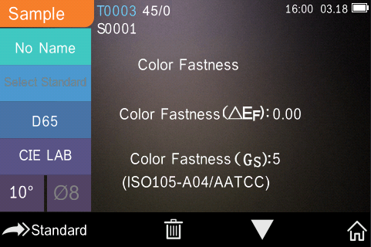

Figure 9 Color Index

If the measurement of traffic signs in the system settings is off, the "Select Standard" in Figure 7 will be gray and there will be no response by clicking the shortcut key. If the measurement of traffic signs is on, the "Select Standard" in Figure 7 will display normally, and clicking the shortcut key will enter the selection interface of traffic signs.

The spectral reflectance interface of Figure 8A will also become traffic sign information, as shown in Figure 8B.

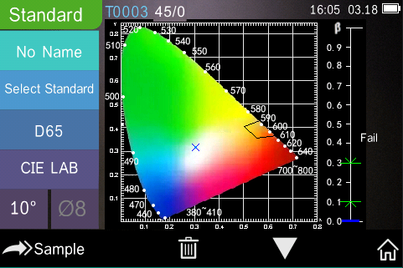

Figure 8B Traffic sign information

## 2.3.2 Standard Measurement

Please enter “Standard Measurement” interface to perform measurements as shown in Figure 10.

Put the measuring aperture close on the standard sample, press “Testing” key. There is a “Beep” sound, and the LED indication light will turn to green from yellow, then it shows measurement finished as shown in Figure 10 and in Figure 11.

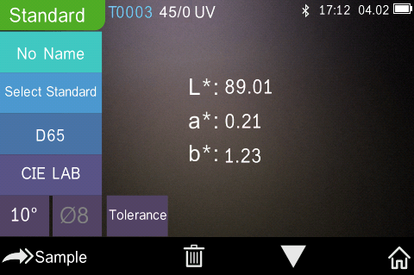

Figure 10 Standard Measurement

Note: If turn off the auto-save function, delete button “图片2” will be save button “图片8” and click “图片8” to save the current data.

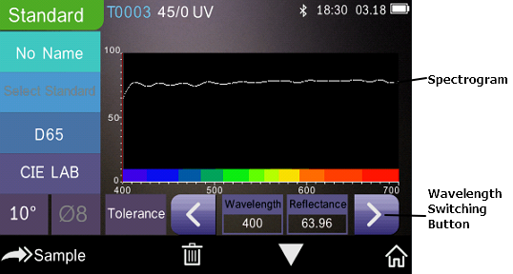

Figure 11 Reflectance of Standard Measurement

Detail instructions of standard measurement are as following:

1) Interface Title: Indicating it is under interface of standard measurement.

2) Condition area: display system setting such as the current serial number, lighting source, UV (on/off), Bluetooth (on/off), and the current time, date and power etc.

3) Serial number of standard: It is generated by the system automatically, and started from T0001 to T1000.

4) Standard Name: Display the current measurement standard name, and click it to quickly modify, or the default is No name.

5) Select standard: click to set the select standard for traffic signs information.

Note: When traffic signs measurement in the system setting opens, it will normally display and then can be set; or it will be gray and can’t be set.

Tolerance setting: Click to set the tolerance of the current standard as required. ΔE* is the total setting tolerance(CIE1976). The left ΔL* is the lower limit of the setting standard brightness tolerance, the right ΔL* is the upper limit of the setting standard brightness tolerance, and the upper limit of the right tolerance must be larger than the lower limit of tolerance; Δa*, Δb* are set in the same way as ΔL*. Click the corresponding tolerance value to enter the corresponding value setting interface. After setting, click “图片3” on the lower side to save and exit the tolerance setting interface. When the sample is measured, only ΔE*, ΔL*, Δa*, Δb* are within the allowable tolerance range, and the sample will show “Pass”, or show “Failure”. This function only exists when you turn on the function of “Display Measurement Result” in the system setting.

7) Light Source: Set as needed before testing, click the shortcut key to switch different light among the D 6 5、A、C、F 1 ~ F 1 2 etc.

8) Color space: Set as needed before testing, click the shortcut key to switch different color spaces among CIE lab、CIE XYZ、Hunter lab etc.

9) Observer angle: Set as needed before testing, click to switch the observer angle 10 and 2.

10) Measurement aperture: Set as needed before testing, indicate the current measurement aperture on use.

11) Switch to sample measurement: Clickto sample measurement.

12) Delete/Save: If the auto-save function opens, click “图片7” to delete the current data. If the auto-save function closes, it will display save button, and click “图片8” to save the current data.

13) Page Turing: Click “图片5” to quickly switch the current data among data display area, spectrum display area and color index display area.

14) Main menu: Click “图片1” to enter the main menu interface.

15) Wavelength switch button: As shown in Figure 11, click “” or “”, the wave length and reflectance of the current sample will switch as range of 10nm interval.

16) β: the luminance factor of traffic signs; it will show “Pass” when the measured value is within the set range, otherwise, it shows “Failure”, as shown in Figure 8B.

## 

## 2.3.3 Traffic Signs Measurement

Traffic signs measurement is a professional demand measurement, which can be judged according to the standard, or customizing standard.

First, select “on” for “traffic signs measurement” in the system setting, as shown in figure 12.

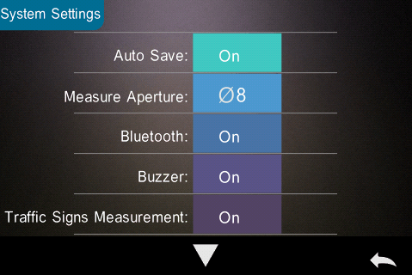

Figure 12 Select “on” in “traffic signs measurement”

Then, click “图片3” to return to the standard measurement interface. At this time, “Select Standard” is displayed normally. Click this shortcut button to set the corresponding traffic signs standard according to user requirements. The following is an example of “White - RetroReflective sheeting -Daytime Color (without metal coating)”.

The select standard interface includes four modules: RetroReflective sheeting, safety colours, customizing standard and add standards (gray by default, can be added by upper computer). Select the required “RetroReflective sheeting”, and then select “Daytime Color (without metal coating)” and “white” successively, as shown in Figures 13, 14, and 15, respectively.

After finishing select standard, return to the standard measurement interface, and press the testing key slightly to complete the standard measurement. The value will be displayed on the chrominance measurement interface.

Click “图片5” to turn the page, and check whether the chromate coordinate of the measured sample is within the polygon of the traffic sign standard and whether the β value is under the allowable range of the traffic sign standard as shown in Figure 8B. It will show “Pass” only if both items meet the requirements, otherwise it will display “Fail”.

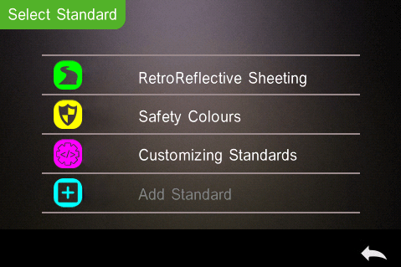

Figure 13 Select Standard

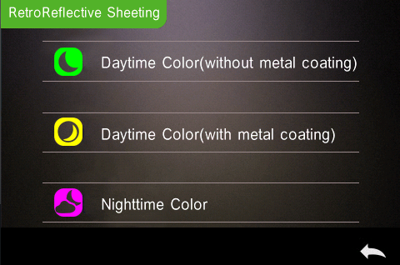

Figure 14 RetroReflective sheeting

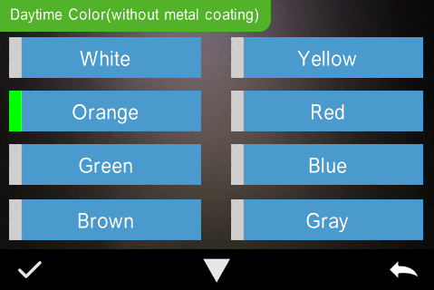

Figure 15 Daytime Color(without metal coating)

## 2.3.4 Sample Measurement

After testing the standard, click  to enter Sample Measurement interface. Put the measuring aperture close on the measured sample, press “Testing” key. There is a “Beep” sound, and the LED indication light will turn to green from yellow, then it shows measurement finished as shown in Figure 16 and in Figure 17. Sample measurement is similar with standard measurement but it will display the color difference between the current standard and measured sample.

Detail instructions of sample measurement are as following:

1) Interface Title: Indicating it is under interface of sample measurement.

2) Standard Serial No: the current serial number of standard, starts with T, followed by numbers, and all sample chromatic data is based on the current standard.

3) Sample Serial No: the current serial number of sample, starts with S, followed by numbers, generated by the system automatically, uniquely identify current sample.

4) Sample Name: Display the current measurement sample name, and click it to quickly modify, or the default is No name.

5) Switch to standard measurement: Clickto sample measurement.

6) Delta E (Color Difference): The color difference between standard and

sample.

1. Color Offset/Measurement Result: only display color offset when you turn on the function in the system setting. Display the test result under the color formula and tolerance. If the result is larger than the tolerance value, it will show “Failure”, or show “Pass”. This function only exists when you turn on the function of “Display Measurement Result” in the system setting.

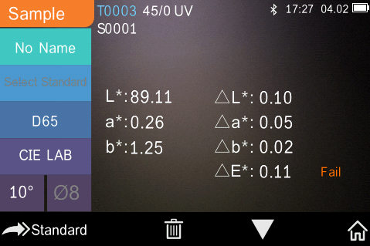

Figure 16 Sample Measurement

1. Wavelength switch button: click “” or “” , the wave length and reflectance of the current sample will switch as range of 10nm interval.

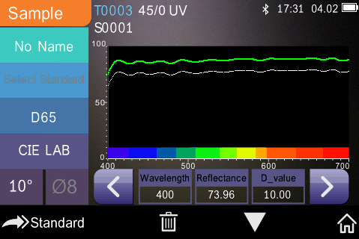

Figure 17 Reflectance of Sample Measurement

## 2.3.5 Average Measurement

When the measured sample is very large or relatively not very uniform, it needs to be measured several points to get an average reflectance to show the sample true chromatic value. This instrument can realize 2-99 times average measurement. It can be set for both standard and sample measurement.

In the main menu, click “Average Measurement” as shown in Figure 18, input average times and click “图片2” to confirm.

When the average measurement setting is completed, corresponding prompt will show on the measurement interface, as shown in Figure 19.

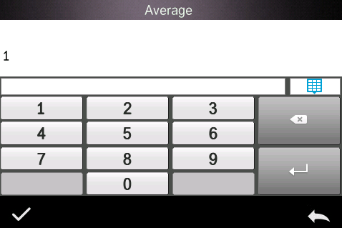

Figure 18 Average Measurement

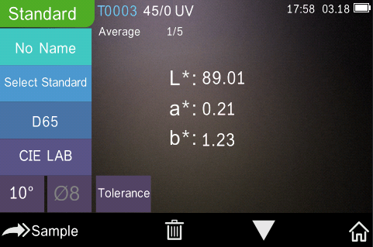

Figure 19 Average Measurement Display

## 2.4 Connecting PC

The instrument has a PC software with powerful extended function, and it could realize more chromatic data analysis. It can connect to PC through USB cable or Bluetooth (Only for the model with Bluetooth function).

## 2.4.1 USB Connection

First, install the software on the computer, then use USB cable to connect PC and the instrument. The software will aromatically connect to the instrument. If it successes to connect, it will display the icon of USB connection, then measure the sample and standard or analyze the data on the computer. But if not, it won’t display any.

## 2.4.2 Bluetooth Connection

For these models with Bluetooth function, it can connect to PC software through Bluetooth.

After installing the PC software, open Bluetooth function in the system setting, and set Bluetooth matching in the PC software setting. If Bluetooth matching successfully, it could measure the sample and standard or analyze the data on the computer. About Bluetooth, Bluetooth adapter, and PC software, please follow the steps of software user manual in the chart of Bluetooth.

## 2.5 Print

Micro Printer is an optional accessory and is required to be purchased separately.

Users should measure the sample first, and save all records. Then connect to micro printer by USB cable. Find the printed data from the sample or standard records as shown in Figure 20.

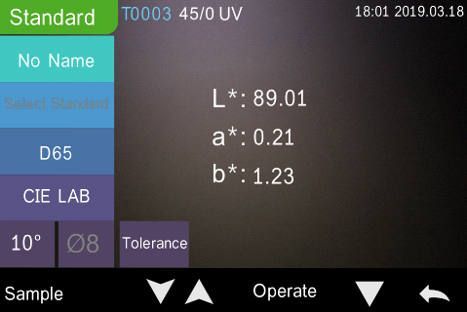

Figure 20 Standard record

Click “Operate” to pop up menu as shown in Figure 20, and select “Print Data”(in Figure 21) to print the current data.

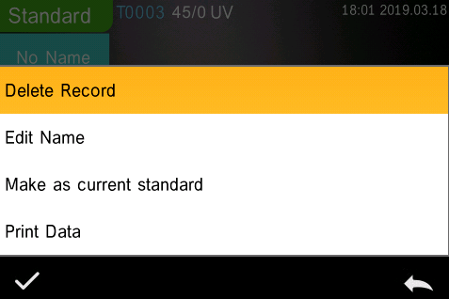

Figure 21 Print operation interface

3. Main Menu

Click ”图片1”in the measurement interface(Figure 3) or”图片3” in other interfaces to enter the main menu(Figure4 ) and set all system functions from each sub menu.

## 3.1 Data Manage

Click “Data Manage” in main menu to enter data management interface as shown in Figure 22. Data management is mainly for “Check Record”, “Delete Record”, “Search Record” and “Standard Input”.

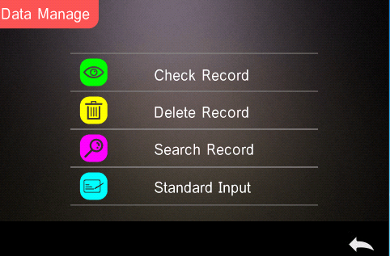

Figure 22 Data Manage Interface

## 3.1.1 Check Record

（1）Check the Standard Record

Select “Check Record” to enter “Standard Record” interface as shown in Figure20. The measurement condition shows the standard light mode, UV status and the measurement time and date.

Click “图片11” or “图片12” to check next or previous record.

Click "图片5" to switch between chroma data, reflectance spectrum (traffic roadmap), and color index. If the “Traffic Sign Measurement”in the system settings is on, the original standard measurement record containing the traffic sign will display the traffic road sign information on the second page of the standard record (the reflectance curve is not displayed at this time); When “Traffic Sign Measurement” is off, all standard records will display a reflectance graph on the second page of the standard record.

In Figure21, it allows you to “Delete Record”, “Edit Name”, “Make as current standard” or “Print Data” after select the button and click 图片2 .

Delete Record: Click “Delete Record” to enter the record delete warning interface (Figure 25).Press “图片2” to Delete record, Press “ 图片3“ to cancel and come back.

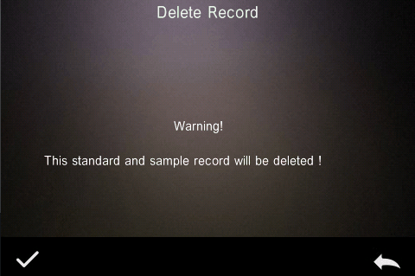

Figure 25 Delete record reminder interface

Edit Name: Press “Edit Name” to enter the interface showed as Figure 26, input new name (not over 16 characters), click “图片2” to confirm or “图片3” to cancel..

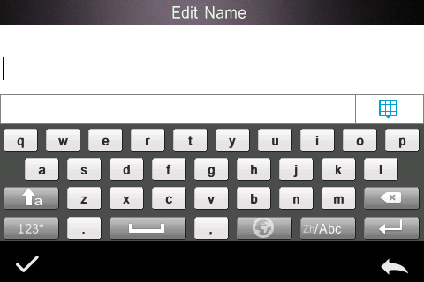

Figure 26 Edit Name Interface

Make as current standard: Press “Standard” to set the current record as the current standard as the Figure 27 showed, press “” to measure the objects under the current standard.

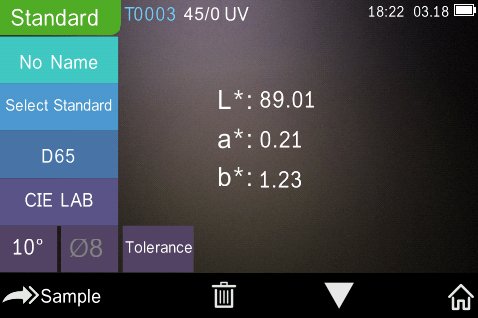

Figure 1 Make as current standard Interface

Print Data：Click “Print Data” to print the current record data through printer.

(2)Check the Sample Record

Click “Sample” in standard record interface to check the sample records which are measured with current standard as shown in Figure 28.

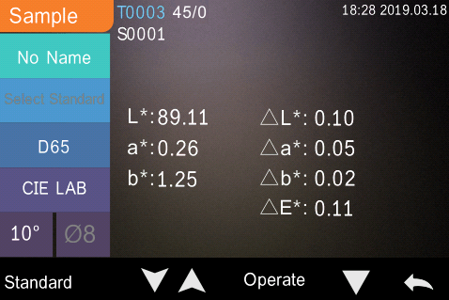

Figure 2 Sample Record Interface

Click “图片11” or “图片12” to check previous or next record.

Click “图片5” to switch among chromatic data, reflectance, color index .

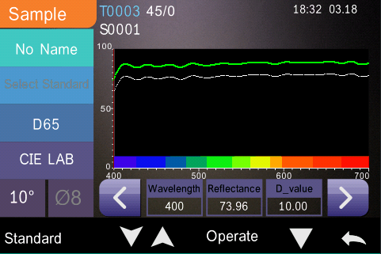

Figure 29 sample record reflectance spectrum interface

Click “Operate” to “Delete Record”, “Edit Name”, “Make as Current Standard” or “Print Data”. It is the same as above.

## 3.1.2 Delete Record

In the data manage interface, click "Delete Record" to enter the delete record interface, as shown in Figure 30. Delete records include "Delete All Samples" and "Delete All Records”.

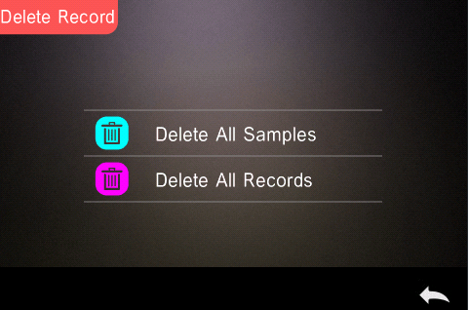

Figure 3 Delete Record Interface

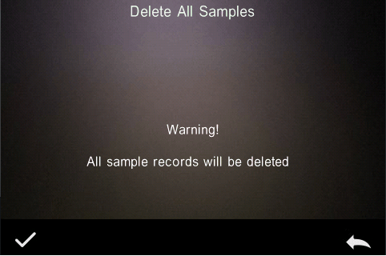

Figure 4 Delete All Samples Warning Prompt Warning Interface

Click the corresponding option, it will pop up a warning interface, click “图片2” will delete all corresponding records; click “图片3” will cancel the operation, as shown in Figure 26.

## 3.1.3 Search Record

In the data managet interface, click "Search Record" to enter the search menu, as shown in Figure 32. It could choose "Search Standard Name", "Search Standard Index" and "Search Sample Name".

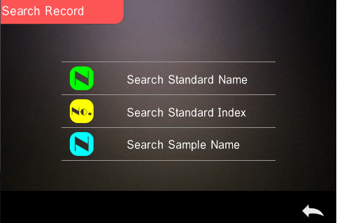

Figure 32 Search Menu Interface

Search Standard Name

Click “Search Standard Name”, to pop up to input search name interface as shown in Figure 33. Input searched name or contained character, then click “图片2” to confirm, the instrument will search all standard records automatically and list all matching records, as shown in Figure 34, click “图片11” & “图片12” to check all matching records. If there is no matching record, it will prompt "This record is empty" and return to the search record menu.

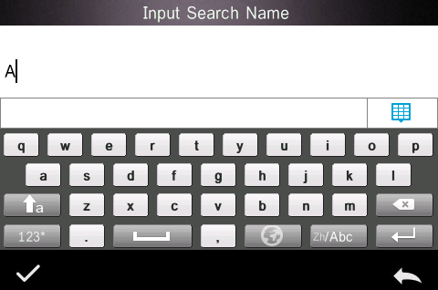

Figure 5 Input Search Name Window

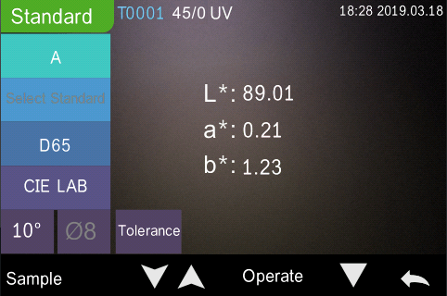

Figure 6 Search Record Result

Search Standard Index

Click “Search Standard Index”, to pop up to input search index serial number interface as shown in Figure 35, Input the Index No., then click “图片2” to execute the search. The instrument will search all standard records automatically and list all matching records.

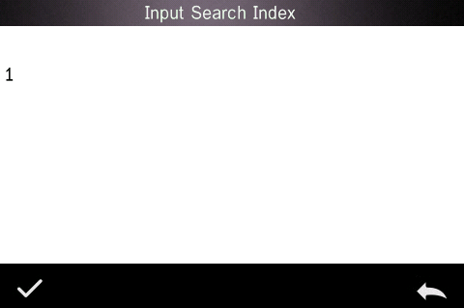

Figure 7 Input Search Index

Search Sample Name

Click “Search Sample Name”, as shown in, input searched sample name or contained character, then click ”图片2” to confirm, the instrument will search all standard records automatically and list all matching records.

## 3.1.4 Standard Input

In the data management interface, click "Standard Input" to enter the standard input interface, as shown in Figure 36.

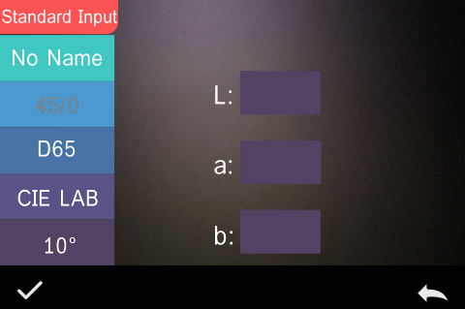

Figure 8 Standard Input Interface

Click "No Name" to input the standard name.

Click “ D65” to set the Light source of the standard.

Click “CIE LAB” to set the color space of the standard.At present, it only supports CIE LAB, CIE XYZ..

Click “10°” to set the standard observer angle (2° or 10°)

Click “L” or “a” or “b” to set the value for “L” and “a” and “b”, after input the value for “L” , click “图片2” to confirm(as Figure 37 shown) , same step for “a” and “b” setting, after the “L”, “a”, “b” are all confirmed, the input standard will be stored in the standard record list, and the standard index will be cumulative.

Note: In the instrument, users can’t manually input the reflectance and the input standard data is only valid in the current observe angle, measurement mode and light source. In the check standard record interface, if the observer angle, measurement mode and the light source changed, the corresponding chromatic data will be displayed as "- - - - -"

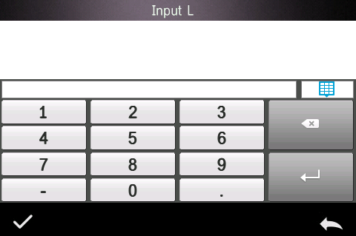

Figure 37 Input the coordinates of L

## 3.2 Calibration

Black-and-white calibration is the benchmark for chromaticity data measurement. It must be done accurately, otherwise it will affect the validity of the test data.

When the black-and-white calibration environment and the current sample test environment are quite different (such as when the temperature fluctuates drastically), the instrument needs to be calibrated in time. The last successful calibration time exceeds the set time, needs to be re-calibrated before the sample measurement.

The whiteboard should be cleaned regularly and kept in a safe, dust-proof, dry condition. Black whiteboard calibration method, please refer to section 2.2 for details.

For black and white calibration operation, please refer to Section 2.2.

## 3.3 Illuminant Setting

User should set corresponding Illuminant according to the actual test conditions. In the “Illuminant” interface, it can set the standard observer angle, light source and UV light source (different model has different configuration).

In the main menu interface, click "Illuminant" to enter the light source setting interface, as shown in Figure 38.

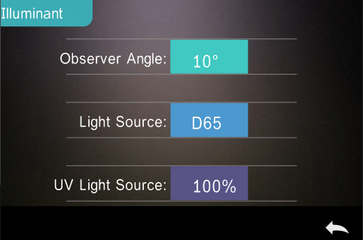

Figure 9 Illuminant Setting Interface

Click “Observer Angle”: to switch 10° or 2°. 10° is CIE1964 standard, while 2° is CIE1931 standard.

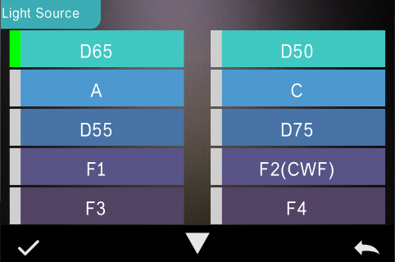

Figure 10 Light Source Selection Window

Click “Light Source”: as shown in Figure 39, users could select D65, A, D55, D50, C,D75,F1 ~F12 ......

Click “UV Light Source”: to select the UV light source switch. 100% means UV light on while 0% means off. It is recommended to turn on the UV light source when measuring fluorescent sample, and turn off when measuring general sample.

## 3.4 Average Measurement

When the measured sample is very large or relatively not very uniform, users need to measure several representative points to get an average reflectance to show the sample true chromatic value. This instrument can achieve 2-99 times average measurement.

For detailed operation, please refer to Section 2.3.5 “Average Measurement”.

## 3.5 Color Space

In the main menu, click “Color Space” to open the color space interface as shown in Figure 40. Select the corresponding color space and click “图片2” to complete the setting.

Note: Increase the βxy color space option.

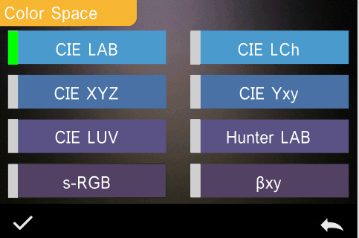

Figure 40 Color Space Selection Interface

## 3.6 Color Index

In “Color Index” interface, user may choose the current color formula and color index, set the parameter factors for color formula and Metameric Index, shown as Figure 41.

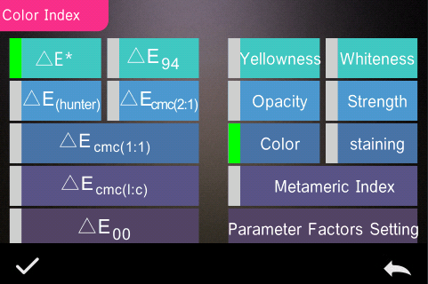

Figure 41 Color Index Interface

## 3.6.1 Set Color Index

In main menu, click “Color Index” as shown in Figure 41. On the left, it is a radio list of color formula; on the upper right, it is radio list of color index; on the lower right, it is parameter factors settings.

Click any color formula or color index to choose the corresponding color formula or color index. Color index is optional, if you want to cancel it, click the selected color index again. After selecting, click “图片2“ to confirm.

The selected color formula will calculate the sample color difference when measuring sample. Color formula ΔE00 as shown in Figure 42.

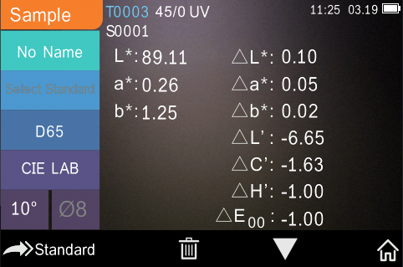

Figure 42 Color Formula ΔE00

The selected color index will displayed in the color index area on standard measurement or sample measurement (some only be displayed on sample measurement according to different color index). In the measurement interface or check record interface, click “图片5” to the color index interface. Yellowness index as shown in Figure 43.

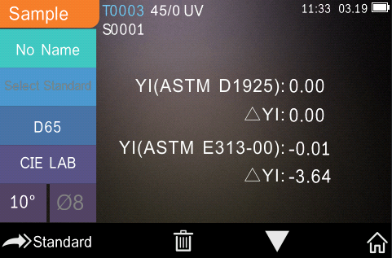

Figure 43 Yellowness Index of The Sample

## 3.6.2 Parameter Factors and Metameric Setting

Click “Parameter Factors Setting” on the color index interface to enter the parameter factors setting interface, as shown in Figure 44.

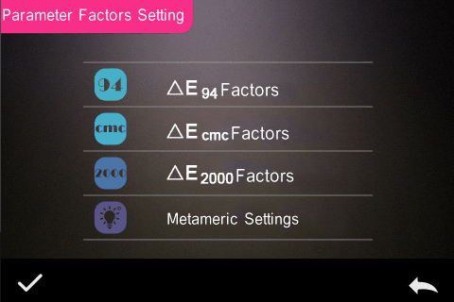

Figure 44 Parameter Factor Settings Interface

1) Parameter Factors Setting

For the color difference formulas CIE DE2000 (ΔE00), CIE DE1994 (ΔE94), CMC (ΔEcmc (1:c)), the user can set the parameter factors of L, C, and H (CMC can only set L and C). The parameter setting of ΔE94 is taken as an example for explanation.

Click “ΔE94 Factors” to enter the ΔE94 factors setting interface, as shown in Figure 45,

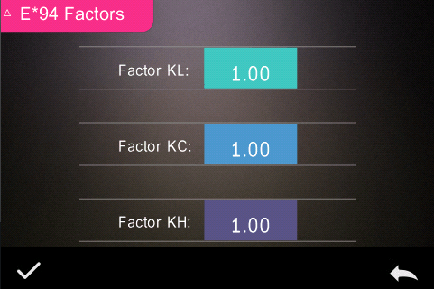Figure 45 ΔE94 Factors Setting Interface

Click the value of factor KL, factor KC, and factor KH to enter the editing interface (as shown in Figure 46), then enter the new value, click "图片2" to confirm, click cancel "图片3" to cancel the saving settings.

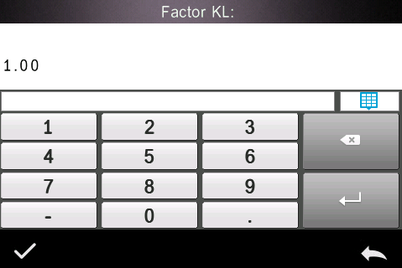Figure 46 Editing Interface Of Factor Kl

2) Metameric Settings

In the parameter factor setting interface, click “Metameric Settings” to enter the Metameric Settings interface. As shown in Fig. 47, set the reference light source 1 and the light source 2 respectively. After setting, click "图片2" to confirm, click cancel "图片3" to cancel the saving settings.

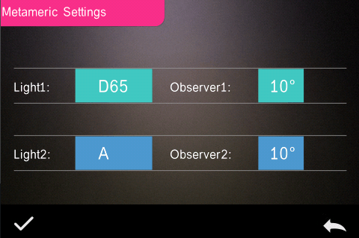

Figure 47 Metameric Setting Interface

## 3.7 Display Settings

Click “Display Settings” on the main menu interface to enter the display setting interface, as shown in Figure 48. In this interface, you can set whether to open the color offset, test result prompts and select left and right hand operation habits.

When the color offset is on, the color deviation of the sample and the standard will be indicated when the sample is measured. When it is off, there is no corresponding prompt.

If you open the test result prompt, if the test result exceeds the tolerance range set by the standard during the sample measurement, the red “Fail” will be displayed. If the error of the sample is within the allowable range of the standard, the display will be green "Pass".

The instrument operation defaults to the right-handed habit. If the user is accustomed to using the left hand, the operating habits can be set to the left hand, and the instrument's operation interface will also be presented according to the left-hand habit.

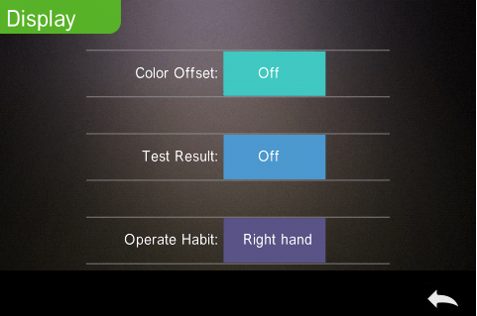

Figure 48 Display Settings Interface

## 3.8 System Settings

Click "System Settings" in the main menu to enter the system setting interface, as shown in Figure 49 (Figure 12), Figure 50, Figure 51.

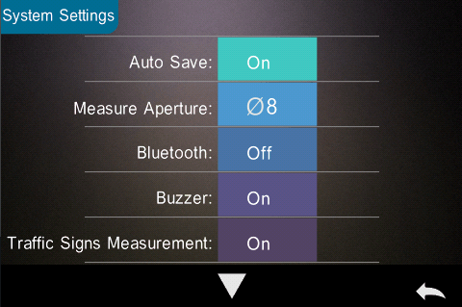Figure 49 System Settings Interface 1

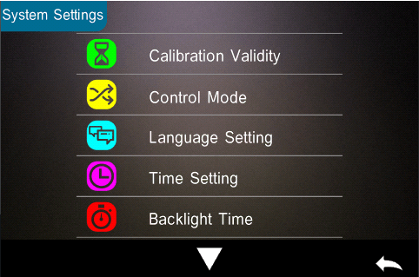

Figure 50 System Settings Interface 2

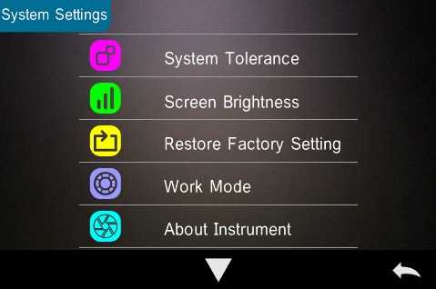

Figure 51 System Settings Interface 3

System settings include: Auto Save, Measure Aperture, Bluetooth, Buzzer, Sample Measurement Mode, Calibration Validity, Control Mode, Language Setting, Time Setting, Backlight Time, Screen Brightness, etc., and also includes Restore Factory Settings, About Instrument information.

## 3.8.1 Auto Save

When the auto save is turned on, each sample after the test is automatically stored in the instrument, otherwise the measurement record will not be automatically saved after the sample test is completed, and it will be stored when the save icon "图片8" is manually clicked.

## 3.8.2 Measuring Aperture

This series of instruments are equipped with Φ 8mm and Φ 4mm measuring calibre. When the measured surface of sample is large and uniform, it is recommended to use Φ 8mm measuring caliber, and when the measured surface is relatively small, it is recommended to use Φ 4mm measuring caliber (some models are equipped with Φ 20mm measuring caliber under special circumstances).

Measuring Aperture Switching Steps:

Step 1, As shown in Fig. 52, press the transparent caliber downward with both hands and pull outward to remove the original caliber; align the measuring caliber to be installed with the mounting hole, and operate in reverse direction. When there is a "click", it means that the measuring caliber is well matched with the buckle position of the instrument.

Step 2, as indicated in Figure 1, if the Φ4mm measuring aperture is already assembled, the aperture switching switch should be set to the SAV position; if the Φ8mm measuring aperture is already assembled, the aperture switching switch should be set to the MAV position.

Step 3, Switch the measurement aperture set by the instrument system to match the actual measurement aperture. Figure 44 shows that the current measurement aperture is Φ8mm. After switching the measurement aperture, you must re-black and white calibration, and follow the instructions of the instrument to complete the black and white calibration.



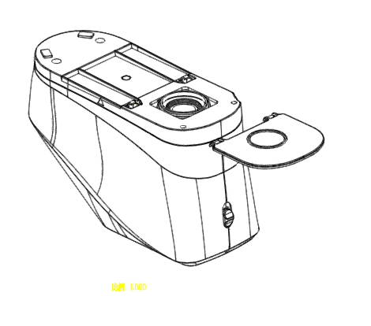

Figure 52 Measuring Aperture Assembling

**Note:**

**Make sure that the aperture of the system is consistent with the actual assembly measurement aperture. In addition, the lens position must be at SAV for the Φ4mm aperture. For the Φ8mm aperture, the lens position must be at the MAV. Otherwise, incorrect measurement results will be generated.**

## 3.8.3 Bluetooth

For Bluetooth-equipped models, you can choose to communicate with the PC software via Bluetooth.

When Bluetooth is turned on, the “” icon will be displayed on the status bar of the measurement interface.In the case of installing the supporting software on the PC side, the Bluetooth switch is turned on in the “System Settings” of the instrument, and the Bluetooth pairing is set in the PC software. After the pairing is successful, the PC software realizes the complete control of the instrument and tests and analyzes the related samples. Refer specifically to section 2.4.2.

## 3.8.4 Buzzer

The buzzer switch controls whether a beep sounds when measuring. When the buzzer is on, a beep will sound every time the measurement starts; otherwise, there is no buzzer prompt during the measurement.

## 3.8.5 Traffic Sign Measurement

The status of traffic sign measurement is related to traffic sign measurement, refer to section 2.3.3. The traffic sign measurement is turned on, the "Select Standard" of the measurement interface is normally displayed; the traffic road sign measurement is turned off, and the "Select Standard" of the measurement interface is set ash.

## 3.8.6 Calibration Validity

Black-and-white calibration is the benchmark for chromaticity data measurement. It must be done accurately, otherwise it will affect the validity of the test data. When the black-and-white calibration environment and the current sample test environment are quite different (such as when the temperature fluctuates drastically),the instrument needs to be calibrated in time. It is recommended to re-calibrate after the last successful calibration time exceeds 24 hours. The "Calibration Alidity" of the instrument in the system settings manages the aging time of the black and white calibration.

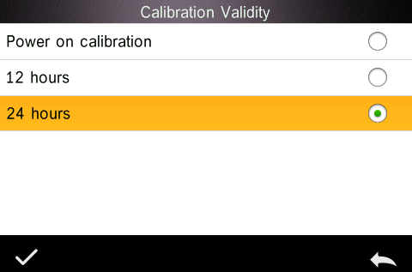

Figure 53 Calibration Validity Selection Interface

Click “Correction Validity” in the system settings interface to enter the calibration validity selection, as shown in Figure 53, the optional calibration effective time has power-on calibration, 12 hours, 24 hours.

If you select power-on calibration, it will automatically enter the black-and-white calibration interface every time you turn it on. If you do not calibrate, you will only be able to view the previous data and not complete the new measurement.

If you select 12 hours, the instrument's calibration validity will expire 12 hours after each calibration. If it expires, you will only be able to view the data but not complete the new measurement. After re-calibration, the calibration validity is restarted.

If you select 24 hours, the instrument's calibration validity will expire 24 hours after each calibration, similar to the selection of 12 hours, but the validity is different.

When the calibration validity expires, on the measurement interface, the LED indicator is red warning and cannot be measured normally. After re-calibrating correctly, the LED indicator turns green.

## 3.8.7 Control Mode

When the instrument communicates with the PC software, the customer can set specific measurement control mode as needed. In the system settings interface, click “Control Mode” to open the control mode selection interface. There are three options: Key, PC Software, Key and PC Software, as shown in Figure 54.

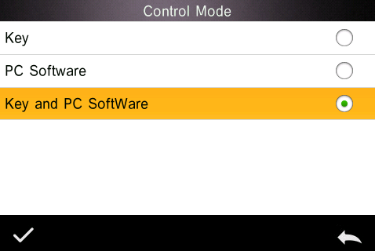

Figure 54 Control Mode Selection Interface

Key: Select this mode, when the instrument communicates with the PC software, the instrument is only triggered by the instrument measurement button.The user needs to complete the test through the instrument test button and upload the data to the PC software.

PC Software: Select this mode, when the instrument communicates with the PC software, the instrument measurement can only be controlled by the PC software to complete the test and upload the data to the PC software.

Key and PC Software: Select this mode, the user can complete the sample test through the instrument test button or PC software command, and upload the data. This mode is the instrument default selection mode.

Note: The measurement control mode only works when the instrument is connected to the PC software. When it is not connected, it can only be measured with the measurement button.

## 3.8.8 Language Settings

The language setting is used to set the language of the instrument interface. Under the system settings interface, click "Language Settings" and select the appropriate language to confirm.

## 3.8.9 Time & Date Settings

When the instrument leaves the factory, it usually synchronizes the local time of the manufacturer, the user can set the instrument time according to the actual situation. In the system setting interface 2, click "Time & Date Settings" to enter Figure 55 for setting.

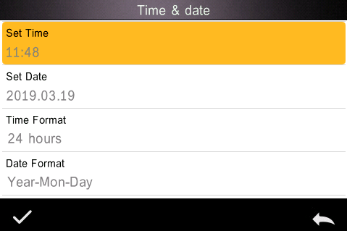

Figure 55 Time & date setting interface

1) Set Time

In the Time & Date Settings interface, click “Set Time” to set the time. After setting, click “图片2” to display the newly set time.

2) Set Date

In the Time & Date Settings interface, click “Set Date” to set the date. After setting, click “图片2” to display the newly set date.

3) Time Format

In the Time & Date Settings interface, click “Time Format” to select and select 12-hour or 24-hour system.

1. Date Format

In the Time & Date Settings interface, click “Date Format” to select and select “Year-Month-Day”, “Month-Day-Year” or “Day-Month-Year”.

## 3.8.10 Backlight Time

Click “Backlight Time” in the system settings interface to enter the “Backlight Time” selection interface.

The configuration items of the backlight time are: "Normally Open", "5 minutes", "60 seconds", "30 seconds", "15 seconds". If you select normally open, it will not automatically backlight and will not automatically shut down when there is no operation, and will automatically shut down until the battery is low. If select "5 minutes", the instrument will count down from the last operation, and after 5 minutes, it will enter the energy-saving backlight status if there is no operation. The "60 seconds", "30 seconds", and "15 seconds" settings have similar meanings.

## 3.8.11 System Tolerance

Click “System Tolerance” in the system settings interface to enter the default system tolerance interface. The system tolerance setting is performed according to the requirements. The ΔE* interface is the total tolerance of the standard(CIE1976); the left ΔL* is the lower limit of the standard brightness tolerance, and the right ΔL* is the upper limit of the standard brightness tolerance.The upper tolerance of the right side must be greater than the lower tolerance limit; the Δa*, Δb* setting method is the same as ΔL*. Click the corresponding tolerance value to enter the corresponding value setting interface. After setting, click the lower side “图片3” to save and exit the tolerance setting interface.

When the standard uses the default system tolerance, the sample is compared with the standard data. Only if ΔE*, ΔL*, Δa*, Δb* are within the allowable tolerance range, the sample will be qualified. Otherwise, the sample will be unqualified. (the test result prompt switch is turned on).

The customer can also set different tolerances for different requirements. In the standard measurement interface, when the standard is tested, click the

tolerance setting of the test interface, and then set the tolerance for the standard. The setting method is the same as the system tolerance.

## 3.8.12 Screen Brightness

Click “Screen Brightness” in the system settings interface to enter the “Screen Brightness” interface. Click "+" to increase the screen brightness, and click "-" to decrease the screen brightness. You can adjust according to the actual situation, after the adjustment is completed, click "图片2" to save the settings, click "图片3" to cancel the save.

## 3.8.13 Restore Factory Setting

Click “Restore Factory Setting” in the system settings interface, and the “Restore Factory Settings” interface will be displayed, as shown in Figure 56. Click “图片2” to clear all measurement records and parameter settings and restore to the factory state; click “图片3” will cancel this operation.

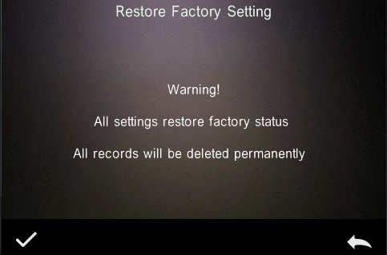

Figure 56 Restore factory settings interface

## 3.8.14 Work Mode

For customers who purchase universal test components, the instrument's work mode should be set to component mode when the instrument is used with the universal test component; in the case of general measurement conditions (by default), use portable.

Click “Work Mode” in the system settings interface, and the interface shown in Figure 57 will be entered. The customer can set a specific work mode according to the need, click “图片2” to save the current setting; click “图片3” to cancel the operation.

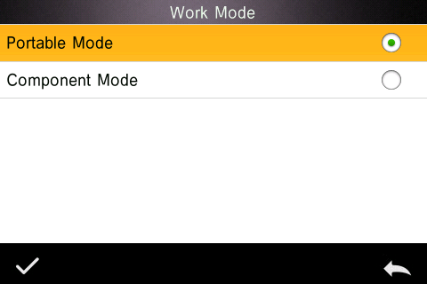

Figure 57 Work mode interface

4. The daily maintenance of the instrument

1) This instrument is a precision optical instrument. Please keep and use the instrument properly. Avoid using and storing the instrument under humid, strong electromagnetic interference, strong light and dusty environment. It is recommended to use and store the instrument in a standard laboratory environment.

2) The whiteboard is a precision optical component. It should be stored and used properly. Avoid rubbing the working surface with sharp objects, avoid soiling the working surface with dirt, and avoid exposing the whiteboard under strong light. Regularly clean the whiteboard working surface with a cloth and alcohol. When calibrating, clean the dust on the working surface of the whiteboard in time.

3) In order to ensure the validity of the test data, the instrument and whiteboard are recommended to be calibrated by the manufacturer or a qualified metrology institute every one year from the date of purchase.

4) The instrument supplies power to the external power adapter. The power supply should be used in a standard manner to avoid frequent plugging and unplugging, to protect the power supply performance and to extend the service life of the power supply.

5) Please do not disassemble the instrument. If there is any problem, please contact the relevant after-sales staff. Tear up the easy-to-tear label will affect the after-sales maintenance service of the instrument.

5.Technical Parameters

## 5.1 Product Features

1. High hardware configuration: pure color capacitive touch screen; Bluetooth 4.0 (some models); con-cave grating , 256 image element dual array CMOS detector;

2. 45/0 geometric optical structure, complies with CIE No.15, GB/T 3978, GB 2893, GB/T 18833, ISO7724/1, ASTM E1164, DIN5033 Teil7;

3. Combination of high-life and low-power LED light source, including UV / excluding UV;

4. Switchable φ8mm & 4mm 2 apertures, adapt to more samples;

5. Measuring spectrum, Lab data accurately, can be used for color matching and accurate color transfer;

6. USB / Bluetooth 2.1 dual communication mode, more adaptable;

7. Super stain-resistant and stable white calibration plate;

8. Large-capacity storage space, can store more than 30,000 test data;

9. Two standard observer angles, a variety of light source modes and color systems, complies with a variety of standard color indicators to meet the needs of various customers for color measurement;

10. PC software has a powerful function extension.