Content
1. Overview 1
2. Operating instructions 4
2.1 Battery instructions
2.2 Switch on and off
2.3 Black and white calibration
2.4 Mobile APP installation and measurement
2.5 Quality management software installation
2.6 Measurement
2.6.1 APP measurement
2.6.2 Stand-alone standard sample measurement
2.6.3 Single machine sample measurement
3. System function description 8
3.1 Data deletion
3.2 Light source settings
3.3 color space
3.4 Color difference formula
3.5 System Settings
3.5.1 Auto save
3.5.2 Sound
3.5.3 Bluetooth
3.5.4 Automatic printing
3.5.5 Calibration
3.5.6 Language selection
3.5.7 Sleep time
3.5.8 Backlight time
3.5.9 Factory reset
3.5.10 Device information
4. Daily maintenance 10
5. Technical parameters 10

Overview
Mini ColorReader is a portable small color measuring instrument with small size, convenient use and accurate measurement. It is widely used in industries such as plastic electronics, paint and coating, textile and garment printing and dyeing.
The instrument can be connected to the mobile phone APP and SQCX PC quality management software to achieve more functional expansion. The mobile APP comes with multiple sets of electronic color cards, which can realize color card retrieval and matching. The mobile phone APP and SQCX PC software have a variety of light source, color space, color index, and reflectance functions, which can realize massive chromaticity index testing.
This instrument has the following advantages:
1) It can be measured after power-on, no need to perform white calibration every time, making color measurement easier;
2) Separate design of calibration whiteboard and measuring port to ensure long service life of whiteboard and accurate measurement;
3) Accurate, stable, small size, easy to carry, APP built-in mobile electronic color card, it is a good helper for mobile color quality control;
4) A variety of chromaticity parameters can be set on the instrument side, test records can be checked, and the stand-alone function is powerful;
5) Built-in rechargeable lithium battery, Type-C USB interface, easy to use;
6) Connect the mobile phone APP and PC SQCX software to achieve more functional expansion.
1. Button and interface description

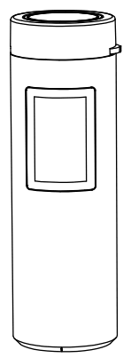
Measuring Button
/Power Switch
Operate Button
LED Indicator
Display

Figure 1 Schematic diagram of button interface (front)

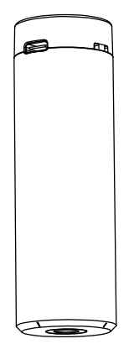
Tether hole
Measuring Aperture
Type-C /USB Port

Figure 2 Schematic diagram of button interface (rear)
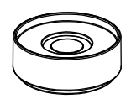
Calibration Cover

Figure 3 Schematic diagram of calibration cover

"Operation button" icon description:
() Left button: swipe left, left button to record/up select:
() Right key: Swipe to the right, right key to record/down select:
() Confirm: Short press to return or switch sample/standard sample, long press to confirm.

2. Operating instructions
2.1 Battery instructions
This instrument uses a built-in lithium battery, the specification of the lithium battery is Li-ion 3.7V, and the capacity is 800mAh. Use a USB data cable to connect to the USB port on the PC or connect to a 5V==1A power adapter to charge the lithium battery. The maximum charging current can reach 500MA. When charging, the battery level is greater than 80%, the LED indicator is green, the battery level is less than 20%, the LED indicator is red, and the battery level is between 20% and 80% is yellow. The display shows a charging prompt, and the charging is complete, indicating that the battery is full.
2.2 Switch on and off
Power on: In the power off state, press the power switch, the instrument is powered on, the LED indicator flashes, the display screen lights up and enters the measurement interface.
Shutdown: In the power-on state, long press the power switch to shut down the instrument. When the automatic sleep mode is turned on, the instrument will automatically shut down.
Note: When not using the instrument for a long time, please turn off the power.
2.3 Black and white calibration
In the measurement interface, long press the "operation button" to enter the system function interface, slide the "operation button" to the left or right, position the cursor on the "black and white calibration", and long press the "operation button" to enter the calibration interface. The instrument has built-in calibration parameters, and calibration is needed when the environment changes drastically.
Black calibration: "black calibration" the instrument against the air, the surrounding must be a darker environment without bright light source, and there is no obstruction within 1 meter of the instrument against the air. Short press the "measurement button" to perform black calibration, and the calibration success prompts "pass". After the black calibration is completed, the white calibration interface is automatically entered.
White calibration: align the measurement aperture with the calibration cover. The calibration cover adopts a spring-type pressing structure, gently press the instrument to make the measurement aperture fit the whiteboard closely, short press the "measurement button" for white calibration, the calibration is successful, and the prompt "pass". After the white calibration is completed, the measurement interface is automatically entered.
2.4 Mobile APP installation and measurement
The mobile APP supports Android operating system version 5.0 and above. Use the mobile browser or WeChat to scan the QR code below, download and install as prompted.
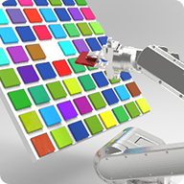

Figure 4 QR code for APP installation Figure 5 App icon after installation

2.5 Quality management software installation
The instrument can establish a connection with the PC-side SQCX quality management software through a USB data cable or a Bluetooth module (only for products equipped with a Bluetooth module) to communicate and achieve more functional expansion. The measurement interface of the instrument connected to the PC is shown in Figure 8.
2.6 Measurement
Standard sample measurement and sample measurement can be realized by instruments, and other chromaticity indexes can be realized by mobile phone APP and SQCX PC software.
2.6.1 APP measurement
After the installation is complete, open the mobile APP (see the mobile APP manual for details on the use of the mobile APP), click "Connect Bluetooth" or "Connect to the instrument", first check the instrument model and SN code in the "Device Information" of the instrument, and then in the mobile APP Select the instrument to be connected (instrument model: SN code) in the "Connected Instruments" list, and click to automatically connect. In the color measurement interface, click "standard sample measurement" or "take standard sample" to obtain the chromaticity data and simulated color of the standard sample. Click "Measure Color Difference" to obtain the chromaticity data, difference and artificial color of the sample, as shown in Figures 6 and 7.
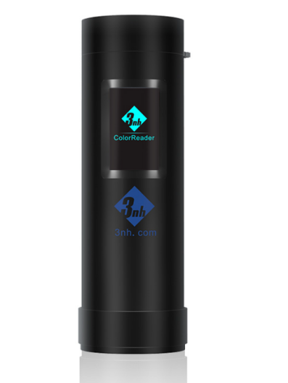
Figure 6 Single machine measurement
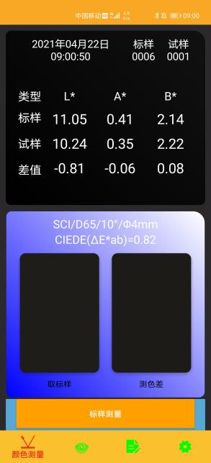

Figure 7 Instrument measurement interface after connected APP
2.6.2 Stand-alone standard sample measurement
In the standard sample measurement interface, align the measurement aperture to the standard sample and press the "measurement button" shortly. The instrument obtains the chromaticity data of the standard sample, as shown in Figure 9. The green indicator LED flashes once when the measurement is completed. The status bar at the top of the instrument screen displays the current measurement conditions, the icon at the bottom displays the USB and Bluetooth connection status, and "01" in the lower right corner indicates the current standard number. The number of the stand-alone standard samples is from 01 to 10. When the standard sample data is full of 10, the system will prompt whether to clear the standard sample again. After clearing, the measurement can be continued. After the standard sample is cleared, the sample associated with the standard sample will also be cleared. Slide the operation button to the left or right to view the target data.
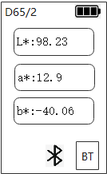
Figure 8 Instrument standard sample measurement

2.6.3 Single machine sample measurement
In the standard sample measurement interface, short press the "operation button" to enter the sample measurement interface associated with the standard sample, as shown in Figure 10. Align the measuring aperture with the sample and press the "measurement button" shortly, and the instrument will obtain the chromaticity data of the sample. The green indicator LED flashes once when the measurement is completed. The “01” on the left in the lower right corner of the instrument screen represents the standard sample number associated with the sample, and the 01 on the right represents the current sample number, and the sample number ranges from 01-99. After 99 pieces of sample data are full, the system prompts whether to clear the sample again, and the measurement can be continued after the sample is cleared. Slide the operation button to the left or right to view the sample data.
The default DE tolerance of the instrument is 1.0. When the color difference is within the tolerance range, it will prompt "Qualified", otherwise, it will prompt "Bad". The instrument DE tolerance can be set via APP and SQCX.
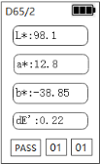
Figure 9 Instrument sample measurement
2.7 Mini printer
The mini printer is a non-standard accessory and needs to be purchased separately. The instrument is connected to a specially equipped mini printer, which can print measurement data.

3. System function description
Long press the "operation button" in the measurement interface to enter the system function interface. Slide the "operating button" to the left or right to select the system function, and long press the "confirm" button to make the corresponding settings.
3.1 Data deletion
Data deletion can delete measurement data.
Select " Standard Delete" and long press the "Operation Button" to delete all standard sample records and sample records in the instrument.
Select "Sample Delete" and long press the "Operation Button" to delete all sample records in the instrument and keep the standard sample records.
Note: After the record is deleted, the data cannot be recovered, please operate carefully to prevent accidentally deleting the required history record.
3.2 Light source settings
The light source setting includes the observer angle and the light source setting.
The observer angle can choose 2° and 10° (different models have differences);
The light source can choose D65, A, C, D50, D55, D75, F1, F2, F3, F4, F5, F6, F7, F8, F9, F10, F11, F12 (different models have differences).
3.3 color space
The color space can choose CIE LAB, XYZ, Yxy, LCh, CIE LUV, s-RGB, HunterLab, βxy, DIN Lab99. The default color space of the instrument is CIE LAB (different models are different).
3.4 Color difference formula
The color difference formula interface can choose DE*ab, DE*uv, DE*94, DE*cmc2:1, DE*cmc1:1, DE*00, DIN De99, DE(Hunter) (different models have differences).
3.5 System Settings
3.5.1 Auto save
When auto-save is turned on, the measurement result will be automatically stored in the instrument for each measurement. Otherwise, the sample measurement will end and the measurement record will not be automatically saved.
3.5.2 Sound
When the buzzer sound is turned on, a reminder sound will sound every time you operate, otherwise there will be no reminder sound.
3.5.3 Bluetooth
For instruments equipped with Bluetooth, it can communicate with mobile phone APP or PC-side quality management software through Bluetooth.
3.5.4 Automatic printing
When automatic printing is turned on, the sample will be automatically printed every time it is measured. Otherwise, the sample will not be automatically printed after the measurement is completed, and you need to manually click to print.
3.5.5 Calibration
Calibration (calibration threshold enable) is used to set whether to enable calibration threshold inspection. When set to off, when the instrument performs black and white calibration, the corrected data will not be checked; when set to on, when the instrument performs black and white calibration, the data collected by the detector will be checked to meet the verification rules. Calibration can pass.
The calibration threshold enable will not affect the test results, and the instrument does not need frequent black and white calibration. It is recommended to perform black and white calibration only when it is used for the first time, when the temperature difference environment has changed significantly, after a long period of unused use, or when the measurement data of the instrument is found to be inaccurate.
3.5.6 Language selection
The system language can be Chinese or English.
3.5.7 Sleep time
Set the automatic shutdown time after the screen is turned off. The sleep time is divided into "30 seconds", "60 seconds", "90 seconds", and "no sleep". If you choose not to sleep, the instrument will not automatically shut down. If it is set to "30 seconds", the instrument will count when the screen is off, and will shut down after 30 seconds and enter the power saving mode. The meanings of "60 seconds" and "90 seconds" are the same as above. When the instrument is sleeping, you can start the instrument by short pressing the operation button.
3.5.8 Backlight time
Set the display lighting time, the time is divided into "30 seconds", "60 seconds", "90 seconds", "normally open". If normally open is selected, the screen will always be on. If it is set to "30 seconds", the instrument will count from the last operation, and the display will turn off after 30 seconds. The meanings of "60 seconds" and "90 seconds" are the same as above.
3.5.9 Factory reset
Select "Restore Factory", the instrument will clear all measurement records and user settings, and restore to the factory state.
Note: After restoring the factory settings, all data cannot be restored, please operate with caution.
3.5.10 Device information
Display instrument model, SN code, software and hardware version number and other information.

Daily maintenance
1) This instrument is a precision optical instrument. Please keep and use the instrument properly. Avoid using and storing the instrument in humid, strong electromagnetic interference, strong light, and dusty environments. It is recommended to use and store the instrument in a standard laboratory environment (temperature 20 degrees Celsius, 1 standard atmosphere, humidity 50~70%RH).
2) The whiteboard is a precision optical element. It should be kept and used properly. Avoid hitting the working surface with sharp objects, avoid contaminating the working surface with dirt, and avoid exposing the whiteboard under strong light. Clean the working surface of the whiteboard with a wiping cloth dipped in alcohol regularly, and remove the dust on the working surface in time when correcting.
3) In order to ensure the validity of the measurement data, it is recommended that the complete instrument and the whiteboard should be inspected by the manufacturer or a qualified metrology institute for one year from the date of purchase.
4) Please do not disassemble the instrument privately. If you have any questions, please contact the relevant after-sales staff, tearing off the easy-to-tear label will affect the after-sales maintenance of the instrument.

5. Technical parameters
Optical Geometry | 45/0（45 circular uniform illumination 0 ° reception）, Conforms to standards CIE No.15，GB/T 3978.
Features | Used for color difference quality control in plastic electronics, paint and coating, textile and garment printing and dyeing, ceramics and other industries;  Small size, easy to carry, search for the color cards and multifunction expanded through smartphone APP
Integrating Sphere Size | Φ20mm
Illuminant Device | Full spectrum LED light source
Spectro Method | Filter spectro（Some models do not have this function）
Sensor | CMOS sensor
Wavelength Range | 400～700nm
Measuring Aperture | Φ8mm
SCI/SCE | SCI
Color Space | CIE LAB, XYZ, Yxy, LCh, CIE LUV, s-RGB, HunterLab, βxy, DIN Lab99（Different models are different）
Color Difference Formula | ΔE*ab,ΔE*uv,ΔE*94,ΔE*cmc(2:1),ΔE*cmc(1:1),ΔE*00, DINΔE99,ΔE(Hunter)  （Different models are different）
Other Color Index | WI(ASTM E313，CIE/ISO, AATCC, Hunter)，  YI(ASTM D1925，ASTM 313),  Metamerism Index Mt， Color fastness, color strength, Opacity, 555 color classification, Munsell(C/2) (implemented by mobile APP)  （Some models do not have this function）
Display Accuracy | 0.01
Observer Angle | 2/10°（Some models only support 10°）
Illuminants | D65, A, C, D50, D55, D75, F1, F2(CWF), F3, F4，F5，F6, F7(DLF), F8, F9，F10(TPL5), F11(TL84), F12(TL83/U30)  （Different models are different）
Display | Sample chromaticity value, color difference value, pass/fail result, color simulation, color deviation, reflectance (partly through mobile APP)  （Some models don’t support reflectance）
Measuring Time | About 1.0s
Repeatability | Color：ΔE*ab within 0.05（After warm-up calibration, the average value of measuring the whiteboard 30 times at an interval of 5s）
Accuracy | Pass National Metrology(Some models are not guaranteed）
Measuring Mode | Single measurement，Average measurement（2~99times））（Implemented through smartphone App）
Locating Method | Spot positioning（Some models do not have this function)
Dimension | Ø30X100mm
Weight | 88g
Battery | Lithium battery, can do tests continuously for 12000 times in a single full charge
Light source lifespan | 5-years more than 3 million times measurements
Screen | IPS full color screen, 1.14inch
Port | Type-C USB；Bluetooth 5.0；Buttons
Data Storage | Standards: 10pcs, Samples: 100pcs. Mass storage can be expanded through mobile APP（Different models are different）
Language | Chinese，English
Working Temperature range | 0~40℃，0~85%RH（No condensation），Altitude：lower than 2000m
Storage Temperature Range | -20~50℃，0~85%RH（No condensation）
Standard Accessories | Data cable, manual, calibration box, SQCX PC Color quality management software, MOBCCS APP (download from official website)
Optional Accessories | USB mini printer
Note | Technical parameters are for reference only, subject to actual instruments.

