Operation Instruction
V1.0

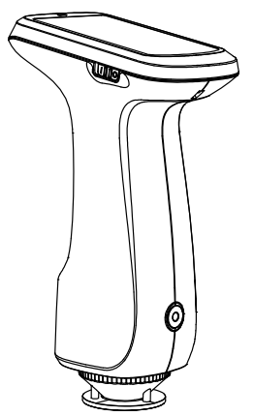

This instrument is a very safe device, but in order to ensure that you can use it correctly and safelyplease carefully read and strictly abide by the following clauses to avoid accidental injury or harm.The loss caused by not using the instrument according to the operation guide of this manual is notwithin the scope of our company.
Battery | - This machine is a built-in battery, please use the original battery, and other batteries cannot be disassembled to avoid damaging the instrument or causing other faults.  - Do not disassemble, squeeze, strike and heat the battery privately, nor put the battery in a fire or high temperature environment, otherwise it will explode and cause a fire.  - After the instrument is fully charged, when not in use, the external power supply should be cut off to prevent electric shock and damage to the instrument.  - If you don't use the instrument for a long time, you should charge the instrument once every two weeks, otherwise the internal battery will be easily damaged, which will make it impossible to use the instrument again.
External power supply | - When external power supply is needed, please use the standard power adapter of this instrument, and do not use other power adapters that do not meet the technical specifications, otherwise it may shorten the battery life or even cause electric shock to damage the instrument or cause fire.  - If the instrument is not used for a long time, the external power supply should be cut off to prevent the instrument from burning and causing fire.
Instrument | - Do not use this instrument in places with flammable or combustible gases (gasoline, etc.), otherwise it may cause fire.  - Do not disassemble the instrument privately, otherwise it will destroy the instrument, and dust and metal foreign objects may enter the instrument, and the instrument may be short-circuited, resulting in electric shock, destruction of the instrument and even fire.  - In the process of using the instrument, if the instrument emits burnt odor, it should be stopped immediately and sent to the maintenance point for testing and maintenance.
Please keep this manual properly for reference at any time.

CONTENT
Instructions 2
Cautions 3
1.External Structure and Description 4
2.Operating Instructions 6
2.1 Power On & Off 6
2.2 Black and White Calibration 6
2.3 Description of Measurement Interface 10
2.4 Description of Measurement Interface 11
2.4.1 Standard Measurement 12
2.4.2 Sample Measurement 14
2.5Communication with PC with Bluetooth 16
2.5.1 Communicate with PC through USB 17
2.5.2 Communicate with PC and Mobile APP via Bluetooth 17
3. Description of System Function 17
3.1 Data management 17
3.1.1 Check the Records 18
3.1.2 Delete Records 22
3.1.3 Standard Sample Input 24
3.2 Black and White Calibration 27
3.3 Illuminant 28
3.4 Color Space 29
3.5 Color Index 30
3.5.1 Color Index 30
3.5.2 Color Difference Formula 32
3.6 System Settings 34
4.Daily Maintenance 48
5. Technical parameters 48
5.1 Product Features 48
5.2 Technical Specifications 49
Appendix I 51
1. Object Color 51
2. Color Difference Formula 51
3. Normal Color Difference Allowable Range 52

Instructions
SpectroColorimeter is a domestic color measuring instrument independently developed by our company with independent intellectual property rights. It is a color measuring instrument developed according to CIE (International Commission on Illumination) standards and national standards. It is a simple spectral color difference instrument with convenient use, stable performance, fast and accurate measurement.
This instrument has the following advantages (some models have different configurations):
- It can be measured when it is turned on, and it is not necessary to correct black and white every time, which simplifies the operation steps;
- Camera locating, light spot positioning or cross positioning are adopted, which can quicklyaim at the measuring part;
- Equipped with 3.5-inch capacitive touch TFT display screen, large storage space and Bluetooth /USB interface;
- Connect PC-side quality management software to realize more function expansion;
- Can be connected to the color management software of mobile APP to meet the various needs of users;
- Original whiteboard calibration technology, reliable calibration, greatly increasing the service life of whiteboard;
- Φ11mm, Φ10mm, Φ6mm, Φ5mm, Φ3mm, Φ1x3mm, which are suitable for more test samples;
- It can test the reflection spectrum and various chromaticity indexes of the object, with accurate measurement and simple use.

Cautions
- This instrument is a precision measuring instrument. When measuring, drastic changes in the external environment of the instrument should be avoided, such as flickering of ambient light and rapid changes in temperature.
- When measuring, keep the instrument stable, the measuring port close to the measured object, and avoid shaking and displacement. This instrument is not waterproof and cannot be used in high humidity environment or water mist.
- Keep the instrument clean and tidy, and avoid liquid, powder or solid foreign matter such as water and dust from entering the measuring caliber and the inside of the instrument, and avoid collision and collision with the instrument;
- After using the instrument, put the instrument and related accessories into the instrument box and keep them properly;
- The instrument should be stored in a dry and cool environment;
- Users are not allowed to make any unauthorized changes to this instrument. Any unauthorized changes may affect the accuracy of the instrument and even irreversibly damage the instrument;

1.External Structure and Description

TYPE-C interface
Indicator light off
TFT display screen

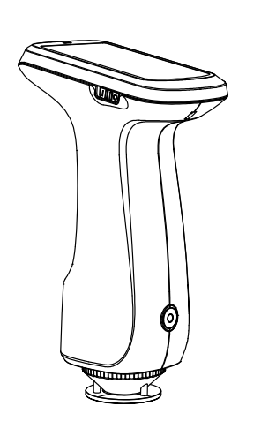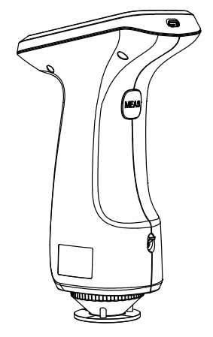
Wristband
Fixing
M5 Fixed Hreaded Hole
Measuring Button
Charging Needle
Aperture
Aperture Switch
Power Switch
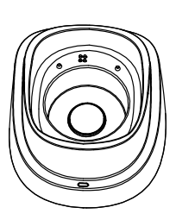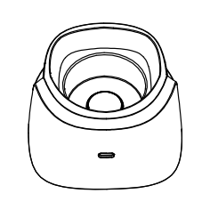
TYPE-C interface
Indicator light
White Board

Figure1 Schematic diagram of instrument button interface

Power 1/0 switch: when the switch is turned to "1", the instrument is powered on; When the switch is toggled to "0", the instrument is powered off and turned off, and the hardware is turned on and off by toggling the switch.

TYPE-C interface: The TYPE-C interface on the instrument is a common interface, which can be used to connect and communicate with PC, and the instrument automatically judges the connection; It can also be used to connect a printer.
The TYPE-C interface on the base is a power socket, which can charge the instrument (5V==2A).
Note: Two TYPE-C interfaces cannot be connected to the data line for charging at the same time to avoid unknown dangers.

Measurement Button: short press to wake up the instrument in dormant state, and short press to measure in normal state.

Aperture Switch: the aperture change-over switch (some models) is used to change the measuring aperture. When the switch is toggled, the logo is displayed and "M" is displayed, which means that the lens is switched to the position ofφ11mm aperture andφ10 mm aperture; When the switch is toggled, the logo shows "S", which means that the lens is switched toφ6mm aperture position, φ5mm aperture position and φ3mm aperture position. Some models support φ1×3mm measuring aperture. When using φ1×3 aperture, you need to turn the aperture switch to "S".

LED Indicator : The indicator light on the instrument has three indicating states: green, yellow and red. When the power is turned on, it is red when the power is less than 20%; More than 20% is green. The indicator light is yellow when measuring.

Note: The indicator light on the base only has two indicating states: green always on and off. It is turned off when USB is not connected; When the USB cable is plugged in, it will be green and always on.

M5 fixed screw hole: screw interface of fixed instrument, the thread type is standard metric common coarse thread, the pitch is 0.8mm and the depth is 5 mm.

WristbandFixing: used to fix the wrist band. When the wrist band is sleeved on the wrist, it can prevent the instrument from accidentally slipping off.

Charging stand: used for white correction and charging. Please refer to the chapter on black and white correction for details.

2.Operating Instructions

2.1 Power On & Off
As shown in Figure 1, when the 1/0 switch of the power supply is turned to "1", the instrument will be powered on and turned on, and the instrument will automatically enter the startup screen and start. When the 1/0 switch of power supply is turned to "0", the instrument will be powered off.
If you don't do anything for a long time in the power-on state, the instrument will automatically enter the sleep state. At this time, press the "Measure button" to wake up the instrument.

2.2 Black and White Calibration
Click the main menu key () in the measurement interface or other interfaces to enter the main menu interface, as shown in Figure 2.
Click "Black and White Correction" in the main menu to enter the "Black and White Correction" interface, as shown in Figure 3. The whiteboard number and the caliber used will be displayed in the interface.
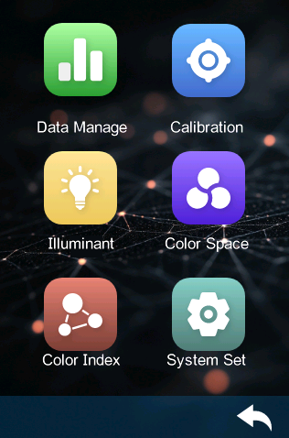
Figure 2 Main Menu
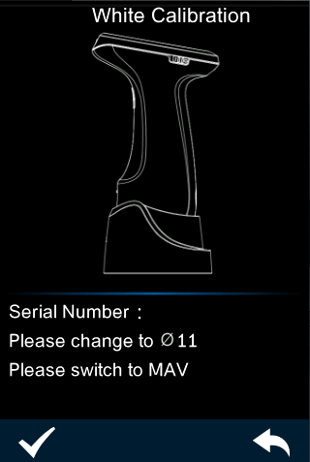
Figure 3 Black and White Calibration
Click "" to return to the main menu interface,White calibration interface, according to the prompt requirements, make white calibration. Please alignthe measuring aperture with the whiteboard and stick it tightly. After the whiteboard number andmeasuring aperture are set correctly, press the ""button or the "Measure" button to start whitecalibration. The words "On calibrating, please waiting" will appear in the interface, and the indicatorwillturn yellow. lf the correct white calibration is completed, it will automatically jump to the blackcalibration interface in Figure 5. lf there is any misunderstanding in the white calibration, thecorresponding reminder box will pop up.
In the black calibration interface, click the ""button or press the "Measure" button to performblack calibration on the instrument, and the words "On calibrating, please waiting" will appear in theinterface, and the indicator will turn yellow. Correct black calibration will automatically jump to the mainmenu interface (as shown in Figure 2).lf there is any misunderstanding in the black calibration, thecorresponding reminder box will pop up.

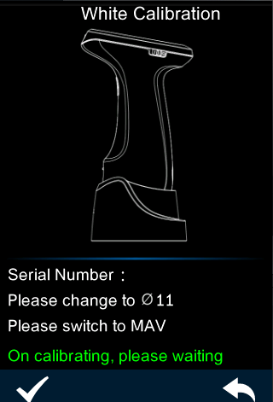
Figure 4 White Calibration
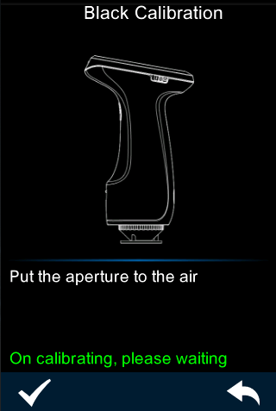
Figure 5 Black Calibration

After the black calibration is completed, you will jump back to the main menu in Figure 2, perform corresponding operations as needed, and click "" to return to the standard measurement interface.

2.3 Description of Measurement Interface
As shown in Figure 6, the upper part of the measurement interface is the working status area, where the measurement mode and Bluetooth status set by the instrument are displayed in real time. The middle part of the test interface is the data display area, and the instrument displays the corresponding chromaticity data according to the settings of the current user. Below the data display area are a shortcut display area and an operation button area, and the current data can be operated by clicking the corresponding operation button .
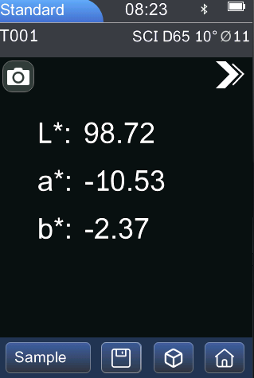
Multifunctional Shortcut Button
Data Display area
Standard/Sample Switching Area
Delete
Work States
Main Menu

Figure 6 Measurement Interface

2.4 Description of Measurement Interface
Measurement is divided into standard measurement and sample measurement. Standard measurement is generally used to measure the chromaticity data of the target sample, while sample measurement is used to measure the color difference or contrast chromaticity data between the sample and the target sample.
After the instrument is turned on and the correct black-and-white board calibration is completed, the measurement can be carried out (the customer can set the corresponding light source, color space and color index in the main menu interface as needed). If you are not in the measurement interface at present, you can click the "" button on the interface to return to the measurement interface.
Note: The default color space of the system is CIE lab, the color difference formula is ΔE*ab, and the color index is none.

2.4.1 Standard Measurement
On the standard measurement interface, aim the measured sample at the measuring aperture of theinstrument and stick it tightly. Press the measuring button lightly, and the buzzer will "drip" and theLED indicator will turn from vellow to green, which means the measurement is completed. Theinterface of the tested sample after the test is completed is shown in Figure 7.

Time
Interface Title
Bluetooth logo

Power
Standard/Sample Switching Area

Delete
Multifunctional Shortcut button
menu
Chromaticity Value
Measurement Mode
Aperture
Work Status
Camera Loacting
Standard NameNNameNsample name
MainMenu
Figure 7 Standard Measurement

- Interface Title: indicates that you are currently in the standard measurement interface.

2) Status Bar: displays system setting information, such as Bluetooth logo, measurement mode, current time, date, light source, observation angle, aperture and power consumption. If you choose to turn on Bluetooth, the status bar will display its logo accordingly, otherwise it will not be displayed.

- Checking and Positioning: Click on the camera (some models) to position the measuring position with the camera. After positioning, press the measuring button lightly to complete the measurement.

- Standard Name: displays the name of the currently measured standard sample, which starts with "T" followed by serial number by default, from T001 to T500.

- Standard Chromaticity Value : the measured value of standard sample. Some instruments display one decimal place, and some instruments display two decimal places.

- Multifunctional Shortcut Button: Click the shortcut menu button to switch SCI, observation angle and light source.

Note: Switching between SCI and SCE of display mode only switches the currently displayed data, and the measurement modes of standard and samples are set in Measurement Mode of System Settings.
If the current test data does not support the mode selected by the customer, the corresponding display may be "-"(for example, if the measurement mode is SCI, but the user switches SCE, SCE,Lab will be displayed as "-").

- Standard /Sample Switching Area: Click to switch to the sample measurement interface.

- Delete/Save: Click Delete the current measurement data when automatic measurement saving is turned on. When the automatic saving of measurement is turned off, the button "" will be displayed. Click to save the current measurement data.
9) Wavelength Switching Button: As shown in Figure 8, click the button to switch the reflectivity of the currently measured sample and the wavelength of light at intervals of 10nm.
Note: The reflectivity interface can be switched by "" to indicate the current interface.
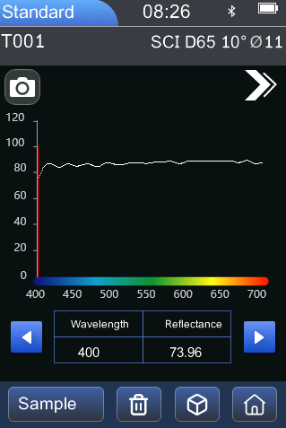
reflectivity

Fig. 8 Reflectance measured by standard sample

2.4.2 Sample Measurement
Under the standard measurement interface, click "Sample Measurement" to switch to the samplemeasurement interface. Point the measured sample at the measuring aperture of the instrument andstick it tightly. Press the measuring button lightly, and the buzzer will "drip" and the LED indicator willturn from yellow to green, which means that this measurement is completed, The interface of thesample after measurement is shown in Figure 9, and the diferences from the standard measurement are described in detail below.
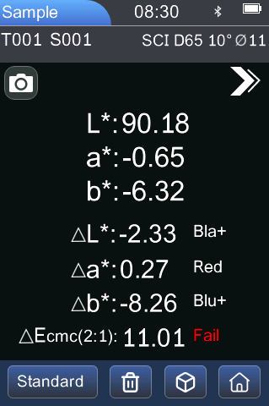
Color Deviation
Measurement
Result

Standard/Sample Switching Area
Color Difference
Value
Sample chromaticity value
Sample Name

Figure 9 Sample Measurement

1) Interface Title: indicates that you are currently under the sample measurement interface.
2) Sample Name: displays the name of the currently tested sample, which starts with "S" by default, followed by the serial number.
3) Chromaticity Value of Sample: display the measured value of sample in the current display mode. Some models display one decimal place, and some models display two decimal places.
4) Color Difference Value: displays the difference between the sample color value and the standard color value in the current display mode.
5) Color Deviation: the color deviation of the current sample compared with the standard sample. Only when "Color Bias" is turned on in the display settings will it be displayed.
6) Measurement Result: display the test result of the current sample, which is determined by the tolerance of the standard sample and the specified color difference formula. If the color difference value exceeds the tolerance, it will be displayed as "Fail", otherwise it will be displayed as "Pass". It will only be displayed if the display setting turns on "Test Result Prompt".
7) Reflectance Difference: at the current reflectivity, measure the difference between the sample and the standard . As shown in Figure 10, click the button, and the current measured sample light wavelength, sample reflectivity and sample standard reflectivity difference will be switched at intervals of 10nm.
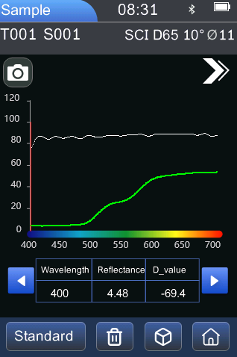
reflectivity

Reflectance difference
Figure 10 Measured Reflectivity of Sample

2.5Communication with PC with Bluetooth
The PC-side software has strong function expansion, which can realize more chromaticity data analysis. This series of instruments can communicate with PC software models (some models) through USB data cable and Bluetooth module (only for products equipped with Bluetooth module).

2.5.1 Communicate with PC through USB
When the client program is installed on the PC, connecting the instrument to the PC with USB data cable will automatically identify the connection. If the connection is successful, the terminal instrument can be fully controlled by software, and relevant samples can be tested and analyzed.

2.5.2 Communicate with PC and Mobile APP via Bluetooth
For some instruments equipped with Bluetooth module, they can communicate with PC through Bluetooth.
When the client program is installed on the PC, turn on the "Bluetooth" option in the "System Settings" of the instrument, and pair the computer with Bluetooth. After the pairing is successful, the software uses Bluetooth connection mode to connect, and the Bluetooth icon appears in the lower right corner of the software, which indicates that the connection is successful through Bluetooth. Then the terminal instrument can be fully controlled by software, and the relevant samples can be tested and analyzed.
When the APP is installed on the mobile phone, turn on the "Bluetooth" option in the "System Settings" of the instrument, and pair the APP with the instrument. After the pairing is successful, the APP is connected in Bluetooth connection mode, and the software realizes the full control of the terminal instrument, and the relevant samples are tested and analyzed.

3.Description of System Function
Click the main menu () in the measurement interface to enter the main menu interface (as shown in Figure 2). In other interfaces, you can click the back key () to enter the main menu, from which you can enter the submenus to realize all system function settings.

3.1 Data management
Click "Data Management" in the main menu interface to enter the data management interface, as shown in Figure 11. Data management is mainly used to view and operate the measured records.
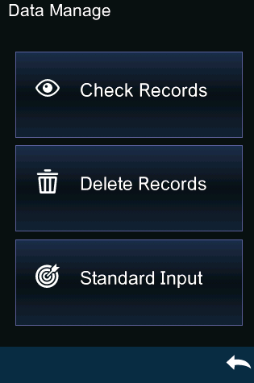
Figure 11 Data Management

3.1.1 Check the Records

1) Check the standard sample records
Click "View Records" in the data management interface to enter the "Standard Sample Records" interface, as shown in Figure 12.
Note: the chromaticity value recorded by the instrument when viewing the standard sample shows two decimal places.
Clickto browse the next record, and clickto browse the previous record.
Click "" to perform the following operations: SCI, 10°, record deletion and standard sample import, as shown in Figure 13.

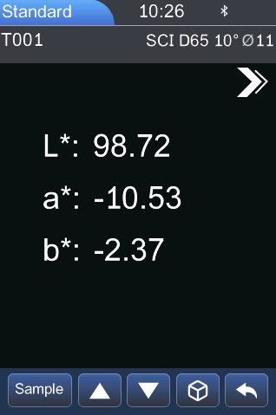
Figure 12 Standard Record
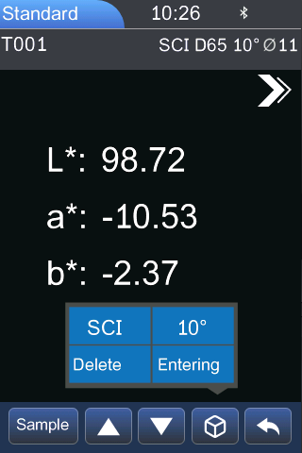
Figure 13Standard Record Operation Menu

SCI: Click SCI to switch the measurement mode to SCE mode.
10°: Click "10°" to switch the observation angle to 2°.
Delete : click "Delete " to enter the record deletion interface, and click "OK" to finish the deletion; Or click Cancel to delete the operation and return to the operation menu.
Entering: Click "Entering" to set the standard being checked as the current standard, and then click'sample measurement" to measure the sample under this standard

Check Sample Records
Click "Sample" in the interface of standard record to view the sample record under this standard , as shown in Figure 11.

Clickto browse the next record, and clickto browse the previous record.
Click "" to perform the following operations: transferring standard samples, deleting records, SCI and 10°, as shown in Figure 15.
Entering: click "entering" to set the sample record being viewed as the new current standard sample, and then click "Sample Measurement" to measure the sample under this standard sample.
SCI: Click SCI to switch the measurement mode to SCE mode.
10°: Click "10°" to switch the observation angle to 2°.
Delete : click "Delete" to enter the record deletion interface, and click "OK" to finish the deletion; Or click Cancel to delete the operation and return to the operation menu.
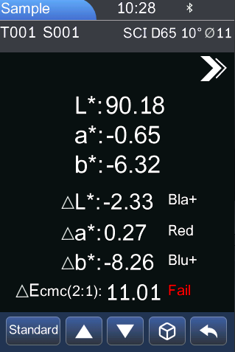
Figure 14 Sample Record
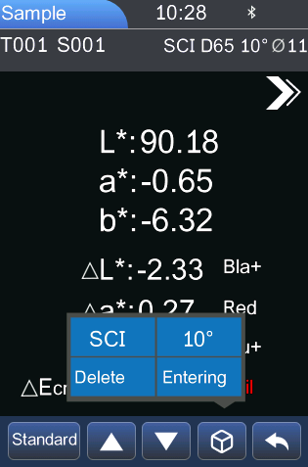
Figure 15 Sample Record Operation Menu

3.1.2 Delete Records
Click "Delete Records" in the data management interface to enter the menu interface of deleting records, as shown in Figure 16. Delete records are divided into "Delete all records" and "Delete all samples".
Click the corresponding option to enter the deletion prompt warning interface, and clickin the warning interface to delete all the corresponding records; If you want to cancel, you can click, as shown in Figure 17.

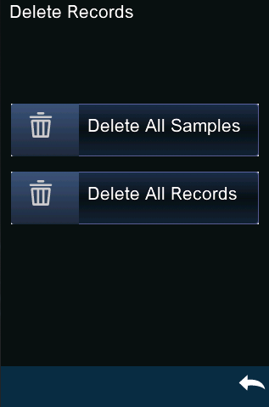
Figure 16 Delete Record Interface
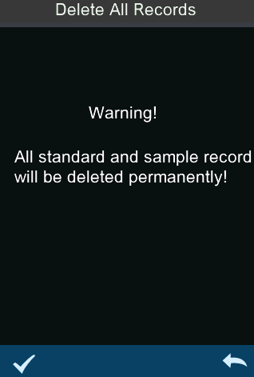
Figure 17 Delete Prompt Box

3.1.3 Standard Sample Input
Click "Standard Sample Input" in the data management interface to enter the standard input interface, as shown in Figure 18, Figure 19 and Figure 20. After successful input, the current data can be viewed in the standard measurement/standard record interface.
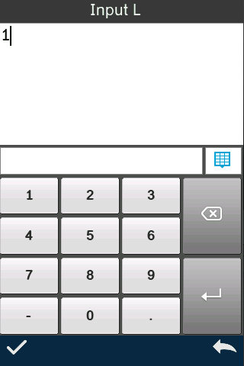
Figure 18 Standard Input L

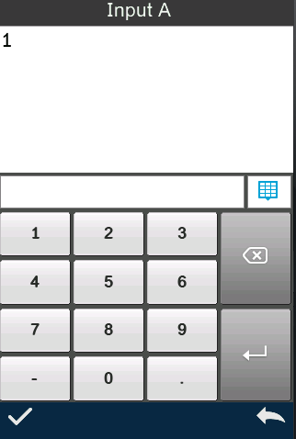
Figure 19 Standard Input A
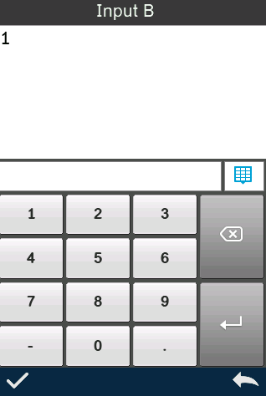
Figure 20 Standard Input B

3.2 Black and White Calibration
As the benchmark of chromaticity data measurement, black-and-white calibration must be carried outaccurately, otherwise it will affect the accuracy of test data. When the black-and-white calibrationenvironment is quite different from the current sample testing environment (such as drastic fluctuationsin temperature and humidity), or the data is obviously abnormal, it is necessary to calibrate the black-and-white board in time. When the instrument is used continuously for 8 hours or the instrument isswitched on and off again, it is also recommended to do a black-and-white board calibration again.The whiteboard should be cleaned regularly, and the charging seat should be properly kept in a dark,dustproof and dry condition.
Please refer to Section 2.2 for black-and-white calibration method.

3.3 Illuminant
Click "Illuminant" in the main menu interface to enter the light source setting interface, as shown in Figure 21.

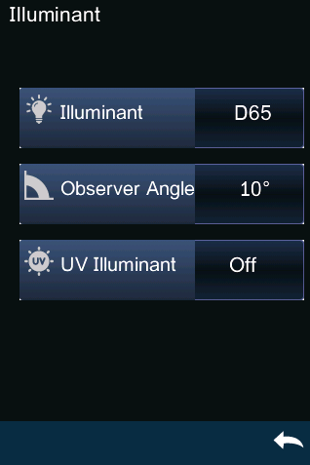
UV Illuminant

Observer Angle
Illuminant
Figure 21 Illuminant
The user sets the corresponding light source according to the actual measurement conditions. In the Illuminant setting interface, you can set the standard observer angle, standard light source type and UV light source (different types of instruments have different configurations) of the system.
Click the observer's angle to switch between10°and 2°. Among them, 10° is CIE1964 standard; 2° is CIE1931 standard.
Click the light source, and there are options in the light source selection interface: D65, D50, A, C, D55, D75, F1, F2(CWF), F3, F4, F5, F6, F7(DLF), F8, F9, F10(TPL5), F11(TL84) and F12 (TL83).
Click on the UV light source to switch the UV light source switch. lt is recommended to turn on the UV light source when testing fluorescent samples and turn off the UV light source when testing commonsamples.

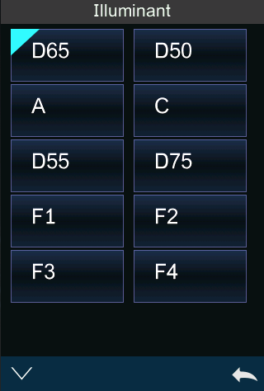
Figure 22 Illuminant Selection

3.4 Color Space
Click "Color Space" in the main menu to open the color space interface, as shown in Figure 23. Select the corresponding color space in the color space interface to complete the color space setting. Color space options are CIE LAB, XYZ, Yxy, LCh, CIE LUV, s-RGB, HunterLab, etc.
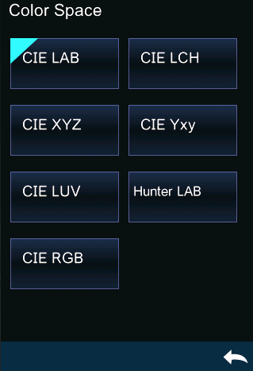
Figure 23 Color Space

3.5 Color Index

3.5.1 Color Index
Click "Color Index" under the color index menu to enter the color index window, as shown in Figure 24.
Let's take the setting of "color index" as an example to explain in detail.
In the color index interface, the color index options are: Yellowness, Whiteness, Opacity, Strength, Color , Staining, Metameric Index: MI.

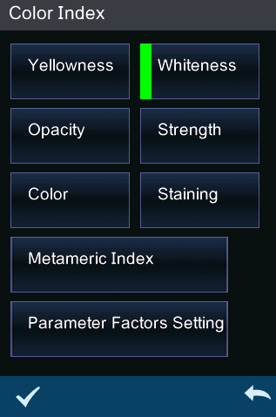
Figure 24 Color Index Interface
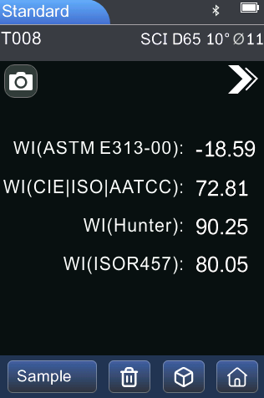
Figure 25 Color Index interface of Whiteness
The selected color index will be displayed in the color index interface of the measurement interface, as shown in Figure 25.
The selected color index will be displayed in the color index display area of standard and sample measurement (depending on the index, it may only be displayed in the sample).

3.5.2 Color Difference Formula
Click "Color Difference Formula" under the color index menu to enter the color difference formula window, as shown in Figure 26.
Let's take setting the "color difference formula" as CMC(2:1) as an example to explain in detail.
In the color index interface, the color difference formula options are CIE 1976, CIE 94, Hunter, CMC (2: 1), CMC (1: 1), CMC (L: C) and CIE 2000.

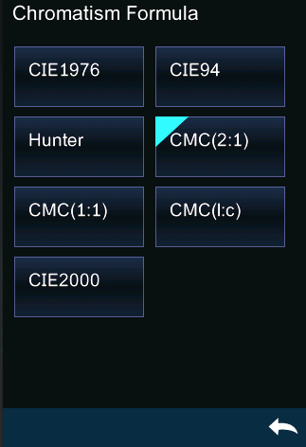
Figure 26 Color Difference Formula Interface
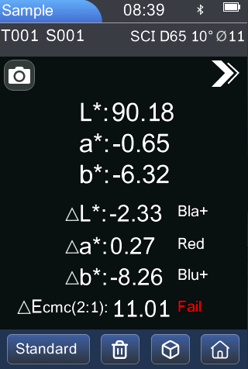
Figure 27 Calculation of Color Difference Using ΔE CMC (2: 1)
The selected color difference formula will be used to calculate the color difference of the sample when it is measured, as shown in Figure 27.
The selected color index will be displayed in the color index display area of standard and sample measurement (depending on the index, it may only be displayed in the sample).

3.6 System Settings
Click "System Settings" in the main menu to enter the interface of system settings, as shown in Figure 28. System settings include measurement settings and instrument settings. Click to view and select different setting options.

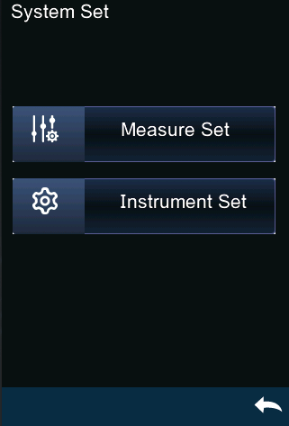
Figure 28 System Setting

3.6.1 Measurement Settings
Click "Measurement Settings" in system settings to enter the interface of measurement settings, as shown in Figure 29. Measurement settings include automatic saving of measurement, aperture selection, Bluetooth, simple mode, measurement mode, display setting, tolerance setting, average measurement, printing setting, buzzer and other options. You can view and select different setting options.

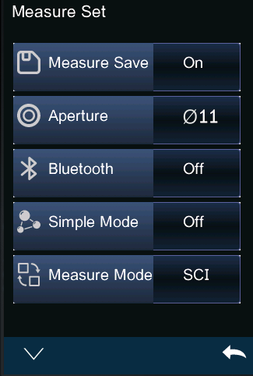
Figure 29 Measurement Setting

Automatic Saving of measurement
When automatic saving of measurement is turned on, every sample tested will be automatically saved in the instrument, otherwise the record will not be automatically saved after the sample is tested, and it will be saved only after the save icon "" is manually clicked, as shown in Figure 30.
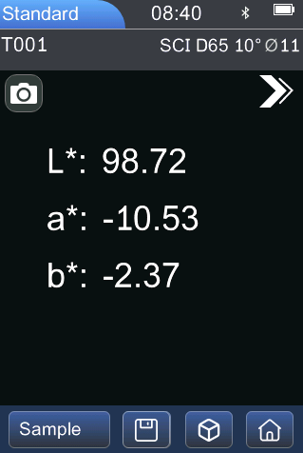
Figure 30 When automatic saving is turned off,
the measurement results need to be saved manually

Measuring Aperture
This series of instruments are equipped with φ 11 mm, φ 10 mm , φ 6 mm , φ 5 mm , φ 3 mm and φ 1× 3 measuring aperture (different models are equipped with different measuring apertures). When the measured surface of the sample is large and uniform, it is recommended to use φ 11 mm and φ 10 mm , and when the measured surface of the sample is small, it is recommended to useΦ6mm、Φ5mm、Φ3mm、Φ1×3 measuring aperture.
Measuring aperture (φ 11 mm/φ 10 mm/φ 6 mm/φ 5 mm/φ 3 mm/φ 1× 3 mm) switching needs to complete the following two steps:
Step 1: Install the aperture: rotate the measuring aperture counterclockwise to remove the original aperture; Align the measuring apreture to be installed with the mounting hole of the integrating sphere, and turn it clockwise. When there is a "click", it means that the measuring aperture and the integrating sphere are well matched, that is, the measuring aperture to be installed is installed.
Step 2: Switch the position of the optical lens. If the assembled aperture is φ 11mm /φ 10 mm , you need to turn the aperture switch to the position of MAV; If the diameter is φ 6mm/φ 5mm/φ 3mm, it is necessary to turn the diameter change-over switch to the position of SAV; If the assembled diameter φ 1× 3 is used to measure the diameter, it is necessary to turn the diameter change-over switch to the position of SAV.
Step 3: Switch the aperture setting in the instrument software, and manually set the corresponding aperture of φ 11 mm/φ 10 mm/φ 6 mm/φ 5 mm/φ 3 mm/φ 1× 3 mm.
Note:Ensure the measurement aperture, optical lens position, and software settings are consistent for accurate test results.
φ1×3mm→ Lens: SAV, Software: 1×3
φ3mm → Lens: SAV, Software: φ3
φ5mm → Lens: SAV, Software: φ5
φ6mm → Lens: SAV, Software: φ6
φ10mm → Lens: MAV, Software: φ10
φ11mm → Lens: MAV, Software: φ11
The selected aperture is shown on the test interface status bar.
After changing the aperture, perform black and white calibration again before taking new measurements.

Bluetooth
For the product model equipped with Bluetooth, you can choose to communicate with PC software through Bluetooth.
When Bluetooth is turned on, the Bluetooth icon will be displayed on the status bar of the measurement interface. When the client program is installed on the PC, turn on Bluetooth in the instrument "System Settings" to pair the computer with Bluetooth. After the pairing is successful, the software connects in Bluetooth connection mode, and a prompt appears in the lower right corner of the software, which indicates that the connection is successful through Bluetooth. Then the terminal instrument can be fully controlled by software, and the relevant samples can be tested and analyzed.

Simple Mode
After the simple mode is turned on, return to the measurement page for standard sample measurement. After the standard sample measurement, it will automatically switch to the sample measurement mode.

Measurement Mode
SCI is a measurement mode including specular reflection light, and SCE is a measurement mode excluding specular reflection light. This instrument realizes the SCI/SCE test mode switching through the traditional way of setting the mechanical optical trap. The motor drives the paddle to block the mechanical optical trap, which is the SCI measurement mode, and the paddle is open, which is the SCE measurement mode.
Standard measurement, the instrument automatically completes SCI and SCE measurement, and the test time is about 3 seconds.
When measuring the sample, the instrument measures according to the measurement mode set by the customer. According to the needs of measuring products, customers can set the measuring mode as SCI, SCE or I+E, and some models only have some options.
I+E is SCI+SCE mode. The measurement time of SCI/SCE alone is about 1.5 seconds, and the simultaneous measurement of SCI+SCE takes 3.2 seconds.
If the current measuring mode of the instrument is SCI (the working status area is displayed as SCI), the instrument will only test the SCI data of the sample. If the display mode is set as SCE, the corresponding chromaticity data will be displayed as "-",and the spectral data and color index will not be displayed.

Display Settings
Click "Display Settings" in the main menu interface to enter the display settings interface, as shown in Figure 31. In this interface, you can set whether to turn on color offset and test result prompt.
When the color offset is turned on, the color offset of the comparison between the sample and the standard will be prompted when the sample is measured, as shown in Figure 32, and there is no prompt when it is turned off.
If the test result prompt is turned on, when the sample is measured, if the test result exceeds the tolerance range set by the standard , it will prompt fail, and if the error of the sample is within the tolerance range of the standard, it will show pass, as shown in Figure 32.
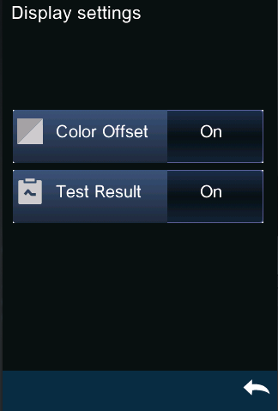
Figure 31 Display Settings
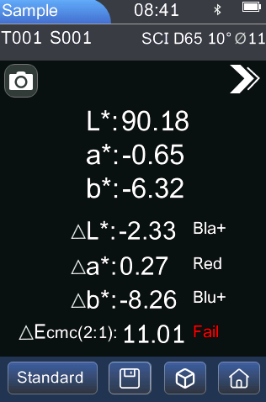
Color deviation of sample
Test Result
Figure 32Open Color Deviation and Measurement Results

Tolerance Setting
Select "Tolerance Setting" in the measurement setting interface to enter the tolerance prompt setting interface. Users can set the tolerance value in the tolerance setting interface according to the requirements of color management. After selecting the number to be modified, the numeric keyboard will pop up. Press the ""button to move the cursor to the next digit. When the cursor is at the last digit, press the ""button to save the settings and return to the measurement setting interface. If you don't want to set or modify the tolerance, you can press "" to return to the main menu interface.
When the tolerance setting is completed, the instrument will automatically judge whether the total color difference △E* is qualified according to the tolerance set by the user when measuring the sample. If the total color difference △E* is less than the tolerance value, it is qualified, and if it is greater than the tolerance value, it is unqualified.
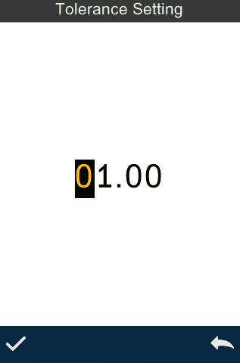
Figure 33 Tolerance Setting

Average Measurement
When that sample to be measure is relatively large or uneven, the multi-point average reflectivity is obtained by measure a plurality of representative test points, and then the calculated chromaticity data can represent the real chromaticity value of the sample to be measure better, and the instrument can realize the average measurement of 2-99.
Click "Average Measurement" in the main menu interface to enter the average measurement interface, where you can set the average measurement times, as shown in Figure 34. Then enter the average number of measurements, and clickto confirm. If the average number of inputs is 1, it will be measured in the conventional way; If it is greater than 1, the measurement results will be generated after measuring the specified number of times when measuring the standard and the sample.

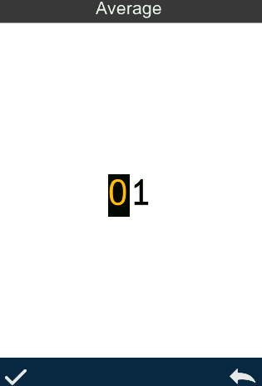
Figure 34 Average Measurement

Print Setting
Micro printers are non-standard accessories and need to be purchased separately.
Use USB printer or Bluetooth printer to print out the current measurement record (some models). "Print Settings" is off by default in "System Settings" in the main menu. When printing is needed, just select to turn on the corresponding printer (as shown in Figure 35).
- Use USB printer
The user can first connect the micro printer to the instrument through USB, and after the micro printer is connected to the instrument through USB, the measurement interface can perform the operation of printing while measuring. The instrument will send the current measurement record data to the printer, and the printer will finish the printing.
- Use Bluetooth printer
Similar to using a USB printer, the user can connect the instrument to the micro printer first, and print while measuring in the measurement interface. The instrument will send the current measurement record data to the printer, and the printer will finish the printing work.
Use steps of Bluetooth printer:
1. Press and hold the power of the Bluetooth printer for a long time, and let go when you see the indicator light flashing.
2. Enter into System Setting Printer SettingBluetooth Printer.
3. Enter the mac address on the back of the Bluetooth printer in BLE mac, with a fixed length of 12 characters (for example, "4CE173C3F00E"), and the MAC address will be automatically stored.
4. Click Connect Printer .
5. After the Bluetooth printer is connected, you can print while measuring in the measurement interface.
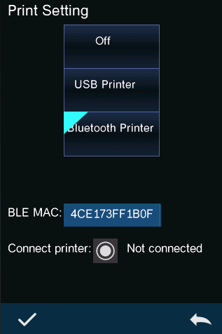
Figure 35 Print Setting

3.6.2 Instrument Settings
Click "Instrument Settings" in system settings to enter the interface of instrument settings, as shown in Figure 36. Instrument settings include language selection, time setting, screen backlight time, factory reset and about the instrument. You can view and select different setting options.
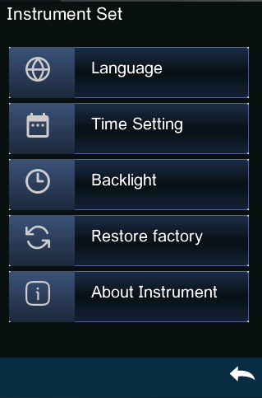
Figure 36 Instrument Setting

Language Setting
Language setting is used to set the language of the instrument interface. In the system settings interface, click "Language Settings", and then select the corresponding language to confirm.

Timeset
When the instrument leaves the factory, the local time of the manufacturer is usually synchronized, and the customer can also set the time of the instrument according to the actual situation. Click "Time Setting" in the system setting interface to enter the interface shown in Figure 37.
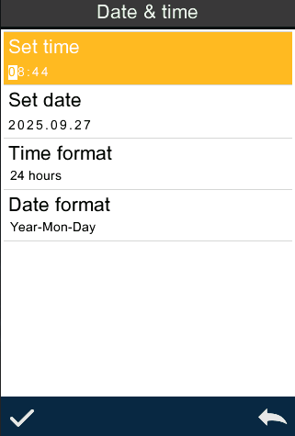
Figure 37 Time and Date Setting

Screen Backlight Time
Click "Screen Backlight Time" in the system setting interface to enter the "Screen Backlight Time" selection interface.
Backlight time is divided into: always on, 5 minutes, 60 seconds, 30 seconds and 15 seconds. If normally open is selected, the screen will not be automatically displayed when there is no operation. If it is set to "60 seconds", the instrument will be timed from the last customer operation, and the screen will stop after 60 seconds, making it in power saving mode. The settings of "5 minutes", "30 seconds" and "15 seconds" have the same meanings as above. When the instrument is on the screen, you can press the "measure button" to wake up the instrument.

Restore Factory Settings
Click "Restore Factory Settings" in the system settings interface to enter the interface shown in Figure 38. ClickInstruments to clear all measurement records and customer settings and restore them to the factory status; Clickto cancel this operation.
Note: The operating instrument will clear all data and user settings, and return to the factory state. All data cannot be recovered. Please operate with caution.
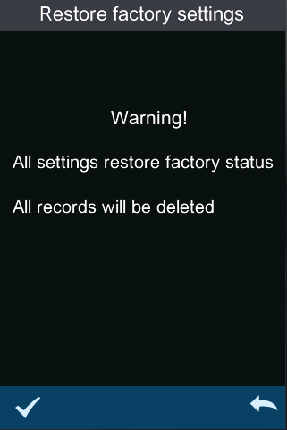
Figure 38 RestoreFactory Setting

About Instruments
Display information such as instrument model and current software version.

4.Daily Maintenance
1) This instrument is a precision optical instrument, so please keep and use it properly, and avoid using and storing it in damp, strong electromagnetic interference, strong light and dusty environment. It is recommended to use and store the instrument in a standard laboratory environment (temperature 20 degrees Celsius, 1 standard atmospheric pressure, humidity 50~70%RH).
2) The calibration box is a precision optical element, so it should be properly kept and used. Avoidbumping the working face with sharp objects, soiling the working face with dirt and exposure to stronglight. Clean the working face of the calibration box with regular wiping cloth dipped in alcohol, and getrid of the dust on the working face in time during calibration.
3) In order to ensure the validity of the test data, it is suggested that the whole instrument and calibration box of the colorimeter should be inspected by the manufacturer or a qualified metrology institute one year from the date of purchase.
4) This instrument supplies power for the built-in lithium battery. If the instrument is not used for a long time, please charge it every two weeks to protect the performance and prolong the life of the lithium battery.
5) Please don't disassemble the instrument without permission. If you have any questions, please contact the relevant after-sales staff. Tearing up the easy-to-tear label will affect the after-sales maintenance service of the instrument.

5. Technical parameters

5.1 Product Features
- This instrument fully considers the user's experience and adopts the theme concept of humanized design-making measurement easier.
- It is convenient, fast and accurate to use the original illumination spot positioning or cross platform positioning.
- This instrument can be directly measured without black-and-white calibrition, which improves the convenience of the colorimeter.
- This instrument adopts a new photoelectric integrating sphere design, which greatly improves the repeatability and stability of measurement.
- This instrument has a variety of technical specifications, and users can choose according to their needs.

5.2 Technical Specifications
Optical  Geometry | D/8 (diffuse illumination, receiving in 8 direction), SC/SCE (including speculareflection light/removing specular reflection light), conforming to standards ClE No.15GB/T3978,GB 2893,GB/T18833, ISO 724-1,ASTM E164, DIN 5033 TEIL 7.
Characteristic | Silicon photodiode array (double row 16 groups) is used for color difference quality control inplastic electronics, paint ink, textile and garment printing and dyeing, printing,ceramics and other industries; UV can be used for fluorescence sample measurement.
Light Source | Combined full-spectrum LED light source, UV light source
Integrating sphere size | Φ40mm
Splitting mode | Nano-integrated spectral device
Sensor | Silicon photodiode array (double row 16 groups)
Wavelength Range | 400-700nm
Measuring Aperture | 3mm platform +3mm nozzle +5mm platform +5mm nozzle +6mm platform +6mm nozzle +10mm platform +10mm nozzle +11mm platform +11mm nozzle +1*3 nozzle (different models have differences).
Specular Component | SCI/SCE
Color Space | CIE LAB,XYZ,Yxy,LCh,CIE LUV,s-RGB,HunterLab
Color difference formula | ΔE*ab,ΔE*uv,ΔE*94,ΔE*cmc(2:1),ΔE*cmc(1:1),ΔE*00, ΔE(Hunter)
Other chromaticity indexes | Spectral reflectance, WI(ASTM E313, CIE/ISO, AATCC, Hunter, Taube, Berger, Stensby), YI (ASTM D1925, ASTM 313), Metamerism Index Mt, Staining Fastness, Color Fastness, Strength , Opacity, 555 Index，Blackness（My,dM） Color Density CMYK(A,T,E,M), Tint(ASTM E313-00)，Munsell（Some functions are realized through the computer）
Observer Angle | 2°/10°
Illuminant | D65, A, B, C, D50, D55, D75, F1, F2 (CWF), F3, F4, F5, F6, F7 (DLF), F8, F9, F10 (TPL5), F11 (TL84), F12 (TL83/U30).
Displayed Data | Spectrogram/Values, Samples Chromaticity Values, Color Difference Values/Graph, PASS/FAIL Result, Color Offset
Measuring time | About 1s
Repeatability | Spectral reflectance: MAV/SCI, Standard deviation within 0.1% (400 nm to 700 nm: within 0.18%)  Chromaticity value: MAV/SCI, within ΔE*ab 0.02 ( When a white calibration plate is measured 30 times at 5 second intervals after white calibration)
Inter-instrument Error | MAV/SCI, Within ΔE*ab 0.2  (Average for 12 BCRA Series II color tiles)
Display accuracy | 0.01
Measured Reflectance Range | 0-200%
Reflectivity resolution | 0.01%
Measurement Mode | Single measurement, average measurement (2~99 times)
Locating mode | Camera Locating,stabilizer cross position (different models have differences)
WhiteboardVerificationMode | Non-contact automatic whiteboard calibration (different models have differences)
Dimension | 120*75*207mm
Weight | About 367g (excluding calibration base)
Battery | Lithium battery, 3.7V, 3200mAh, 8000 times in 8 hours.
Illuminant Life Span | More than 1.2 million measurements in 10 years
Displayed Data | TFT true color 3.5inch, capacitive touch screen
Data Port | USB, bluetooth
Data Storage | There are 500 standard samples and 15,000 samples (one piece of data can include SCI/SCE at the same time), and APP/PC is stored in mass (different models have differences).
Software Support | Andriod,IOS,Windows, wechat applet, HarmonyOS (different models have differences).
language | Simplified Chinese, English, traditional Chinese
Operating Environment | 0~40℃, 0~85%RH (no condensing), Altitude < 2000m
Storage Environment | -20~50℃, 0~85%RH (no condensing)
Standard Accessory | Power adapter, data cable, instruction manual, quality management software (downloaded from official website), white calibration box, protective cover, wristband, measuring aperture.
Optional Accessory | Micro Printer, Powder Test Box
Note: | 1. Technical parameters are for reference only, subject to the actual products sold.  2. lt is subject to change without prior notice.

Appendix I

1. Object Color
There are three elements in observing color: illumination source, object and observer. Any one of these three changes will affect the color perception of the observer. When the lighting source and the observer do not change, then the object will determine the color perception formed by the observer.
The reason why an object can affect the final color perception is that the reflection spectrum (transmission spectrum) of the object modulates the light source spectrum. Different objects have different reflection spectra (transmission spectra), and the light source spectrum is modulated by the reflection spectra (transmission spectra) of different objects to obtain different results. Because the observer remains the same, it presents different colors. The principle is shown in the following figure.
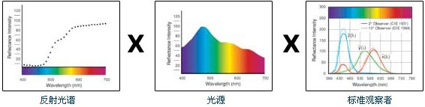
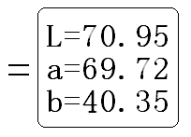

2. Color Difference Formula
CIE 1976 ΔE*ab
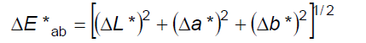
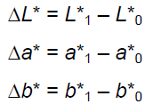
CIE 2000 ΔE*ab:
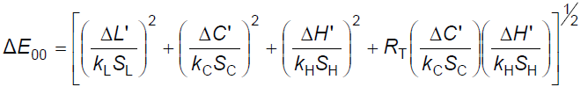
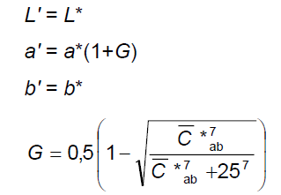
CIE 1994 ΔE*ab:

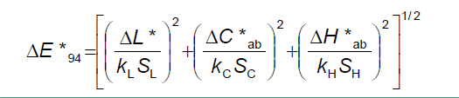
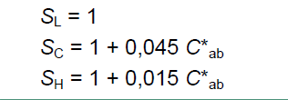

3. Normal Color Difference Allowable Range
The allowable range of normal skin color differences varies in different industries and application scenarios. The following are the allowable models of skin colordifferences in some major industries.
Scope description:
- Electronic device industry
Standard: △ E (color difference unit) is usually required to be lower than 0.5 to ensure the color accuracy of screen display and product appearance.
2. Plastic coating industry
Standard: △ E is required to be lower than 1.0, which is suitable for low-color control of plastic products and coating products.
3. Textile industry
General standard: △E is considered as an acceptable range at 2.0, especially in textile color management.
Specific standards: In some standards, it is required that the color difference of a specific department is not less than Grade 4, and the corresponding color difference is between 0 and 2.0.
4. Printing industry
Range: A color cast range of 1.5 to 3.0 is usually regarded as normal, but the specific value may vary according to the product grade and customer requirements.
Standard: Some standards stipulate that the color difference value of both fine products and general products should not exceed 6.
5. Railway signal flag
Standard: The color difference is less than or equal to 3.0 to ensure the clarity and recognition of the signal flag.

Color difference and visual perception;

△E | Degree of human visual perception | △E | Degree of human visual perception
0-0.25 | Very small or no chromatic aberration, ideal match. | 1.0-2.0 | Moderate chromatic aberration, perceptible to human eyes, acceptable in specific applications.
0.25-0.5 | Slight chromatic aberration, usually acceptable. | 2.0-4.0 | Obvious chromatic aberration, acceptable under certain conditions.
0.5-1.0 | Slight to moderate chromatic aberration, acceptable for some applications. | Above 4.0 | The color difference is very large, which is unacceptable for most applications.

